GRAVITY, ACTUALLY
Einstein’s Relativity in Plain Words: Falling, Time, Black Holes, and the Waves We Finally Heard

Lothar J. Musiol

Falling is the straight path.
What we call gravity is spacetime not lining up.
Since 2015 we have watched the bends move.

Copyright
Gravity, Actually: Einstein’s Relativity in Plain Words: Falling, Time, Black Holes, and the Waves We Finally Heard
Copyright © 2026 Lothar J. Musiol. All rights reserved.
No part of this book may be reproduced, stored, or transmitted in any form without the written permission of the author, except for brief quotations in a review.
This is an original work. It is not an abridgment or adaptation of Misner, Thorne, and Wheeler’s Gravitation, or of Taylor and Wheeler’s Spacetime Physics and Exploring Black Holes, or of Wheeler’s A Journey into Gravity and Spacetime. Some of the teaching ideas in those books are retold here in new words and with new diagrams, and each is credited where it is used and in Further reading and sources. No text or figures from them are reproduced.
Pictures. The thirteen diagrams (the two ants, the light clock, the two surveyors, the light cone, tidal stretching, the sheet and the clock-rate curve, the stack of clock-rate surfaces, the GPS clock budget, gravitational lensing, the slice of space around a black hole, the Kruskal map, the LIGO layout, and the slice through a wormhole), the three number tables, and both covers were drawn for this book with Python plotting scripts. No AI image generator was used for any picture in this book. Three pictures are real images, used under their licenses and credited where they appear: fruit floating in the International Space Station (NASA, public domain), the black hole in M87 by the Event Horizon Telescope Collaboration (CC BY 4.0), and the Bullet Cluster composite released by NASA (public domain). Details are on the Picture credits page.
First edition, 2026.

Contents
Before you start
How to read the labels
1. The apple that did not fall
The natural state
A patent clerk and a falling man
Two cabins that will not join
The ant on the apple
What a small room can hide
What people get wrong here
Heavy and light
A note on the word force
The floor has a lawyer
The dive, sold honestly
A room at Princeton
Exercises
2. Straight, but not in space
The one equation for spacetime
The surveyors
The train, told without a trick
The twin, told carefully
How fast is fast enough to notice
The sideways fall
Light is the edge
The pole in the barn
Clocks on airliners
Exercises
3. Tides are the real gravity
The ocean is a slow experiment
Why a black hole tears, and a cabin does not
Two crumbs falling side by side
The funnel, and its limit
A clock higher up
What the tide is not
A boomerang through the Earth
The Moon’s slow retreat
Exercises
4. What bends it
The other equation
The planet that would not sit still
The phone in your pocket
Other audits
What the equation is not
Stacks of surfaces
The eclipse that almost washed out
Pound and Rebka, twenty-two meters
Exercises
5. Stars with a last size
The white dwarf
The neutron star
Past the last size
The bill the waves sent
The scruff on the chart
The boat to England
Exercises
6. The universe is not flying apart through space
No center, no outside
The afterglow
The stretch is speeding up
The other blank
A number you can hold
The pigeons were innocent
The Bullet Cluster
Exercises
7. The place you do not come back from
Two true stories
How we know they are there
The bookkeeper and the shell observers
Spin
A planet pretending to be a dish
What a short book got right
Drawing the slice
A better map
Orbits near the door
Exercises
8. The bends can travel
A ruler shorter than a proton
Light and ripples from the same place
Since the first chirp
What the chirp is not
They did not believe the chirp
Exercises
What is still open
Measurements and readings, side by side
The wormhole surface
Appendix A. The steps the argument needs
Light clock
Simultaneity
Spacelike and timelike
Velocity addition
Proper time
Geoid
Equivalence limit
Field equation in words
Chandrasekhar limit
Mass gap
Horizon radius
Shadow versus door
Hawking temperature
Ringdown
Standard siren
Frame dragging
Innermost orbit
Andromeda slice
Pulsar timing
Two supernovae and a kilonova
Appendix B. The worked numbers
Speed: the factor, the sum, and the interval
Mass: where the horizon sits
Height: how much faster a higher clock runs
The budget, as numbers
Appendix C. Experiments with their own numbers
Michelson and Morley, 1887
Rossi and Hall, 1941
Gravity Probe A, 1976
Galileo satellites, 2014
The star S2
EHT 2019 mass
EHT 2022
Cygnus X-1
GW170817 distance
GW150914 frequency
Oppenheimer and Snyder, 1939
Penrose, 1965
Lunar laser ranging
Optical clocks
Appendix D. Short essays
Einstein synchronization
The stress that gravitates
Light bending, the factor of two
LIGO, what the arm measures
Core collapse
Appendix E. Review questions, with answers
Glossary
Further reading and sources
Books
Papers and measurements
Where the teaching ideas come from
Picture credits
Thank you for reading
About the Author
Also by Lothar J. Musiol

Before you start
Let go of an apple and nothing pulls it down. That is the idea of this book, and it is simple and strange. In a falling room the apple stays put beside your hand. The straight path is the falling one. The push you feel, standing on the Earth, is the ground getting in the way.
That one idea is at work all around you. The sea will rise twice today. The phone in your pocket found you by comparing clocks. The cup on the table has a weight only while the table refuses to fall. Curiosity is enough to start, and the questions in this book are there for teaching yourself.
That picture comes from Einstein, worked out between 1907 and 1915. Three physicists later wrote the great graduate book on it: Charles Misner, Kip Thorne, and John Wheeler, in 1973. Their book, Gravitation, is a masterpiece, written for graduate students: nearly 1,300 pages, built on the tensor mathematics the full theory needs. This book is for everyone else who wants the same ideas. It is not that book made smaller. It tells those ideas in ordinary words, and brings them up to what we have actually seen: clocks in orbit, a microwave glow from the early universe, black-hole shadows imaged in 2019 and 2022, and ripples in geometry caught in 2015 and 2017.
This is a book about gravity for a reader who will not become a physicist. It is not a course. Two equations carry the chapters, and each is shown once. The exercises use a few short formulas, and each one is named where it is used. If a sentence does not make sense the first time, the sentence is at fault.
Read a chapter. Close the book. Say the sentence the chapter named. If you cannot, the chapter has not finished with you. A wrong sentence is retired in the open, so you can catch yourself using it later.
You can skip a box. You should not skip a number. The numbers are there so the scale is felt, not admired. A horizon the size of a town is a different object from a horizon the size of a marble, even when the rule is the same.
Eight chapters follow, then a short close on what nobody knows. After that come the appendices: the steps the argument needs, the worked numbers, the experiments with their own numbers, a few short essays, and review questions with answers. The glossary is for the words. The reading list is the next read, and the papers behind the claims.

How to read the labels
Every section in the chapters carries one of two labels. Core sections are the argument. Read them in order and the book holds together. Extension sections are scenes, history, and second looks. They are worth the time, but you can skip any of them on a first read without losing the thread.
The labels borrow an idea from Misner, Thorne, and Wheeler’s Gravitation, the large 1973 textbook whose spirit this book borrows. That book runs on two tracks: Track 1 is the core of a first course, and Track 2 is enrichment built on it, with a note at the start of each Track 2 part saying what it depends on. Core and Extension are the same idea at a smaller scale. Here every Extension section depends only on the Core sections before it. Gravitation also sets worked calculations and side pictures apart in numbered boxes, so the main line can run past them. A few chapters here do the same.
Early in each chapter, right after the opening scene, a short box headed In this chapter gives the goal, the route the chapter takes, the sentence to say and the sentence to retire, and one question to carry. Each chapter closes with a recap box and a set of exercises. The exercises are optional. They have numbers in them, and every one has a worked solution and the usual mistake, because the usual mistake is where most of the learning is. Where a later page leans on an earlier one, it names the section, so you can turn back to it.

1. The apple that did not fall
Hold an apple. Your hand is pushing up. Let go. The apple and the ground approach each other, and we say the apple fell.
Now imagine the same let-go inside a falling elevator, after the cable has snapped and before anything hits. You let go of the apple. It hangs beside you. It does not drop to the floor, because the floor is dropping too. Your feet do not press the floor. A cup of coffee does not pour. A dropped key stays by your hand. For those few seconds the room is quieter than any room on the ground.
Nothing in that room has switched gravity off. The Earth is still there. What changed is that you stopped resisting. You, the apple, and the elevator are all doing the same thing, and so nothing in the room has to push anything else.
On the pavement the story feels different only because the pavement will not go with you. Your body tries to follow the apple. The ground will not allow it. Bones and floor press back. That press is what you have always called your weight. Weight is not the falling. Weight is the interruption of the falling.
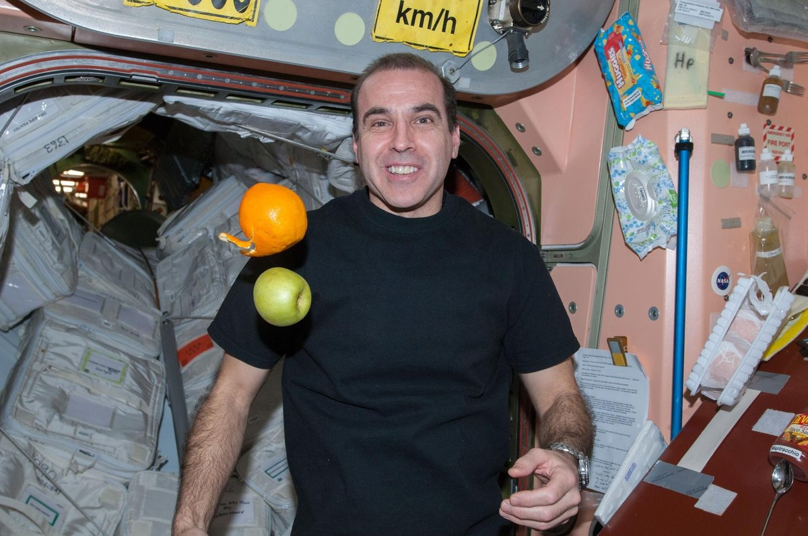
The falling cabin, for real. Fresh fruit floats beside astronaut Rick Mastracchio in the Unity module of the International Space Station, February 2014. Station, astronaut, and fruit all fall around the Earth together, so nothing presses on anything. Gravity up there is still about 89 percent of its ground value. Photo: NASA (ISS038-E-043011), public domain.
IN THIS CHAPTER
Goal. By the end you should be able to say: the apple let go is on the straight path, and weight is the floor refusing that path.
Route. First the falling room, where nothing presses. Then the pavement, where the press returns. Then the sentence Newton still earns, which is a tool, not the picture. Then Einstein’s falling man, which is the same room. Do not start with the sky. The sky comes after the floor is clear.
Say. The apple let go is on the straight path, and weight is the floor.
Do not say. Zero gravity, the Earth switched off, Newton was wrong.
A question to carry. If the apple is not being pulled, why does the scale still have a number on it?

The natural state
CORE
This is easy to miss, because we live on the interruption. We stand, sit, and sleep on something that refuses to follow the straight path. So we named the unusual thing, the push, and called the usual thing a force that has to be explained.
Pilots know the other way around. In a training plane flying a parabola, with the engines set just to cancel the drag of the air, there is a stretch of about twenty seconds, over the top and down again, where a pencil let go in the cockpit stays where it is put. The same thing happens, longer, on the International Space Station. The station is not far enough from Earth for gravity to have gone away. It is falling the whole time. It falls and misses, around and around, because it also has a sideways speed. Inside, people float. They are not free of the Earth. They are free of the floor.
A bathroom scale makes the same point without a rocket. Stand on it. It reads a number, and you call that number your weight. Step off a diving board, and for the moment before the water there is no reading, because there is no scale under you keeping you from the straight path. The number on the scale was never the Earth’s tug, measured directly. It was the floor’s reply.

A patent clerk and a falling man
CORE
Late in 1907 Einstein was working in the patent office in Bern. He later called it the happiest thought of his life: a man falling from a roof does not feel his own weight. Inside the falling man’s world, for a short time, there is no gravity to notice. Loose objects stay with him. He cannot tell, from any experiment done in his pocket, that the Earth is there.
That thought is the start of the new picture. If a falling room looks like a room with no gravity, then a room at rest on the Earth looks like a room that is being accelerated upward. The floor pushes. The apple, let go, keeps the path the floor has abandoned, and so the apple and the floor approach. You do not need a tug in the apple to tell that story. You need a floor that will not fall.
The eight years after were not happy in the same way. He wanted a rule for the bent geometry, and the mathematics was not the kind he already owned. He asked friends. He tried wrong turns in public, which is brave and also a little funny, because the wrong turns were published. In November 1915, in four papers to the Prussian Academy, a week apart, he got to the rule. The tiny leftover turn in Mercury’s orbit, a hair’s width in the sky that had puzzled astronomers for decades (see “The planet that would not sit still”), came out. The bending of starlight by the Sun came out, twice the number he had published in 1911. He was, for a few weeks, a man who had finished the thing. The war was on. Almost nobody was in the mood.
The happy thought took an afternoon. The rule took eight years. Both belong in the book. People prefer the afternoon.

Two cabins that will not join
CORE
Imagine a small falling cabin in London, and another in Nairobi. Inside each one, for a short time, everything is simple. A ball rolls in a straight line. A clock ticks as clocks tick. Light goes straight. Each cabin is a good laboratory.
Now try to glue the two laboratories into one big laboratory, with one set of straight lines that works for both. You cannot. The cabin in London is falling toward the Earth’s center on its own line. The cabin in Nairobi is falling on a different line. Those lines are not parallel, and they are not straight in the same sense all the way along. Follow them and they meet, down at the center of the Earth, if the Earth were not in the way.
That failure to join is the signature of gravity: the part that no choice of room can remove. Locally, in a small enough room and a short enough time, falling looks like no gravity at all. Spread the rooms apart, or wait longer, and the separate rooms will not fit together. The world has a shape that will not lie flat. What sets the falling path itself, near the Earth, is the way clocks run faster with height (see “A clock higher up”).

The ant on the apple
CORE
The best-known picture of this failure to join opens Gravitation, the 1973 textbook by Charles Misner, Kip Thorne, and John Wheeler. Here is the idea in our own words. An ant walks on an apple. It has no map and no view from above. It has one rule: never steer. Each step goes where the last one pointed, the legs on the left and the legs on the right stepping the same length. On a tabletop that rule draws a straight line. On the apple it draws the straightest line the skin allows. Mathematicians call such a line a geodesic.
Now send two ants off near the stem, side by side, on paths that start parallel. Each keeps the rule. Neither feels a tug. Yet the gap between them changes as they walk, and near the dip at the stem it changes fast. One ant philosopher might invent a force that pulls ants together. A more careful one would measure the skin instead. Every small patch is nearly flat, but the patches do not fit together into one flat sheet. The drift belongs to the skin, not to the ants.
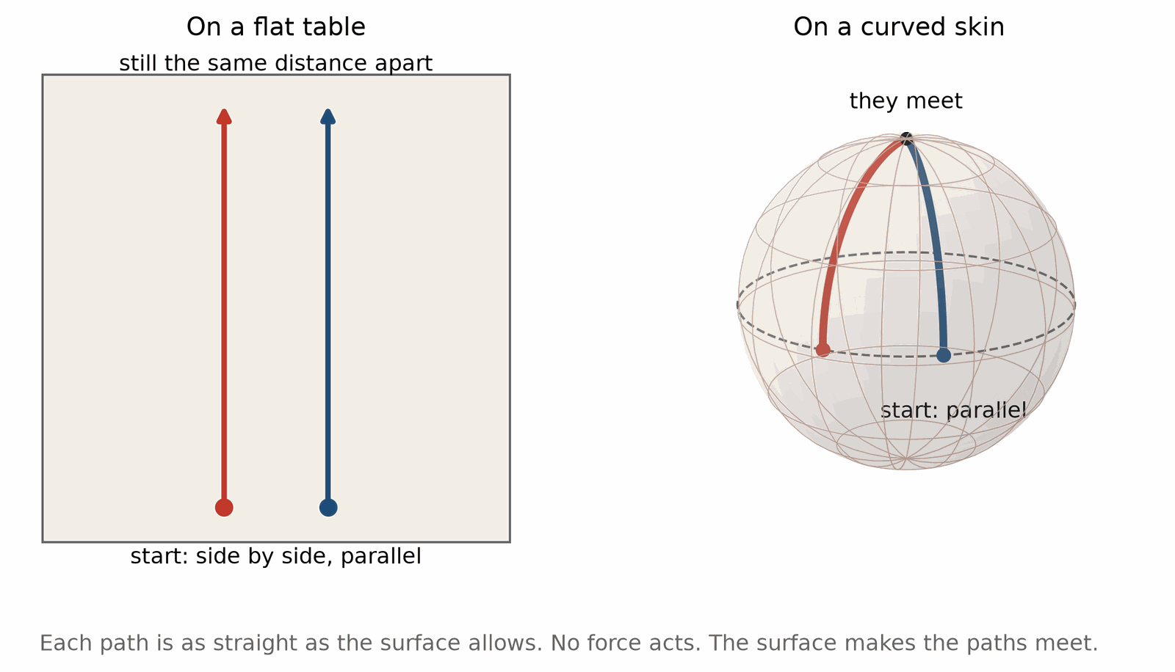
Two ants that never steer. On a flat table, paths that start parallel stay parallel. On a curved skin (drawn as a ball, the simplest curved skin) they meet. Spacetime is the skin. Falling cabins are the ants.
Spacetime is the apple. The ants are falling cabins, each quiet inside, each on its straightest path. The drift between neighbors is what this book calls the tide (see “The ocean is a slow experiment”), and the dip near the stem is where the mass sits. Wheeler later boiled the theory down to a two-part slogan, which in our words runs: the shape of spacetime tells matter how to move, and matter tells spacetime how to bend. This chapter is the first half. The second half has its own chapter (see “The other equation”). The rest of the book is what the two halves mean for clocks, stars, the dark sky, and the detectors that finally felt the apple’s skin twitch.

What a small room can hide
CORE
How small is small enough? On Earth, a room the size of a house, for a few seconds, is small enough. A ball let go in a falling house stays with the house. Stretch the experiment to a kilometer, or wait an hour, and the hiding fails. The ball at one end and the ball at the other drift. That drift is the part of gravity that falling does not cancel. It is the tide, and it has its own chapter (see “The ocean is a slow experiment”).
The same limit explains why the happy thought does not empty the world of gravity. It only moves gravity from the force you feel in your feet to the mismatch between rooms. A single room can be made quiet. The Earth full of rooms cannot.
Stand on a hill and look at a town. Every house has a floor pushing up. Every person in those houses is interrupted in the same general way, toward the center of the Earth. The interruptions are not quite the same. A person on the hill is a little farther from the center than a person in the valley. The difference is too small to feel. It is not too small to measure, and it is the seed of the curvature story.
Misner, Thorne, and Wheeler give the small room a name, a local Lorentz frame, and a motto: physics is simple only when you look locally. Taylor and Wheeler, in Spacetime Physics, call it a free-float frame. The names differ and the rule is the same. Inside the room the flat rules of the next chapter hold, to the accuracy your instruments can reach, and the better the instruments, the smaller the room has to be.
BOX 1.1. HOW BIG IS A LOCAL ROOM?
• Two balls hang side by side, a distance d apart, in a cabin falling near the Earth. Both fall toward the Earth’s center, so their paths converge. The gap closes with an acceleration of about g × d / R, where R is the Earth’s radius.
• For d = 1 m: 9.81 × 1 / 6,371,000 = 1.5 × 10⁻⁶ m/s². In 3 seconds of fall the gap closes by ½ × 1.5 × 10⁻⁶ × 3² ≈ 7 micrometers, less than the width of a hair.
• A tape measure says the cabin is free of gravity. A laser interferometer says it is not. How local is local depends on the ruler.

What people get wrong here
CORE
The first wrong picture is that astronauts float because they are far from Earth. They are not far. The station is about 400 kilometers up, a four-hour drive at highway speed if a road went straight up, and the Earth’s pull is still most of what it is on the ground. They float because they are falling, and the station is falling with them.
The second wrong picture is that weightlessness means gravity has been switched off. Nothing is switched off. You have simply stopped resisting the fall.
The third wrong picture is that Newton was overthrown. He was completed. His pull remains the right tool for bridges, tides in a harbor, and a probe coasting to Mars. The new picture is what you need when clocks disagree, when light bends, when a dying star finds no size it can hold, and when the sky itself stretches.

Heavy and light
CORE
Heavy and light fall together, once the air is out of the argument. That is the only older fact the falling room needs. If they did not, the apple in the elevator would still have a weight of its own, and the floor would not be the whole story.

A note on the word force
CORE
Nothing in this chapter asks you to stop saying that gravity pulls. Engineers say it. Newton said it. The sentence works, for slow things, far from dense masses, which is most of life. The new sentence is for when the old one starts to creak: at the clocks in orbit, at the edge of a collapsed star, across the sky between galaxies. There, pull is the nickname. The thing itself is the failure of straight paths to mesh.
Keep both sentences. Use the nickname at the hardware store. Use the other one when the apple is floating, and the floor is the only thing that seems to know about weight.

The floor has a lawyer
EXTENSION · can be skipped on a first read
Ask a person what holds them up and they will say gravity, which is the wrong witness. Gravity is the reason they would be moving. The floor is the reason they are not. A lawyer could win this case with a scale and a step. Step off, and the case is dismissed for lack of a plaintiff. There is no weight to argue about while you are falling. The argument resumes at the landing, and the landing is the whole of the evidence.
Everyday speech can keep the sentence that the apple fell. Physics adds what the scale cannot see: nothing tugs the apple down, and the ground declined the path the apple is on.

The dive, sold honestly
EXTENSION · can be skipped on a first read
A company will sell you twenty seconds in a plane that has nosed over. The brochure says zero gravity. The plane is only about ten kilometers up, a ten-minute drive if a road went straight up. What you have bought is an interruption of the interruption. The floor of the plane has agreed, for twenty seconds, to take the path your body was already trying to take. A pen stays where the hand left it. A smile floats. Then the pilot pulls out, the floor returns, and the smiles land, ruder than before.
Pilots call the path a parabola. That name is honest. The brochure is a sales word for a geometry lesson. Nothing was switched off. The agreement was switched on. When the floor follows the same path as your body, you feel no weight. When it refuses, the scale reports the push.

A room at Princeton
EXTENSION · can be skipped on a first read
John Wheeler liked sentences a person could carry out of the room. His two-part slogan for the theory is the one quoted in “The ant on the apple”. He also liked the apple, and the idea that a student should meet the geometry before the machinery. The graduate book he wrote with Misner and Thorne is the machinery, a thousand pages of it, published in 1973. This book is the sentence, and the scenes that make the sentence hard to wriggle out of.
Wheeler did not invent the name black hole. Versions of it were already in the air by 1964. In 1967, tired of saying “gravitationally completely collapsed object,” he took up the short phrase, by his own account after someone in an audience called it out, and his standing made it stick. A good name, once it sticks, rarely needs defending.
RECAP
• A falling room is quiet. The apple let go is on the straight path, and so are you.
• Weight is the floor refusing that path. A scale measures the floor’s push, not the Earth’s pull.
• Orbit is falling with a sideways speed. At the space station gravity is still about 89 percent of its ground value.
• Small falling rooms work. Large ones do not join up, and that failure to join is the part of gravity no falling room can hide.
• Newton’s pull is the right tool for slow things. It is the nickname, not the picture.

Exercises
Exercise 1.1 · Core
The space station orbits about 400 km up. Earth’s radius is 6,371 km, and gravity weakens with the square of the distance from Earth’s center. What fraction of ground-level gravity acts on the station?
Worked solution. The distance from the center is 6,371 + 400 = 6,771 km. The ratio is (6,371 / 6,771)² = 0.941² = 0.885. About 89 percent, or 8.7 m/s² instead of 9.8 m/s². The astronauts float because they and the station fall together, not because gravity has gone.
The usual mistake. Measuring from the ground instead of from the center, or concluding that there is no gravity in space. Four hundred kilometers barely changes the distance to the center.
Exercise 1.2 · Core
A 70 kg person stands on a bathroom scale in an elevator. What does the scale display (in kilograms, as scales do) when the elevator accelerates upward at 2.0 m/s², downward at 2.0 m/s², and after the cable snaps? Use g = 9.81 m/s².
Worked solution. The scale reports the floor’s push N. Upward: N = m(g + a) = 70 × 11.81 = 827 N, displayed as 827 / 9.81 = 84 kg. Downward: N = 70 × 7.81 = 547 N, displayed as 56 kg. Cable snapped: a = g, so N = 0 and the display reads 0. The Earth’s pull was the same in all three cases.
The usual mistake. Thinking the scale measures the Earth’s pull. It measures the floor’s reply, which is why it changes while the Earth does not.
Exercise 1.3 · Core
In a vacuum chamber, a 1 kg ball and a 10 kg ball are dropped from 20 m. How long does each take, and how fast is each moving at the bottom?
Worked solution. Time t = √(2h / g) = √(40 / 9.81) = 2.02 s for both. Speed v = √(2gh) = √(2 × 9.81 × 20) = 19.8 m/s for both. Mass does not appear in either formula.
The usual mistake. Expecting the heavy ball to win because it is pulled harder. It is pulled ten times harder and has ten times the inertia, and the two cancel exactly. That cancellation is what makes the falling room quiet.
Exercise 1.4 · Core
How fast must the station move sideways, at 6,771 km from Earth’s center, so that the Earth curves away as fast as it falls? Use v = √(GM / r) with GM = 3.986 × 10¹⁴ m³/s². How long is one lap?
Worked solution. Put r in meters: 6.771 × 10⁶ m. v = √(3.986 × 10¹⁴ / 6.771 × 10⁶) = √(5.887 × 10⁷) = 7,670 m/s, about 7.7 km/s. One lap is 2πr / v = 2π × 6.771 × 10⁶ / 7,670 = 5,550 s, about 92 minutes.
The usual mistake. Leaving r in kilometers. That gives v ≈ 243 km/s, which is faster than the Earth goes around the Sun. Keep every length in meters when GM is in m³/s².
Exercise 1.5 · Core
A diver steps off a 3 m board. How long is the fall, and what would a scale strapped to the diver’s feet read during it?
Worked solution. t = √(2 × 3 / 9.81) = 0.78 s. The scale reads zero the whole way, because nothing under the diver resists the fall.
The usual mistake. Saying the diver is “a little lighter” on the way down. The reading is not reduced. It is gone, because the floor is gone.
Exercise 1.6 · Core
You want a falling room in which two balls set side by side drift together by less than 1 mm during a 4-second fall. Using the side-by-side rule a = g × d / R from Box 1.1, how far apart can the balls be?
Worked solution. The drift in time t is ½ × a × t², so a must stay below 2 × 0.001 / 4² = 1.25 × 10⁻⁴ m/s². Then d = a × R / g = 1.25 × 10⁻⁴ × 6.371 × 10⁶ / 9.81 = 81 m. A room about 80 meters wide passes this test. A wider one does not.
The usual mistake. Dropping the ½ in ½at², which halves the answer to about 40 m, or using the up-and-down rule 2g × d / R, which belongs to balls placed one above the other.
Exercise 1.7 · Extension
A rocket in deep space accelerates at 9.81 m/s². An astronaut lets go of an apple 1.5 m above the floor. When does the floor reach the apple? Compare with the same drop on Earth.
Worked solution. The apple keeps the speed it had, and the floor catches up: 1.5 = ½ × 9.81 × t², so t = 0.553 s. On Earth the equation is the same and so is the answer, 0.553 s. No experiment in a small closed room tells the two apart.
The usual mistake. Saying the apple falls in the rocket. Nothing pulls it. The floor comes up to meet it, and the point of the comparison is that the same description works on Earth.
Exercise 1.8 · Extension
A plane gives its passengers 22 seconds of floating. If the plane’s path is a symmetric parabola, what vertical speed does it have at the start of the float and at the end?
Worked solution. During the float the plane’s vertical speed changes at 9.81 m/s². Over 22 s it changes by 9.81 × 22 = 216 m/s. Symmetric means +108 m/s (climbing) at the start and −108 m/s (descending) at the end. That is why the pilot climbs steeply first and pulls out hard after.
The usual mistake. Thinking the plane must be very high, or in space, for the float to work. It only has to follow the free-fall path, and the floor follows it too.

2. Straight, but not in space
Before gravity can be a bend, there has to be something to bend. That something is not space alone. It is space and time together.
Light is the measure. In empty space, light moves at one speed for everyone, no matter how they themselves are moving. That sounds like a small fact. It is not. If a ball is thrown forward from a moving train, a person on the platform sees a faster ball. If a lamp is switched on from a moving train, the person on the platform does not see faster light. The speed comes out the same. Experiments have checked this in every way we know how to check it. It holds.
Once light has one speed for everybody, clocks and rulers cannot be the shared objects we thought they were. Two people in steady motion, each with a good clock, will not agree on how much time passed between two events, and both clocks are working. They will not agree on the length of the train. They will agree on something else: a mix of distance and time that stays the same for both. That mix is the real interval. Space and time are the pieces. The interval is the thing.
IN THIS CHAPTER
Goal. By the end you should be able to say: space adds, time subtracts, and two moving people slice the same interval differently.
Route. First the minus sign, with no paradox attached. Then the surveyors, the train, and the twin, each one interval sliced two ways. Then the light clock and the muons, orbits and light as straight paths, the light cone, the pole in the barn, and clocks flown on airliners. A paradox in a popular book is usually two slices treated as one.
Say. Space adds, time subtracts, and the slices differ.
Do not say. Time slows down for the person holding the clock. One of the two observers must be mistaken.
A question to carry. If both clocks are right, what exactly were they disagreeing about?

The one equation for spacetime
CORE
This is the first of the two equations in the book. It is the interval, the mix that both observers agree on. Written for a small step:
(interval) squared = minus (time step) squared + (space step) squared
Δs² = −c² Δt² + Δx² + Δy² + Δz²
Read it left to right. Δs is the interval, the thing that stays the same. Δt is the time between two nearby events, Δx, Δy, Δz the space between them. c is the speed of light, there so that time and distance are in the same units. The minus sign is the whole news. Time and space are not the same piece. Add them with a minus and a plus, and you get a quantity both the train and the platform agree on, even when they disagree about the time and about the length separately.
A light ray is the case where the interval is zero: the time step and the space step cancel. That is why light is the edge of the possible. A clock that travels from one event to the other measures the interval along its path, in time. The straight path, later, will mean the path that makes this interval as long as it can be. Falling is that path, once the geometry is allowed to bend and the simple formula above holds only in a small enough room.
You do not need to calculate with this. You need the minus sign. Space adds. Time subtracts. The mix is what is real. Everything called a paradox in special relativity is two people splitting the mix differently.

The surveyors
CORE
Edwin Taylor and John Wheeler open their book Spacetime Physics with a parable that makes the interval feel inevitable. Here is its gist, retold. Two surveyors map the same town. One takes north from a compass, the other from the Pole Star, and the two norths differ by a few degrees. So every corner stake gets two pairs of numbers, so far east and so far north in one book, and different amounts in the other. Neither book is wrong. The quarrel ends when someone notices that the straight-line distance from the town square to any stake, found by Pythagoras, comes out the same in both books, as long as both directions are measured in the same unit. In the parable, north had always been measured in miles and east in meters, which hid the agreement until the miles were converted.
Spacetime is the same story with one twist. Two observers moving past each other disagree about how much time separates two events and how much space. They agree on the interval, once time is put in the same unit as space. The conversion factor is the speed of light. One second of time is about 300,000 kilometers of time. One nanosecond is about 30 centimeters. The twist is the minus sign. In the town the two parts add. In spacetime one is taken from the other, which is why a fast traveler can rack up a big space part and a big time part and still carry a small number on the wristwatch.
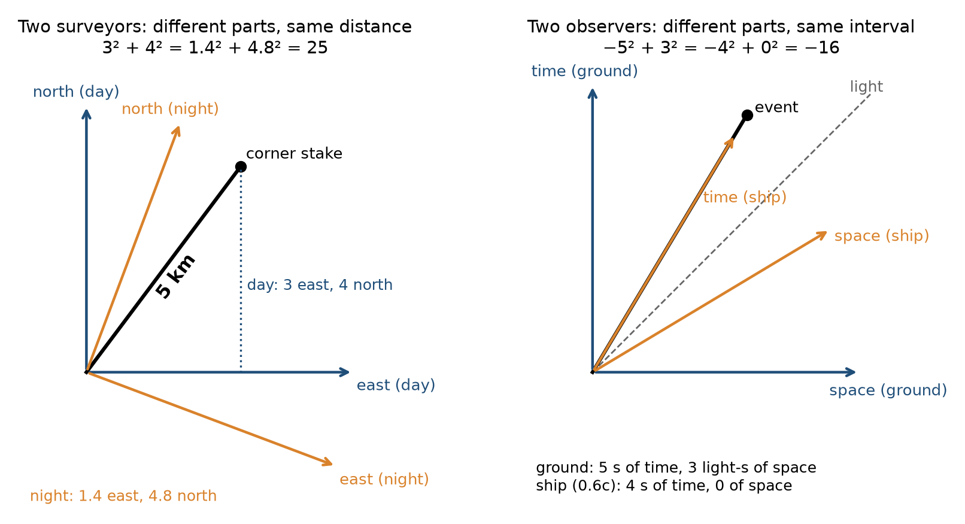
Left: two surveyors with different norths give the same stake different east and north numbers, but the same distance. Right: the ground and a ship moving at 0.6c give the same event different time and space numbers, but the same interval. Time in seconds, space in light-seconds.
BOX 2.1. THE SAME EVENT IN TWO BOOKS
• Ground book: the event is 5 seconds after the start and 3 light-seconds away. With the book’s sign convention, the interval squared is −5² + 3² = −25 + 9 = −16. Negative means timelike.
• Ship book: the ship left the start at 0.6c, so it is at the event when it happens. Space part: 0. Time part: whatever makes the interval squared −16 again, so 4 seconds.
• The ship’s clock reads 4 s, the ground’s clocks read 5 s, and both books agree on −16. (Some books put the minus on space instead and write +16. The sign is a convention. The agreement is the physics.)

The train, told without a trick
CORE
A lamp flashes in the middle of a moving train. A rider on the train, who sees the train as standing still, sees the flash reach the front and the back together. The light had the same distance to go, and one speed. A person on the platform sees the back of the train coming forward to meet the light, and the front of the train running away from it. The platform person sees the flash reach the back of the train first. Both are right. There is no shared “at the same time” for events in different places, once the people are moving relative to each other.
This is not a failure of the clocks. It is the minus sign doing its job. The two people slice the interval differently. Neither slice is the true one. The interval is.
The same fact shortens the train, as the platform measures it, and leaves it ordinary, as the rider measures it. Length, like simultaneity, is a slice. The interval does not care which slice you chose.

The twin, told carefully
CORE
One twin stays home. The other rides a fast ship, turns around, and comes back. The traveler has aged less. This is not a trick of viewpoint, and it is not the home twin’s mistake. The two trips are different. The home twin stays on one steady path. The traveler changes direction, which means the traveler’s path through space and time is not the straight one. The straight path is the one with the most proper time. The stay-at-home twin lives more years. Atomic clocks on airplanes have done a small version of this trip (see “Clocks on airliners”). The clocks agree with the story.
“Time slows down” is a lazy sentence. A clock on a fast ship does not feel slow to the person carrying it. It ticks a second a second. Compared with a clock that took another path, fewer seconds have passed. Both are right about their own seconds.
You can feel the shape of this without a ship. Walk across a field in a straight line. A friend walks the same two endpoints by way of a detour. Your friend walked farther. In spacetime the accounting flips, because of the minus sign: the detour, the path that changes direction, records less time, not more. The twin who turns around took the detour. The twin who stayed took the straight path and got more time.
Taylor and Wheeler, in Spacetime Physics and again in Exploring Black Holes, give the rule a name, the principle of maximal aging: between two meetings, a free clock takes the path on which it ages the most. In flat spacetime any detour, turnaround, or rocket burn costs the traveler time. Near a mass the rule still holds for nearby paths: a free fall ages more than its close neighbors.

How fast is fast enough to notice
CORE
At a walk, the disagreement of clocks is a joke of a number. At a jet’s cruise, atomic clocks can see it. At a sizable fraction of the speed of light, it is the whole story. Particle machines live there. A short-lived particle made in a collision lasts longer, by the laboratory clock, if it is moving fast, and the extra life is exactly the interval’s accounting. The particle’s own clock runs normally. The laboratory sees a longer life because the particle’s path through spacetime is not the laboratory’s path.
The light clock shows where the factor comes from. Two mirrors face each other, and a flash bounces between them. One round trip is one tick. Put the clock on a train. On board, the flash goes straight up and down. From the platform, the mirrors move while the flash is on its way, so the flash travels a zigzag, which is longer. Light has one speed for both observers, so the longer path takes longer, and the platform counts fewer ticks of the moving clock. Pythagoras on the triangle gives the factor 1 / √(1 − v²/c²). At 0.6c it is 1.25. At 0.8c it is 1.667. At walking speed it is 1 for every purpose a watch can serve.
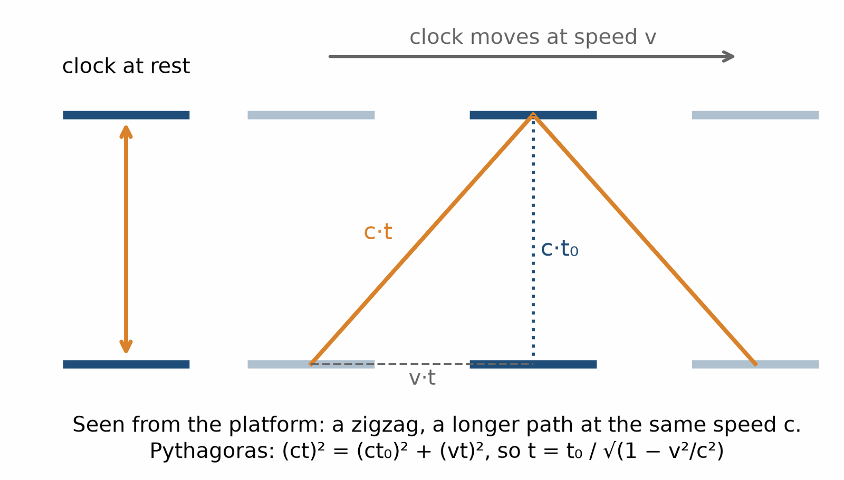
The light clock. On board, the flash goes straight up. From the platform it travels a longer zigzag at the same speed, so each tick takes longer.
Muons are the everyday test. Cosmic rays make them about fifteen kilometers up, and they arrive moving at about 0.998 of the speed of light. A muon at rest lives about 2.2 millionths of a second, long enough to travel about 660 meters. At 0.998c the factor is about 16, so in the ground’s frame the muon lives sixteen times longer, and many reach the ground. Counters on mountains and at sea level find them in the numbers the factor predicts.
Nothing mystical has been added. The minus sign, checked in machines that run every day, is the stage on which the later bend of gravity is built. If this chapter were wrong, the next ones would have nothing to bend.

The sideways fall
CORE
Now put gravity back, but only as a bend in this joined space and time. A satellite is the cleanest picture. From the ground it looks like a stone that has been pulled into a circle and is somehow not falling. That is the old picture, and it is useful, and it is backward.
The satellite is falling the whole time. It has a large sideways speed, so the Earth curves away under it as fast as it drops. Inside, a tool let go stays by the astronaut’s hand. Nothing is holding the satellite up. Nothing needs to. Its path is as straight as a path can be, in a geometry that does not lie flat.
The same is true of the Moon, and of the Earth around the Sun. The Sun is not reeling the Earth in on a string. The Earth is going straight in a bent geometry, and that straightest path, drawn in space alone, is the nearly circular ellipse astronomers chart.
Light does this too. A ray passing the Sun is not tugged off course the way a comet is in the old picture. Near the Sun, straight for light is a line we, far away, draw as bent. In 1919, during an eclipse, astronomers measured stars shifted by about the amount Einstein had said (see “The eclipse that almost washed out”). The measurement was rough. Later radio work, on quasars passing near the Sun in the sky, made it sharp. Light bends by the amount the geometry says.
You do not have to trust a 1919 photograph. Trust the phone in your pocket (see “The phone in your pocket”). It is lost if this chapter is wrong.

Light is the edge
CORE
A light ray is the interval set to zero. The time step and the space step cancel. That is why light is not a thing that goes very fast inside the possible. It is the edge of the possible. Nothing that carries news outruns it. A gravitational wave does not outrun it either, which the neutron-star merger of 2017 checked with under two seconds and a new dot in a nearby galaxy (see “Light and ripples from the same place”). Every measurement so far has respected that edge.
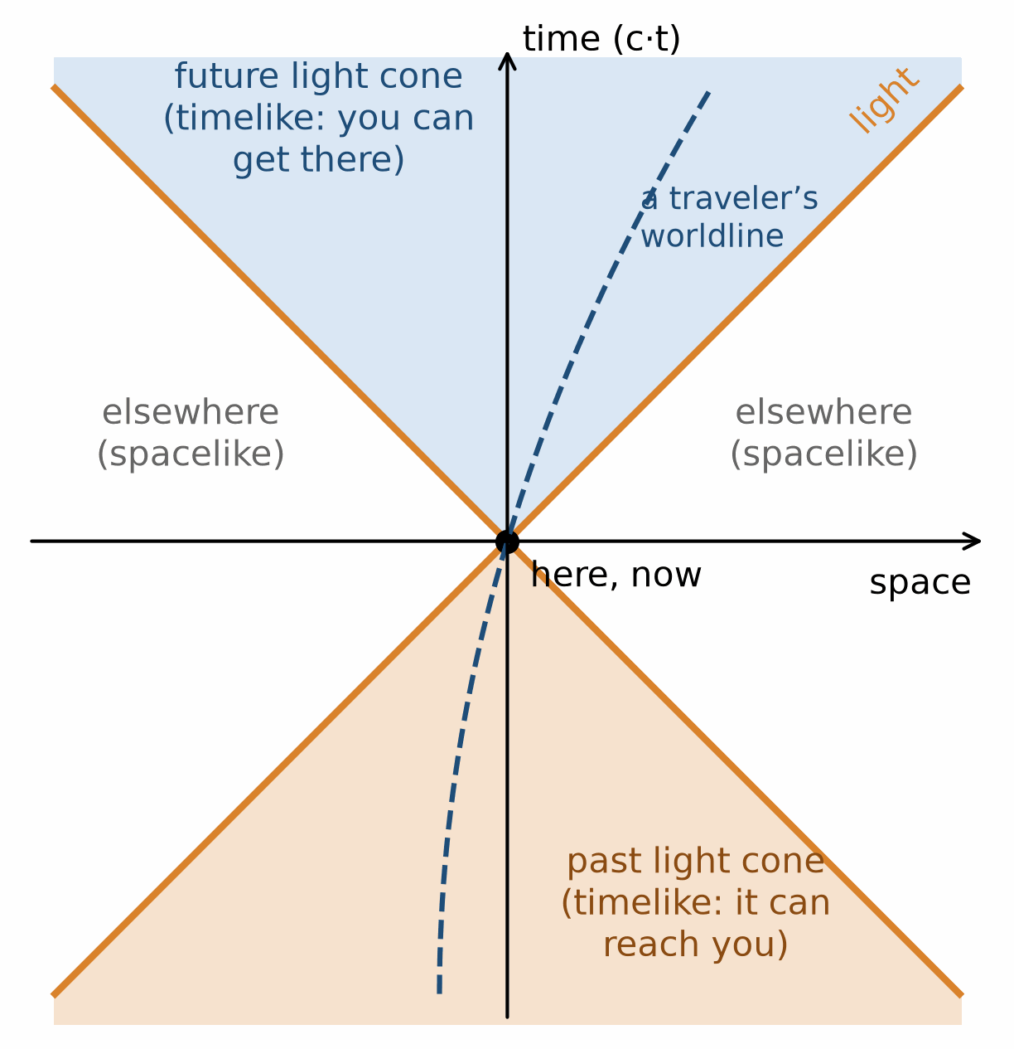
The light cone. Light runs along the edges. Anything you can reach, or that can reach you, lies inside the cones. The regions outside are spacelike: nothing can connect them to here and now.
Draw time going up the page and space across it, with light running at forty-five degrees. Every path a traveler can take stays steeper than the light lines. The interval tells you which side of the line an event is on. If the time part wins, the pair is timelike, a traveler can attend both, and every observer agrees which came first. If the space part wins, the pair is spacelike, and the order is a choice of slice.

The pole in the barn
EXTENSION · can be skipped on a first read
Spacetime Physics is full of paradoxes built to be argued over, and the best known is the pole and the barn. Here it is, told our way. A runner carries a 20-meter pole toward a 10-meter barn with a door at each end. She runs so fast that the factor γ is 2, about 0.87 of the speed of light. The farmer says: the moving pole is 10 meters long, so for an instant it fits, and I can shut both doors at once. The runner says: the barn is the thing moving, so it is 5 meters long, and a 20-meter pole cannot fit in a 5-meter barn. Both are right about their own measurements.
The doors settle it. Shut at the same moment by the farmer’s clocks, they are not shut at the same moment by the runner’s. By her clocks the far door closes and opens again before the pole’s front reaches it, and the near door closes only after the pole’s back has passed. Nothing is crushed and no rule is broken. The quarrel was about the slice again (see “The train, told without a trick”).

Clocks on airliners
EXTENSION · can be skipped on a first read
In October 1971 Joseph Hafele and Richard Keating flew atomic clocks around the world, eastward, then westward, and compared them with clocks that had stayed at the U.S. Naval Observatory in Washington. The eastbound clocks lost time. The westbound clocks gained. The plane is moving, so the interval cares. The plane is also high, so the bend in time cares. The two effects do not cancel, and the Earth’s spin is in the sum, which is why both directions were needed. Eastbound the clocks lost 59 billionths of a second, give or take 10. Westbound they gained 273, give or take 7. The predictions were −40 and +275. The result was published in Science in 1972. Commercial airliners. Ordinary routes. The twin story, done with tickets.
The crews did not age differently in any way a birthday would notice. The clocks noticed. That is the whole of the demonstration. You do not need a spaceship. You need a clock far better than a wristwatch, and a plane, and the patience to fly it both ways because the Earth’s spin is in the sum. Hafele and Keating had the patience. The rest of us inherit the result every time a phone finds a street.
RECAP
• Light has one speed for everyone. Clocks and rulers pay for that.
• The interval mixes time and space with a minus sign, and both observers agree on it.
• Simultaneity and length are slices. Neither slice is the true one.
• The path that turns around carries less proper time. The straight path carries the most.
• The factor 1/√(1 − v²/c²) is 1.25 at 0.6c and about 16 for cosmic-ray muons.

Exercises
Exercise 2.1 · Core
A ship travels at 0.6c, and its clock reads 8 years for the trip. Using the factor γ = 1/√(1 − v²/c²), how much time passes for the people it left behind, in their frame?
Worked solution. v²/c² = 0.36, so 1 − 0.36 = 0.64, √0.64 = 0.8, and γ = 1/0.8 = 1.25. Time at home = 1.25 × 8 = 10 years.
The usual mistake. Dividing instead of multiplying (8 / 1.25 = 6.4 years). The traveling clock records the shorter time. The frame it moves through assigns the longer one.
Exercise 2.2 · Core
Muons made about 15 km up arrive at about 0.998c. A muon at rest lives about 2.2 µs. How far could it travel in one lifetime with no time dilation, and how far with it?
Worked solution. Without: 3.0 × 10⁸ m/s × 2.2 × 10⁻⁶ s = 660 m. With: 1 − 0.998² = 0.003996, √0.003996 = 0.0632, so γ = 15.8. The lifetime in the ground frame is 15.8 × 2.2 = 34.8 µs, and the distance is 0.998 × 3.0 × 10⁸ × 34.8 × 10⁻⁶ ≈ 10.4 km. Many muons cover the 15 km, which is what counters at the ground find.
The usual mistake. Rounding 0.998² to 1, which makes γ infinite, or using a slow speed such as 0.3c, which gives γ = 1.05 and would let almost none arrive. Near c the factor is very sensitive to the last digits of the speed.
Exercise 2.3 · Core
A ship moving at 0.5c fires a probe forward at 0.5c relative to itself. How fast does the probe move relative to the ground? Use (u + v)/(1 + uv/c²).
Worked solution. (0.5 + 0.5)/(1 + 0.5 × 0.5) = 1.0 / 1.25 = 0.8c.
The usual mistake. Adding to 1.0c. The simple sum is the low-speed approximation. It is right for a car and wrong for a beam.
Exercise 2.4 · Core
Events A and B are 4 seconds apart in time and 3 light-seconds apart in space. Using the book’s equation Δs² = −c²Δt² + Δx², is the pair timelike or spacelike? What does a clock that travels from A to B at a steady speed read?
Worked solution. With c = 1 light-second per second: Δs² = −16 + 9 = −7. In this convention a negative value means the time part wins, so the pair is timelike. The traveler covers 3 light-seconds in 4 s, which is 0.75c, and the clock reads √7 = 2.65 s.
The usual mistake. Writing +7 and calling the pair spacelike. Some books put the minus sign on space instead, and then timelike pairs come out positive. Name the convention before you read the sign.
Exercise 2.5 · Core
A star is 8 light-years away. One twin flies there and back at 0.8c. How many years pass at home, and for the traveler?
Worked solution. At home: 16 light-years / 0.8c = 20 years. At 0.8c, γ = 1/√0.36 = 1.667. Traveler: 20 / 1.667 = 12 years. The traveler is 8 years younger at the reunion.
The usual mistake. “Each sees the other’s clock run slow, so they come back the same age.” Only the traveler turned around. The two paths are different, and the straight one carries more proper time.
Exercise 2.6 · Core
A train is 100 m long measured on board. How long does the platform measure it as it passes at 0.6c?
Worked solution. The platform length is the on-board length divided by γ: 100 / 1.25 = 80 m. On board it is still 100 m.
The usual mistake. Saying the rider measures 80 m. Nothing on the train shrinks for the rider. The platform marks the two ends at what the train calls different times.
Exercise 2.7 · Core
One surveyor’s book puts a stake 3 km east and 4 km north of the town square. The other surveyor’s north is turned a little, and her book puts the same stake 2 km east. How far north does her book put it?
Worked solution. Both books agree on the distance: √(3² + 4²) = 5 km. Her north part is √(5² − 2²) = √21 = 4.58 km.
The usual mistake. Shifting the missing kilometer across, 4 + 1 = 5 km north. Parts trade through squares, not one for one. Only the total distance is shared.
Exercise 2.8 · Extension
A pole is 20 m long in its own frame and a barn is 16 m long in its own. How fast must the pole move for the farmer to measure it as exactly the barn’s length?
Worked solution. The farmer measures 20 / γ, so γ = 20 / 16 = 1.25. Then 1 − v²/c² = 1 / 1.25² = 0.64, so v²/c² = 0.36 and v = 0.6c.
The usual mistake. Using γ = 16 / 20 = 0.8. The factor γ is never smaller than 1. A moving length is shorter, so divide the rest length by γ.
Exercise 2.9 · Extension
Two lamps at the ends of a 300 m train (measured on board) flash at the same moment by the train’s clocks. The train moves at 0.6c. How far apart in time are the flashes by the platform’s clocks? Use Δt = γvL/c².
Worked solution. vL/c² = 0.6 × 300 m / (3.0 × 10⁸ m/s) = 6.0 × 10⁻⁷ s. Times γ = 1.25 gives 7.5 × 10⁻⁷ s, or 0.75 µs. By the platform’s clocks the rear lamp flashes first.
The usual mistake. Explaining the gap as the time light takes to reach the observer. This 0.75 µs is what is left after the light-travel time has been subtracted.
Exercise 2.10 · Extension
Hafele and Keating predicted −40 ± 23 ns for the eastbound clocks and measured −59 ± 10 ns. Westbound, they predicted +275 ± 21 ns and measured +273 ± 7 ns. Do prediction and measurement agree?
Worked solution. Eastbound: the difference is 19 ns, and the combined uncertainty is √(23² + 10²) = 25 ns. The difference is smaller than one combined uncertainty, so they agree. Westbound: a difference of 2 ns against a combined uncertainty of √(21² + 7²) = 22 ns. Close agreement.
The usual mistake. Expecting the numbers to be identical. Agreement means a difference within the stated uncertainties, combined properly.

3. Tides are the real gravity
In a small falling room, the feel of gravity disappears. That can sound as if gravity were an illusion. It is not. Make the room taller.
Your head and your feet are at different distances from the Earth’s center. The straight path for your head is not quite the straight path for your feet. In a falling room the difference is tiny, too small to feel. Stretch the room to a kilometer, or wait longer than a few seconds, and the two paths separate. A ball at the ceiling and a ball on the floor drift apart. Two balls side by side drift together, because their straight paths both aim at the center of the Earth and so lean toward each other.
That leftover, the drift you cannot remove by falling, is curvature. It is the part of gravity that no falling room can hide. (The ordinary fall itself is set by how clocks run at different heights; see “A clock higher up”.) Newton already knew the effect. He called it tides.
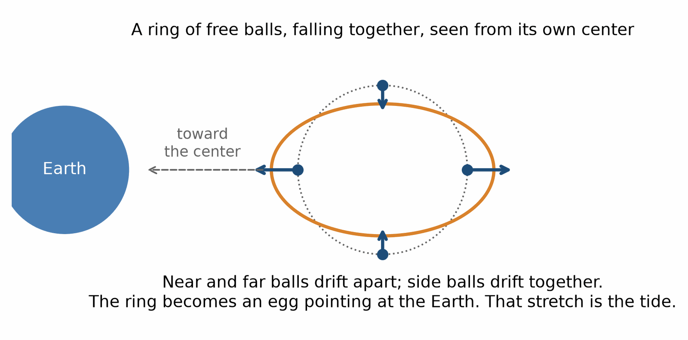
Tidal stretching. A ring of free balls falling toward the Earth becomes an egg: the near and far balls drift apart, the side balls drift together.
IN THIS CHAPTER
Goal. By the end you should be able to say: a small room can be made quiet, and two rooms cannot, and that mismatch is the tide.
Route. First one cabin. Then two cabins whose straight paths will not stay parallel. Then the beach, where the sea rises twice a day, so a string from the Moon is the wrong picture. The harbor table can stay Newton’s. The explanation cannot.
Say. Falling cancels the part that is the same across the room, and leaves the mismatch.
Do not say. The Moon lifts the ocean on a string. A string gives one high tide a day. Most beaches have two.
A question to carry. If the Moon lifted the sea on a string, why does the harbor fill twice a day?

The ocean is a slow experiment
CORE
The Moon is falling around the Earth, and the Earth is falling around the Moon, around their common balance point. The ocean on the near side is a little closer to the Moon than the Earth’s center is. Its straight path bends a little more. The ocean on the far side is a little farther. Its straight path bends a little less. Relative to the center, water is drawn away on both sides. Two bulges, not one. The Earth turns under them, and most beaches have two high tides a day. (The shape of a coast and its basins can change that, and a few places get only one.)
The Sun does the same, weaker, because it is farther. When Sun and Moon line up, the tides are larger. None of this requires a new idea. It is the failure of one straight path to serve a whole extended body.
Spring tides, when Sun and Moon line up, are the two mismatches adding. Neap tides, when Sun and Moon pull at right angles, are the two partly cancelling, so the tides are smaller. The geometry does not take sides. It adds.
Falling does not cancel tides. Falling cancels the part of gravity that is the same for the whole room. What is left is the part that changes from head to foot. That part is the curvature. It is the part that cannot be talked away.
A harbor does not need Einstein to predict its tide table. Newton’s pull, applied to a body of water with a shape, does the job the harbor master needs. The new picture does not replace that table. It says what the table is a measurement of. The bulge is a map of mismatched straight paths.

Why a black hole tears, and a cabin does not
CORE
Near the Earth the drift across a human body is nothing. Near a black hole the size of a star, the straight path at your head and the straight path at your feet disagree wildly, while you are still outside the edge of no return. You would be pulled apart by tides before you reached that edge. Near a giant black hole, the kind that sits at the center of a galaxy, the edge is so far from the center that the tide across a body, at the edge, is gentle. You could cross without feeling a thing. The difference is the size, not the object.
This is the fact movies usually reverse. They put the pain at the door. The door is only the last outward path (see “Two true stories”). The pain, for a small black hole, is the tide, and it starts outside. For a giant one, the door is dull. The trouble is later, deeper, where this book will admit it has no description.

Two crumbs falling side by side
CORE
Textbooks call the tide geodesic deviation, a long name for the ants on the apple (see “The ant on the apple”). Take two crumbs falling freely, close together. Each follows its own straightest path. Watch only the gap. If one crumb is a little nearer the Earth than the other, the gap grows, because the nearer one is pulled a little harder. If they sit side by side at the same height, the gap shrinks, because both fall toward the same center along lines that converge. Misner, Thorne, and Wheeler make this their working definition of curvature: forget the pull, and measure how the gap between neighboring free paths speeds up or slows down. For a body of mass M at distance r, an up-and-down gap d grows at about 2GM/r³ × d each second squared, and a side-by-side gap shrinks at about GM/r³ × d.
One detail is worth stopping for. Start with a small ball of crumbs, all at rest relative to one another, in empty space outside the Earth. The ball stretches along the line to the Earth by twice as much as it squeezes along each of the two directions across it. Two, minus one, minus one, is zero. At first the ball keeps its volume. That balance is Einstein’s equation for empty space, said without symbols. Inside matter the balance tips and the ball starts to shrink (see “The other equation”).

The funnel, and its limit
CORE
The picture people already know is the funnel. A sheet sags under the Earth. A smaller sheet sags under the Moon. A marble rolled nearby curves in. It is a fair sketch of one piece of the story: more mass, deeper well, and the wells of Earth and Moon pulling the sheet between them into a shared slope.
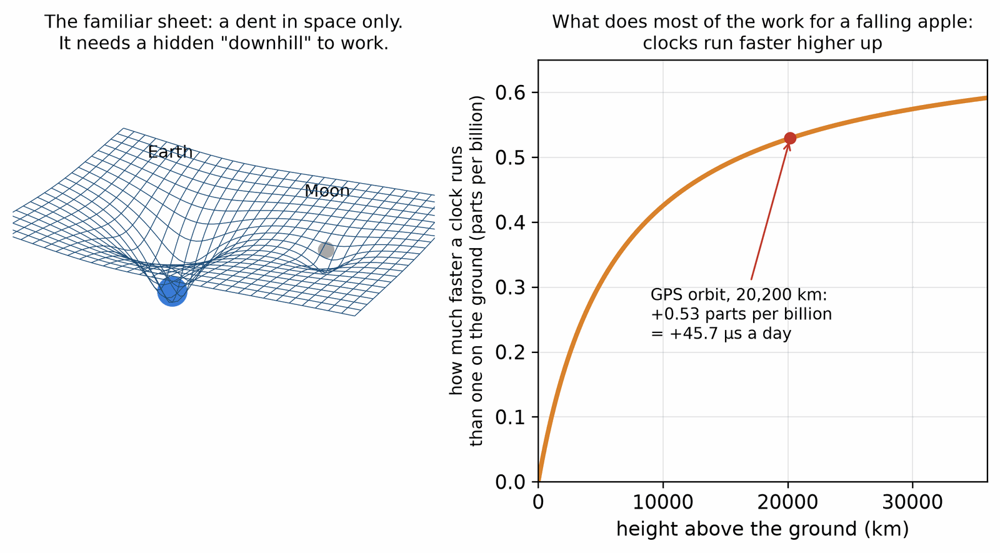
Left: the familiar sheet, with a deep dent for the Earth and a shallow one for the Moon. It shows a dent in space and needs a hidden downhill to work. Right: the part the sheet leaves out. A clock runs faster the higher it is, by about half a part in a billion at the height of the GPS satellites. That bend in time does most of the work in an ordinary fall.
Keep the picture, and keep its limit. A sheet with a ball on it shows a dent in space, and then asks other balls to roll in, as if gravity were a downhill in a hidden third direction. Real falling is mostly a bend in time. The dent in space matters, and light and precise orbits can see it, but the everyday fall of an apple is a clock effect: time at your head and time at your feet do not pass at the same rate, compared with each other, and the straightest path between two moments is the one that drops.
We will not need the machinery that measures this. We only need the fact. Where neighboring straight paths drift, the geometry is curved. Where they do not, it is flat, whatever the floor is doing.

A clock higher up
CORE
Put one clock on the floor and one on a shelf. The shelf clock, higher in the bend, ticks a little fast compared with the floor clock. The difference on Earth, across the height of a room, is absurdly small. Across a tower it has been measured (see “Pound and Rebka, twenty-two meters”). Across the distance from the ground to a satellite it is large enough to ruin a navigation system, which is the next chapter’s number.
The apple’s fall is this fact, seen as a path. The apple is not pulled. It takes the path on which its own clock records the most time, and near the Earth that path curves downward. The floor, refusing that route, is where you feel the push.

What the tide is not
CORE
The tide is not the Moon lifting the ocean on a string. The near bulge is not the whole story, or there would be one high tide a day. The far bulge is the other half, and it is why most beaches have two. The tide is also not a slosh caused by the Earth’s spin alone. The spin carries the beach under the bulges. The bulges are the geometry.
And the tide is not a small correction you can ignore if you understand the apple. The apple’s chapter hid the tide on purpose, by keeping the room small. This chapter takes the hiding off. From here on, gravity means the mismatch, not the push.

A boomerang through the Earth
EXTENSION · can be skipped on a first read
Wheeler’s A Journey into Gravity and Spacetime builds a chapter around a tunnel drilled straight through the Earth. Here is the thought experiment in brief. Pump out the air, pretend the planet is a ball of even density that does not spin, and drop a capsule in. It falls, races through the center, slows on the way up, and arrives at the far side just as it stops. Then it falls back. The round trip takes about 84 minutes, the same as an orbit skimming the surface, and it is the same for any straight tunnel, through the center or not.
Drill a second tunnel at an angle to the first and drop a capsule into each at the same moment. They pass the center together. Two straightest paths that started apart have crossed, the ants again, this time inside the planet, where the tide squeezes in every direction at once. The real Earth is denser toward its center, so a real tunnel through the center would be quicker, about 38 minutes one way instead of 42. The point survives the correction.

The Moon’s slow retreat
EXTENSION · can be skipped on a first read
Tides have a bill of their own. The bulges are dragged a little ahead of the Moon by the turning Earth, and their pull on the Moon nudges it forward in its orbit. The Moon climbs, slowly, and the Earth’s spin slows to pay for it. Laser pulses bounced off the mirrors the Apollo crews left show the Moon moving away by about 3.8 centimeters a year. The day grows longer by about two thousandths of a second a century. None of this needs a new idea. It is the mismatch of straight paths, given four and a half billion years.
RECAP
• Falling cancels the part of gravity that is the same across a room. What is left is the tide.
• The tide is curvature: nearby straight paths that drift apart or together.
• Most beaches have two high tides a day because the near and far sides both stand up relative to the center.
• The Moon raises a bigger tide than the Sun, because tides depend on how the pull changes, not on its size.
• Near a small black hole the tide kills before the horizon. Near a giant one the horizon is dull.

Exercises
Exercise 3.1 · Core
The tidal stretch across the Earth is about 2GMR/d³. For the Moon, M = 7.34 × 10²² kg and d = 3.84 × 10⁸ m. For the Sun, M = 1.99 × 10³⁰ kg and d = 1.50 × 10¹¹ m. Use R = 6.37 × 10⁶ m and G = 6.67 × 10⁻¹¹. Which raises the bigger tide?
Worked solution. Moon: 2 × 6.67 × 10⁻¹¹ × 7.34 × 10²² × 6.37 × 10⁶ / (3.84 × 10⁸)³ = 1.10 × 10⁻⁶ m/s². Sun: the same formula gives 0.51 × 10⁻⁶ m/s². The Moon wins, by a little more than two to one, even though the Sun’s overall pull on the Earth is about 180 times the Moon’s.
The usual mistake. Comparing the pulls (GM/d²) instead of the stretches (2GMR/d³). A tide depends on how the pull changes across the Earth, and that falls off with the cube of the distance.
Exercise 3.2 · Core
The Moon returns to the same place in your sky every 24 hours 50 minutes. How far apart are high tides?
Worked solution. There are two bulges, so high tides come every half lunar day: 12 hours 25 minutes. Each day’s high tide is about 50 minutes later than the day before.
The usual mistake. Answering 24 hours, which is the one-bulge string picture, or exactly 12 hours, which forgets that the Moon moves along its orbit while the Earth turns.
Exercise 3.3 · Core
Near the Earth’s surface, g changes over a height h by about 2gh/R. What is the difference in g between the head and the feet of a 2 m person?
Worked solution. 2 × 9.81 × 2 / (6.371 × 10⁶) = 6.2 × 10⁻⁶ m/s², about six ten-millionths of g. Nobody feels it. A good gravimeter measures it.
The usual mistake. Using h/R alone and dropping the factor 2. The 2 comes from the inverse square: a small change in distance gives twice that fractional change in pull.
Exercise 3.4 · Core
A black hole of 10 Suns has its horizon at 29.5 km. The tidal stretch across a length h at radius r is about 2GMh/r³, with GM = 1.33 × 10²¹ m³/s² for this hole. What is the stretch across 2 m at the horizon, in units of g?
Worked solution. 2 × 1.33 × 10²¹ × 2 / (2.95 × 10⁴)³ = 5.3 × 10²¹ / 2.57 × 10¹³ = 2.1 × 10⁸ m/s². Divided by 9.81, about 20 million g. A person is torn apart well outside the horizon.
The usual mistake. Assuming that a bigger hole must be worse. The next exercise shows the opposite.
Exercise 3.5 · Core
Sgr A*, at the center of the Milky Way, has about 4.3 million Suns and a horizon radius of about 1.27 × 10¹⁰ m. What is the stretch across 2 m at its horizon?
Worked solution. GM = 4.3 × 10⁶ × 1.33 × 10²⁰ = 5.7 × 10²⁶ m³/s². Stretch = 2 × 5.7 × 10²⁶ × 2 / (1.27 × 10¹⁰)³ = 1.1 × 10⁻³ m/s², about a ten-thousandth of g. You would not notice the horizon.
The usual mistake. Thinking the tide at the horizon grows with mass. It shrinks as 1/M², because the horizon radius grows with M and the tide falls with the cube of the radius.
Exercise 3.6 · Core
Two crumbs fall freely near the Earth’s surface, one exactly 1 m above the other. Using the up-and-down rule 2g × d / R, what is their relative acceleration, and how far apart are they after 10 s?
Worked solution. a = 2 × 9.81 × 1 / (6.371 × 10⁶) = 3.1 × 10⁻⁶ m/s². In 10 s the gap grows by ½ × 3.1 × 10⁻⁶ × 10² = 1.5 × 10⁻⁴ m, so the crumbs end up 1.00015 m apart. They drift apart by 0.15 mm.
The usual mistake. Swapping the rules. One above the other, the gap grows with the factor 2. Side by side, it shrinks with the factor 1. Getting the sign wrong turns a stretch into a squeeze.
Exercise 3.7 · Extension
Two balls side by side, 1 km apart, fall freely near the Earth’s surface. Because both aim at the center, they approach each other with a relative acceleration of about g × d/R. How far do they close in 10 s?
Worked solution. a = 9.81 × 1,000 / (6.371 × 10⁶) = 1.54 × 10⁻³ m/s². In 10 s: ½ × 1.54 × 10⁻³ × 10² = 0.077 m, about 8 cm. A house-sized room for a few seconds hides this. A kilometer for ten seconds does not.
The usual mistake. Assuming free-fall paths stay parallel. They converge, because they all point at the center of the Earth.
Exercise 3.8 · Extension
In Wheeler’s tunnel through an idealized Earth of even density, the capsule swings back and forth with period T = 2π√(R/g). Find T with R = 6.371 × 10⁶ m and g = 9.81 m/s².
Worked solution. R/g = 6.371 × 10⁶ / 9.81 = 6.494 × 10⁵ s², √ = 805.9 s, T = 2π × 805.9 = 5,063 s, about 84 minutes. One way takes about 42 minutes. A low orbit has the same period.
The usual mistake. Keeping g at 9.81 m/s² all the way down, as if the whole planet still pulled from below. That gives √(4R/g) = 27 minutes one way. Inside an even ball the pull shrinks in step with the distance from the center, and at the center it is zero.
Exercise 3.9 · Extension
Two clocks differ in rate by about gh/c² when one is a height h above the other. For a shelf 3 m above the floor, how much does the shelf clock gain in a year (3.16 × 10⁷ s)?
Worked solution. 9.81 × 3 / (3.0 × 10⁸)² = 3.3 × 10⁻¹⁶. Over a year: 3.3 × 10⁻¹⁶ × 3.16 × 10⁷ = 1.0 × 10⁻⁸ s, about 10 nanoseconds. Optical clocks now resolve height differences of a centimeter or less.
The usual mistake. Having the higher clock run slow. Higher in the bend means faster compared with the floor.

4. What bends it
Something has to tell the geometry how to bend. Newton said mass. He was mostly right, and incomplete.
Mass bends it. So does pressure. So does energy of every kind, including light, which has energy and no rest mass. A hot gas bends the geometry a little more than the same gas cold, because heat is energy. A beam of light bends it a little. In ordinary life these extras are tiny next to mass. Near a neutron star, or in the first minutes of the universe, they are not tiny.
Einstein’s rule, finished in November 1915, says how. The bend has to match the energy and the pressure, and it has to do so that keeps the books balanced: what flows out of a region as energy was either already inside or came in through the sides. The rule reduces to Newton’s pull when things are slow and not too dense, which is why Newton’s pull still gets spacecraft to Mars. It differs where Newton cannot go: close to the Sun, in strong fields, at high speed, over cosmic distance.
IN THIS CHAPTER
Goal. By the end you should be able to say: mass, pressure, and light bend the geometry, and the paths follow the bend.
Route. First the one equation, said in a sentence: the bend follows the stuff. Then the audits: Mercury’s orbit, the phone in your pocket, late radar echoes, the Moon, and spinning gyroscopes. Then gradients pictured as stacks of surfaces, and two pieces of history, the 1919 eclipse and the Harvard tower. You do not calculate the equation here. You do not drop it.
Say. The bend follows the stuff, and the paths follow the bend.
Do not say. Gravity is a force that has been abolished. Newton’s pull remains the tool for a harbor and a probe.
A question to carry. If Newton’s pull already aimed the probe, what was the small leftover turn in Mercury’s orbit doing there?

The other equation
CORE
This is the second and last equation in the book. In words: curvature equals the energy and pressure in that place. In symbols, Einstein’s field equation:
curvature = energy and pressure
Gμν = (8πG / c⁴) Tμν
The left side, Gμν, is a particular measure of the bend, chosen so the books stay balanced. The right side, Tμν, is everything that gravitates: mass, pressure, light, heat. G is Newton’s constant, c the speed of light, and 8π a number that makes the rule match Newton in the weak, slow limit. The little labels μ and ν mean the equation is really several related equations, one for each way of pairing time and the three directions of space. You do not need to unpack them. The sentence is the equation: the bend here is fixed by what is here.
Wheeler liked to say it as a two-way grip. In our words: spacetime tells matter how to move, and matter tells spacetime how to bend. Gravitation states the idea in its first chapter, and Wheeler kept refining the wording for the rest of his life, in A Journey into Gravity and Spacetime and after.
There is a way to see the right-hand side without symbols, due to the physicists John Baez and Emory Bunn. Take the small ball of crumbs from the tides chapter, all at rest relative to one another (see “Two crumbs falling side by side”). In empty space it keeps its volume at first. Put it somewhere with matter in it, inside the Earth, say, and it starts to shrink. How fast it starts to shrink is set by the density there, plus the pressure counted once for each of the three directions. For rock the pressure part is tiny. For light it is not. In a box of light the pressures in the three directions add up to as much as the energy density itself, so the ball shrinks twice as fast as it would around the same energy at rest.
A later addition, a constant on the left, lets empty space weigh a little. Einstein put it in, took it out, and the sky put it back. It is the loose end this chapter ends on. It is not a third equation you need tonight.
Two equations for the whole book. The interval says what a straight step is. Einstein’s rule says what bends those steps. Every later chapter is one of those two, applied.

The planet that would not sit still
CORE
Mercury was the first crack. Its oval orbit swings around, a little each year. Most of that swing is from the pull of the other planets, and Newton accounts for it. A small remainder, 43 seconds of arc a century, which is a hair, refused to fit. Urbain Le Verrier, who had found Neptune by its pull on Uranus, proposed a planet inside Mercury’s orbit to supply the missing pull. It was named Vulcan, and it was never found. Einstein’s rule produces that hair, from the geometry near the Sun, with nothing extra put in. It was the first sign that the new rule was not just a retelling.
Forty-three seconds of arc is the width of a coin seen from about a hundred meters away, gathered over a hundred years. The fuss was not the size. The fuss was that a theory which had never missed, missed, and the miss sat in the same place every century. A rule that removes a miss like that, without a new planet, has earned a hearing.
Vulcan is a useful ghost. It is what a theory looks like when it would rather add a body than change a rule. The body was never there. The rule was. Later, astronomers will again meet missing pulls, in galaxies and in the expansion of the universe, and name them dark matter and dark energy. The evidence for dark matter is strong, and it may well be a real substance. The lesson of Vulcan is only that a missing tug is not automatically a missing rock.

The phone in your pocket
CORE
A sharper sign is ordinary now. A GPS satellite carries an atomic clock. The clock is moving, so by the rule of the earlier chapter it should tick slow compared with a clock on the ground: about seven millionths of a second a day. The clock is also higher up, where the bend in time is gentler, so it should tick fast: about 45 millionths of a second a day. The fast wins. Left alone, the satellite clock gains about 38 millionths of a second a day on the ground.
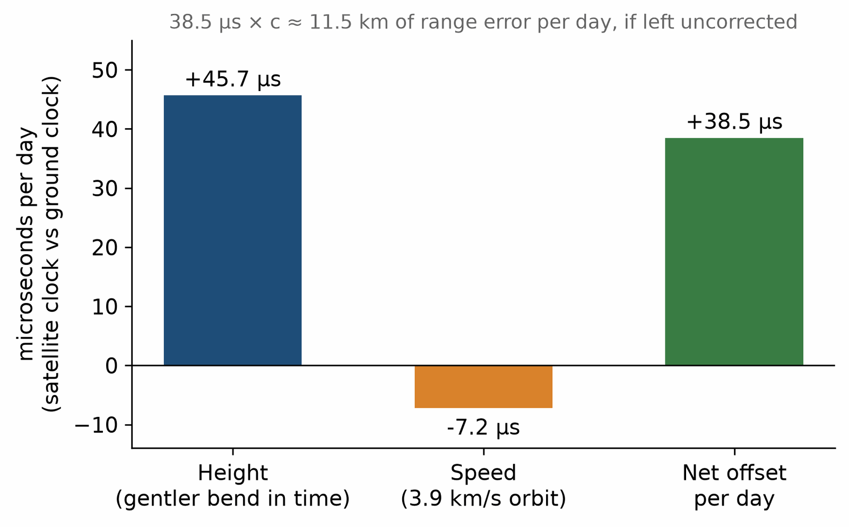
The GPS clock budget. Height makes the satellite clock gain about 45.7 microseconds a day. Speed makes it lose about 7.2. The net is about 38.5.
That sounds like nothing. Light travels about 11 kilometers in that time. The receiver in your phone finds you by timing signals from several satellites, so a clock error becomes a distance error. Leave the correction out and the computed distances to the satellites grow wrong by about 11 kilometers a day, and the fix on your position wanders by kilometers. The system works because the engineers put Einstein’s two corrections in before the satellites launched. Gravity, the bend in time, is in the map that finds your street.
The satellite clock does not run fast because some force on it is weaker. It runs fast because it sits higher in the bend in time. Compared with the ground, more time passes up there per tick of the geometry. The motion correction goes the other way. Both are measured. Both are in the software.
If you turn the corrections off in a thought experiment, the map does not fail poetically. It fails as a drifting pin. The street becomes a neighborhood, then a district. The geometry is not a decoration on the engineering. It is the engineering.

Other audits
CORE
Radar echoes to planets and spacecraft come back late when the path skims the Sun, by the amount the bent time predicts. This is the Shapiro delay. The signal is not slowed by a medium. The path through the bent time is simply a longer interval than the flat accounting expected. The echo is late, and the lateness matches.
The Moon’s distance, read by laser off mirrors left by astronauts, follows the orbit the rule demands, to a precision that would have seemed absurd in 1915. A spinning Earth drags the nearby geometry around with it, a small twist measured by gyroscopes on the Gravity Probe B satellite and by the orbits of other satellites. The drag is tiny. The measurement was hard, and the error bars were honestly large, and the twist was there.
None of these is a parlor trick. They are the rule, audited. The rule has a loose end, and it matters later. Empty space can, in the mathematics, weigh a little. For now it is enough that mass, pressure, and light bend the geometry, and that the bend is not a guess. It is the one that matches the clocks.

What the equation is not
CORE
It is not a recipe for every motion in the sky. It says how the geometry answers to what is there. The motions then follow the straightest paths in that geometry. Two steps, not one: the stuff bends the stage, the stage directs the stuff. That is Wheeler’s two-way grip again (see “The other equation”).
It is also not a claim that we can solve it on a napkin for any lump of matter. A round, still star has a clean outside. Two stars in orbit, close and fast, need a machine. The 2015 chirp was that machine’s output, checked against the sky. The equation was the same one.

Stacks of surfaces
EXTENSION · can be skipped on a first read
Gravitation has a famous habit of drawing mathematical objects as things you could hold. A vector is an arrow. A gradient, which says how fast something changes as you move, is drawn as a stack of surfaces, like the contour lines of a hiking map lifted into layers. Mathematicians call such a stack a one-form. To find how much the quantity changes along a move, lay the arrow through the stack and count the surfaces it pierces. Close-packed layers mean a steep change. A move along the layers crosses none. Where two stacks cross, they cut space into cells, which the authors draw as an egg crate. In the same spirit they treat a tensor as a machine with slots: feed it directions and it returns a number.
The picture fits this book better than it looks. Clock rate changes with height, so surfaces of equal clock rate form a stack, nearly level. If each layer marks one part in 10¹⁶ (the best optical clocks now resolve about a hundred times finer), the layers near the ground are about 0.92 meters apart. Carry a clock up a flight of stairs, three meters, and it crosses about three layers. Carry it along a level corridor and it crosses none. In 2010 a team at NIST in Boulder saw the shift with two optical clocks whose heights differed by just 33 centimeters.
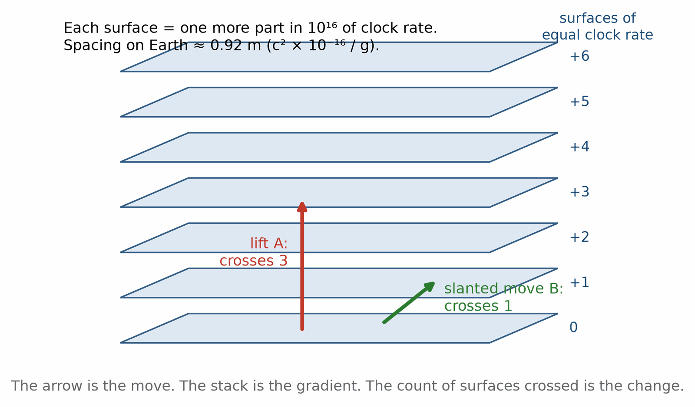
A gradient drawn as a stack of surfaces. Each layer is one more part in 10¹⁶ of clock rate. An arrow straight up crosses three layers. A slanted move crosses one. The count is the change.

The eclipse that almost washed out
EXTENSION · can be skipped on a first read
In May 1919 two expeditions went to see a star shift. One to Sobral, in Brazil. One to Príncipe, an island off Africa, where Arthur Eddington watched the sky and the weather with the same anxiety. The eclipse was the only lamp that could be switched off. The Sun had to be covered, or the stars near it would not show, and the stars near it were the ones whose light had passed through the bend.
The weather on Príncipe was bad. Clouds. A few plates came through. Sobral had better luck and a suspect instrument, a telescope that had misbehaved in the heat. The numbers, when they were reduced, sat nearer Einstein’s new prediction than Newton’s old one. The announcement in November, in London, made Einstein a public figure no equation had managed. The measurement was rough. The headline was not. Later radio work, on quasars passing near the Sun in the sky, did the same test cleanly. The 1919 plates are the legend. The radio is the audit.
Eddington wanted the result. Wanting a result is not the same as faking it, and it is not the same as a clean measurement. Keep the legend. Trust the later audit.
Einstein, shown the telegram, is said to have been calm. His student Ilse Rosenthal-Schneider later recalled him saying that, had the result gone the other way, he would have felt sorry for the dear Lord, because the theory was correct. The story rests on one memory, written down years later, and it is too neat to lean on. The theory had already explained Mercury’s orbit without an audience. The eclipse was the audience.

Pound and Rebka, twenty-two meters
EXTENSION · can be skipped on a first read
The bend in time was first measured on the ground in a building. In 1959 and 1960 Robert Pound and Glen Rebka sent gamma rays from iron nuclei down, and then up, the 22.5-meter tower of the Jefferson Physical Laboratory at Harvard. Over that height the predicted change in frequency is about 2.5 parts in a thousand million million. Light going up arrives a little redder. Light going down arrives a little bluer. They needed a gamma ray with an absurdly sharp frequency, which the newly found Mössbauer effect provided, and a loudspeaker coil to jiggle the source and find the speed that canceled the shift.
Their first result matched the prediction to about ten percent. With Joseph Snider, in 1964, Pound brought it to about one percent. The tower is now a museum piece. Optical clocks today see the same effect across a centimeter or less of height on a laboratory bench.
RECAP
• The bend follows the stuff: mass, pressure, energy, and light. The paths follow the bend.
• Einstein’s field equation says that in one line, and reduces to Newton for slow, weak cases.
• Mercury’s 43 seconds of arc a century came out of the geometry, with no extra planet.
• A GPS clock gains about 45.7 microseconds a day from height and loses about 7.2 from speed. Without the net correction, the distances to the satellites would grow wrong by about 11 kilometers a day.
• Late echoes, laser ranging to the Moon, frame dragging, and the Harvard tower are further audits.

Exercises
Exercise 4.1 · Core
The height term for a satellite clock is (GM/c²)(1/R − 1/r). For the Earth, GM/c² = 4.435 × 10⁻³ m. Use R = 6.371 × 10⁶ m and a GPS orbit radius r = 2.657 × 10⁷ m. How many microseconds a day does the satellite clock gain?
Worked solution. 1/R − 1/r = 1.570 × 10⁻⁷ − 0.376 × 10⁻⁷ = 1.193 × 10⁻⁷ per meter. Multiply by 4.435 × 10⁻³ m to get 5.29 × 10⁻¹⁰. Multiply by 86,400 seconds in a day: 4.57 × 10⁻⁵ s, which is 45.7 µs per day.
The usual mistake. Using the tower formula gh/c² with h = 20,200 km. That assumes g stays at 9.81 m/s² all the way up, and gives 190 µs a day, about four times too much. gh/c² is for towers, not orbits.
Exercise 4.2 · Core
A GPS satellite moves at v = √(GM/r) ≈ 3.87 km/s. Its clock loses about v²/(2c²) because of its speed. How many microseconds a day is that?
Worked solution. (3,873)² / (2 × 8.99 × 10¹⁶) = 1.50 × 10⁷ / 1.80 × 10¹⁷ = 8.35 × 10⁻¹¹. Times 86,400: 7.2 µs per day.
The usual mistake. Forgetting the ½ and getting 14.4 µs.
Exercise 4.3 · Core
Combine the two terms. What is the net daily gain, and how far does light travel in that time?
Worked solution. Net: 45.7 − 7.2 = 38.5 µs per day. Distance: 3.0 × 10⁸ m/s × 38.5 × 10⁻⁶ s = 11,550 m, about 11.5 km.
The usual mistake. Adding the two terms to get 52.9 µs. They have opposite signs: height speeds the clock up, speed slows it down.
Exercise 4.4 · Core
Mercury’s orbit swings by an extra 43 seconds of arc per century. Mercury’s year is 87.97 days. How much is that per orbit?
Worked solution. A century is 36,525 days, which is 36,525 / 87.97 = 415 orbits. 43 / 415 = 0.104 seconds of arc per orbit.
The usual mistake. Dividing by 100 and calling the result the shift per orbit. That is the shift per Earth year.
Exercise 4.5 · Core
A 2 cm coin seen at distance D covers an angle of 0.02/D radians. One second of arc is 4.85 × 10⁻⁶ radians. At what distance does the coin cover 43 seconds of arc?
Worked solution. 43 seconds of arc = 43 × 4.85 × 10⁻⁶ = 2.08 × 10⁻⁴ radians. D = 0.02 / 2.08 × 10⁻⁴ = 96 m. About a hundred meters.
The usual mistake. Mixing up one second and forty-three. A single second of arc is the coin at about 4 km. Forty-three of them is the coin at about 100 m.
Exercise 4.6 · Core
Light grazing the Sun is deflected by 4GM/(c²R). For the Sun, GM/c² = 1,477 m and R = 6.96 × 10⁸ m. What is the deflection in seconds of arc (1 radian = 206,265 seconds of arc)?
Worked solution. 4 × 1,477 / 6.96 × 10⁸ = 8.49 × 10⁻⁶ radians. Times 206,265: 1.75 seconds of arc.
The usual mistake. Using 2GM/(c²R), which gives 0.87 seconds of arc. That is the half value of a particle picture, the number Einstein himself published in 1911 before the full rule doubled it.
Exercise 4.7 · Extension
For the space station, about 400 km up, the height term is +3.6 µs a day and the speed term is −28.3 µs a day. What is the net, and which effect wins?
Worked solution. 3.6 − 28.3 = −24.7 µs a day. Clocks on the station run slow compared with the ground. In a low orbit speed wins; in the high GPS orbit height wins. The two balance for a circular orbit at about 3,200 km altitude.
The usual mistake. Assuming every satellite clock runs fast, the way GPS clocks do.
Exercise 4.8 · Extension
In the Pound–Rebka experiment the fractional frequency shift was gh/c² over h = 22.5 m. What is it, and is light going up redder or bluer?
Worked solution. 9.81 × 22.5 / 8.99 × 10¹⁶ = 2.46 × 10⁻¹⁵. Light going up climbs out of the bend and arrives redder by that fraction. Light going down arrives bluer.
The usual mistake. Saying light going up gets bluer. It is the receiving clock at the top that runs faster, so the arriving light looks redder to it.
Exercise 4.9 · Extension
Laser ranging measures the distance to the Moon to about 1 cm. How precisely must the round-trip time be measured?
Worked solution. A 1 cm change in distance changes the round-trip path by 2 cm. Time = 0.02 m / 3.0 × 10⁸ m/s = 6.7 × 10⁻¹¹ s, about 67 picoseconds.
The usual mistake. Forgetting that the light goes there and back, and getting 33 picoseconds.
Exercise 4.10 · Extension
Inside matter, a small ball of crumbs at rest starts to shrink with V̈/V = −4πGρ when the pressure is negligible. Compute this for a uniform Earth with ρ = 5,510 kg/m³. Then compare with the boomerang tunnel, where each of the three directions squeezes at ω² = (4/3)πGρ.
Worked solution. 4π × 6.674 × 10⁻¹¹ × 5,510 = 4.62 × 10⁻⁶ per second squared. For one direction, ω² = (4/3)π × 6.674 × 10⁻¹¹ × 5,510 = 1.54 × 10⁻⁶, and three directions give 4.62 × 10⁻⁶, the same number. Check: 2π / √(1.54 × 10⁻⁶) = 5,063 s, the tunnel’s 84 minutes.
The usual mistake. Comparing the volume rate with one direction only and finding a factor of 3 that seems wrong. Volume shrinks in all three directions at once, so it shrinks three times as fast as any one length.

5. Stars with a last size
A star is a quarrel that lasts a long time. Gravity pulls in. Heat pushes out. The heat comes from fusion, light nuclei joining into heavier ones, which is why stars shine. As long as the fuel holds and the push matches the pull, the star sits at a size. The Sun has done this for about four and a half billion years, and has about that long again.
Fuel ends. The quarrel does not. What pushes back then is not heat from fusion. It is a stubbornness in matter itself, from the quantum rules: particles of a certain kind refuse to be crowded into the same state. Squeeze a dead star and this refusal pushes out. It is not a force you can see. It is a law about how many particles can share a space.
IN THIS CHAPTER
Goal. By the end you should be able to say: a star is a quarrel between pull and push, fuel ends, and past a last size there is no pillar.
Route. First the white dwarf and its limit, then the neutron star and its limit, then what happens past the last size. Then the shrinking pulsar orbit that paid the wave bill. The first pulsar and Chandrasekhar’s voyage come last, as history.
Say. Past the last refusal there is no pillar.
Do not say. A black hole is a hole in the sky. Every heavy star becomes one.
A question to carry. If a star can always push harder, why is there a gap in the masses?

The white dwarf
CORE
A star like the Sun ends as a white dwarf, an Earth-sized ember of carbon and oxygen, holding itself up by that refusal of electrons to be packed tighter. It works, up to a point. Past about 1.4 times the mass of the Sun, the refusal is not enough. Add more mass and the star gets smaller, not larger, and the squeeze wins. This limit was worked out by Subrahmanyan Chandrasekhar in 1930, on the boat to England. Wilhelm Anderson and Edmund Stoner had reached similar limits a little earlier by rougher routes; Chandrasekhar’s treatment is the one that lasted. Older astronomers did not believe it. The sky did.
The strange part is the direction. In ordinary life, more weight means a thicker pillar. In a white dwarf, more weight means a smaller star, because the refusal of the electrons does not stiffen fast enough. Past the limit, there is no size at which push matches pull. The quarrel has a winner, and it is not the ember.
Sirius has a companion of this kind, found because Sirius itself wobbled. The companion is faint, hot, and about the size of the Earth, with the mass of a star. It was the first white dwarf weighed in public. The limit Chandrasekhar found is why not every dead star can be one.

The neutron star
CORE
Past that limit, electrons and nuclei are crushed together into neutrons. A neutron star is what you get: a city-sized object, some twenty kilometers across, with the mass of a star. A teaspoon would weigh as much as a mountain, if you could bring a teaspoon home. The refusal of neutrons to share a state holds it up. There is a last mass here too, somewhere around two or three times the Sun. The exact number depends on how nuclear matter behaves when we cannot test it in a lab. We have weighed neutron stars near two solar masses. We have not found one at three.
In 1967 a graduate student found the first one, as a scruff on chart paper that came back every 1.337 seconds (the scene is told in “The scruff on the chart”). It was a neutron star, spinning, its magnetic field sweeping a radio beam the way a lighthouse sweeps. Pulsars, we call them. They were the proof that these objects are not a theorist’s dare. Thousands are known now. Some spin hundreds of times a second. Some are clocks good enough to rival the atomic clocks in the GPS story.
A white dwarf is about the size of Earth. A neutron star is about the size of a city. A black hole with the Sun’s mass would have its edge about 3 kilometers from the center. Same rule, three endings, set by mass.

Past the last size
CORE
Add mass beyond the neutron star’s limit and we know of no push that wins. The quarrel ends. The star collapses. What it becomes is the subject of a later chapter. The point here is only that the end is not optional. It is what the geometry does when nothing can push back hard enough.
The collapse is not a failure of the star’s character. It is the equation, applied to a pile that has run out of refusal. Pressure itself gravitates. That is the cruel extra Newton did not have. The harder the core pushes, the more it bends the geometry, and the more the geometry asks it to push. Past a point, pushing makes the demand worse. There is no pillar tall enough.

The bill the waves sent
CORE
One more thing stars do, and it will matter for the ripples. Two neutron stars in orbit bleed energy as bends in the geometry, a slow leak. The orbit tightens. In 1974 Russell Hulse and Joseph Taylor found such a pair. Over the years the orbit shrank at the rate Einstein’s rule predicts, and at no other rate anyone could make fit. They had not caught a ripple in a detector. They had caught the bill the ripples sent. It earned the Nobel Prize in 1993, and it was the warning that the ripples were real (see “A ruler shorter than a proton”).
The pair is a clock. The pulses arrive early or late as the pulsar swings toward us and away. From the swing, the orbit. From years of the orbit, the shrink. The shrink matches the energy the rule says must leave as waves. Nature paid the bill before we built the cash register.

The scruff on the chart
EXTENSION · can be skipped on a first read
In the summer of 1967 a graduate student in Cambridge was reading paper. Not a paper. Paper. Miles of it, from a chart recorder wired to a radio telescope on a field outside the city. The telescope was a field of posts and wire, built to catch the flicker of distant radio sources as the solar wind jostled them. The job was dull in the way that real discovery jobs are dull. You look at everything, because you do not yet know which mark is the one.
Jocelyn Bell, later Jocelyn Bell Burnell, was the person looking. Antony Hewish had designed the array and was her supervisor. The charts came off the recorder in a long strip. Most of the strip was weather, interference, and the honest noise of the sky. In one stretch, a few millimeters of scruff. A bit of pen that did not look like the rest. She had seen scruff before. This scruff came back when the same patch of sky came back, which is the difference between a fault and a fact.
She marked it. The period, once they had a faster recorder on it, was 1.337 seconds, steady to a degree that made the group uneasy. Natural things wobble. This did not. For a few weeks the half-joke in the lab was little green men. They called the source LGM-1, which is the name you give a thing when you are frightened of being the person who announced aliens and then found a loose wire. A second scruff appeared, in a different part of the sky, and the little green men were retired. Two civilizations would have had to agree on the same ridiculous pulse. The universe is not that considerate.
What they had found was a neutron star, spinning, its magnetic field swinging a radio beam the way a lighthouse swings a lamp. Pulsars, the name became. The first one is now PSR B1919+21. Bell had seen the mark that the theory of dead stars had been waiting on, in a stack of paper nobody else was going to read that carefully. The city-sized ember described earlier in this chapter was no longer a dare. It beeped.
In 1974 the Nobel Prize for pulsars went to Hewish, shared with Martin Ryle for radio astronomy as a whole. Bell Burnell was not included. She was the student. The prize has a habit of landing on the supervisor when the student was the one with the mark on the chart. She has told the story since without bitterness. She has said that, by the custom of the time, the prize went to the senior people who led the project, and that she did not think it unfair, although many colleagues protested on her behalf. In 2018 a special Breakthrough prize, three million dollars, came to her for the same work. She gave the money to fund students who look like the person she had been: not already inside the prize. The chart did not care about any of this. The scruff was the scruff.

The boat to England
EXTENSION · can be skipped on a first read
Chandrasekhar’s limit has a scene of its own, and it is also a story about who gets believed. In 1930 he was nineteen, on a ship from India to England, on his way to Cambridge, with time and a calculation. Electrons refuse to be packed. The refusal has a last mass. Past about 1.4 Suns, a white dwarf has no size at which it can sit. He had the arithmetic done before the boat docked. Cambridge did not throw a party.
Arthur Eddington, the man who had made Einstein famous in 1919, disliked the result in public. At a meeting of the Royal Astronomical Society in 1935 he said, in effect, that nature would not be so absurd. A star would not be allowed to collapse. The audience, as audiences do, heard the famous man. Chandrasekhar sat there. He went on working. The limit did not care about the meeting either. Decades later the Nobel Prize came to him for the work Eddington had waved off the stage. Fame is a poor referee. The mass is the referee.
Eddington had been right about the eclipse. He was wrong about the last size. Being right once does not make anyone right the next time.
RECAP
• A star is a quarrel between pull and push. When the fuel ends, quantum refusal pushes back.
• White dwarfs are held by electrons, up to about 1.4 Suns. More mass means a smaller star.
• Neutron stars are held by neutrons, up to a limit near two to three Suns that is not yet pinned down.
• Pressure itself gravitates, so past the last size pushing harder makes things worse.
• The Hulse–Taylor pulsar’s shrinking orbit paid the gravitational-wave bill before any detector heard a wave.

Exercises
Exercise 5.1 · Core
A white dwarf has about one solar mass (1.99 × 10³⁰ kg) in roughly the Earth’s volume (1.08 × 10²¹ m³). What is its average density, and what would a teaspoon (5 mL = 5 × 10⁻⁶ m³) of it weigh?
Worked solution. 1.99 × 10³⁰ / 1.08 × 10²¹ = 1.8 × 10⁹ kg/m³. A teaspoon: 1.8 × 10⁹ × 5 × 10⁻⁶ = 9 × 10³ kg, about 9 tonnes.
The usual mistake. Converting 5 mL to 5 × 10⁻³ m³. A milliliter is a cubic centimeter, 10⁻⁶ m³.
Exercise 5.2 · Core
A neutron star has 1.4 solar masses in a radius of 12 km. What is its density, and what would a teaspoon weigh?
Worked solution. Volume = (4/3)π(1.2 × 10⁴ m)³ = 7.24 × 10¹² m³. Mass = 1.4 × 1.99 × 10³⁰ = 2.79 × 10³⁰ kg. Density = 3.8 × 10¹⁷ kg/m³. A teaspoon: 1.9 × 10¹² kg, about two billion tonnes, the mass of a mountain.
The usual mistake. Cubing 12 instead of 12,000. Leaving the radius in kilometers makes the density a billion times too large.
Exercise 5.3 · Core
The horizon radius of a non-spinning black hole is about 2.95 km per solar mass. For 1.4 Suns, compare the horizon radius with a neutron star’s 12 km radius.
Worked solution. 2.95 × 1.4 = 4.1 km. The neutron star is only about three times its own horizon radius. That is why pressure inside it gravitates so strongly, and why a little more mass leaves no push that wins.
The usual mistake. Thinking a neutron star has a horizon. It is larger than its horizon radius, so light still escapes, and we see pulsars.
Exercise 5.4 · Core
Sirius B has 1.02 solar masses and a radius of about 5,850 km. What is the gravity at its surface, g = GM/R², with GM for the Sun = 1.327 × 10²⁰ m³/s²?
Worked solution. GM = 1.02 × 1.327 × 10²⁰ = 1.354 × 10²⁰. R² = (5.85 × 10⁶)² = 3.42 × 10¹³. g = 3.96 × 10⁶ m/s², about 400,000 times the Earth’s.
The usual mistake. Using the Sun’s radius, or forgetting to convert kilometers to meters.
Exercise 5.5 · Core
A white dwarf of 1.2 Suns gains mass from a companion at 10⁻⁷ Suns a year. How long until it reaches about 1.4 Suns, and what then?
Worked solution. 0.2 / 10⁻⁷ = 2 × 10⁶ years. Then it does not settle down at a larger size. Carbon ignites in a runaway and the star is destroyed: a thermonuclear (Type Ia) supernova, one of the standard lamps of 1998.
The usual mistake. Expecting a larger white dwarf. In this family, more mass means a smaller star, until no size works at all.
Exercise 5.6 · Extension
The fastest known pulsar, PSR J1748−2446ad, spins 716 times a second. If its radius is about 12 km, how fast does its equator move?
Worked solution. Circumference = 2π × 12,000 m = 75,400 m. Speed = 75,400 × 716 = 5.4 × 10⁷ m/s, about 0.18c.
The usual mistake. Forgetting the 2π and multiplying radius by spin rate, which gives 8.6 × 10⁶ m/s.
Exercise 5.7 · Extension
The Hulse–Taylor pulsar’s 7.75-hour orbital period shrinks by about 2.4 × 10⁻¹² seconds every second. How much does it shrink in a year (3.16 × 10⁷ s), and in thirty years?
Worked solution. Per year: 2.4 × 10⁻¹² × 3.16 × 10⁷ = 7.6 × 10⁻⁵ s, about 76 µs. Over thirty years, about 2.3 milliseconds. Small, but pulse timing to microseconds shows it, and it matches the energy the waves should carry away. What astronomers actually track is the time of each closest approach, which comes earlier and earlier as the orbit shrinks. After three decades the accumulated shift is tens of seconds, and it follows Einstein’s prediction closely.
The usual mistake. Expecting a visible change in a 7.75-hour orbit. The shrink lives in the last digits, which is where this subject lives.

6. The universe is not flying apart through space
The galaxies are not rushing outward into a dark empty room. That picture feels natural, and it is the wrong one. The space between them is stretching. It is better to say the galaxies are carried apart by the stretching than that they fly through space. The ruler is growing.
Georges Lemaître in 1927, and Edwin Hubble in 1929 with better distances, found that galaxies have their light shifted redder, and the farther ones more so. Redder, for light, means the wave was stretched on the way. The simple reading, and the right one, is that the stretch happened in the travel. In the old language, distance and speed go together. In the better language, the redshift says how much the scale of the universe grew while the light was on its way.
IN THIS CHAPTER
Goal. By the end you should be able to say: the ruler between the galaxies is growing, and since the late 1990s that growth has been speeding up.
Route. First the loaf, so “flying apart through space” is retired. Then the hiss, which is the early glow. Then the lamps that were too faint. Dark energy is the label on the faintness. The label is not a mechanism.
Say. The ruler grows, and lately it has been growing faster.
Do not say. Galaxies are flying into a dark room. Dark energy is a substance someone has caught.
A question to carry. If everything is pulling, why are the lamps too faint?

No center, no outside
CORE
Where is the center of this stretch? Nowhere. Every galaxy sees the others receding. That is what a stretching ruler does. Raisin bread in the oven is the old classroom picture, and it is allowed here because it does not pretend the dough is sitting in a bowl of space. The raisins stay put in the dough. The dough between them grows. There is no raisin in the middle.
And there is no outside the dough. Asking what the universe is expanding into is like asking what the apple’s skin is curving into, as a question the ant must answer in order to walk. The ant measures the skin. We measure the stretch. The outside is not part of the measurement.
A galaxy nearby can still fall toward us. Andromeda is doing it now. Local pulls win over the stretch when the distance is small. The stretch wins when the distance is large. Both can be true. The bread can have two raisins that happen to be rolling toward each other while the loaf grows.

The afterglow
CORE
If the scale was smaller in the past, the universe was hotter. Far enough back it was too hot for atoms. Light could not travel far. Then it cooled, atoms formed, and the light flew free. That light is still here. The stretch has cooled it from a white heat to a microwave glow, the same in every direction, a few degrees above absolute zero.
Arno Penzias and Robert Wilson found the glow in 1964, while trying to get rid of a hiss in an antenna (see “The pigeons were innocent”). It was the early universe. Later satellites, COBE, then WMAP, then Planck, mapped the glow in detail. It is smooth to one part in a hundred thousand, and the small lumps in it are the seeds of galaxies. The spacing of those lumps is a ruler. It says the large-scale geometry of space is flat, or so close to flat that we cannot yet see the curve. Flat here means the ant’s parallel paths stay parallel on the largest scales. It does not mean nothing bends locally. Stars still bend what is near them.

The stretch is speeding up
CORE
Everyone expected the stretch to be slowing. Mass pulls. A coasting expansion should lose speed the way a ball thrown up loses speed. In 1998 two teams, using exploding stars as standard lamps, found the opposite. Distant lamps were fainter than a slowing universe allows. The stretch is speeding up. Later maps of the microwave glow, and other rungs of the distance ladder, agree.
We call the cause dark energy. The name is a label, not an explanation. It behaves like the loose end from Einstein’s rule: empty space weighing a little, the same little everywhere. Why that little is so small, and not zero, and not huge, is unanswered. The fact of the speedup is not unanswered. The lamps are faint.

The other blank
CORE
There is a second blank. Galaxies spin too fast at their edges. Clusters of galaxies bend light more than their glowing gas and stars can account for. The extra gravity is there. The stuff that should be causing it does not shine, does not block light, and does not sit in atoms. We call it dark matter. We have mapped where it must be, by the way it bends the light of galaxies behind it. We do not know what it is made of. Searches in mines and at colliders have not caught it.
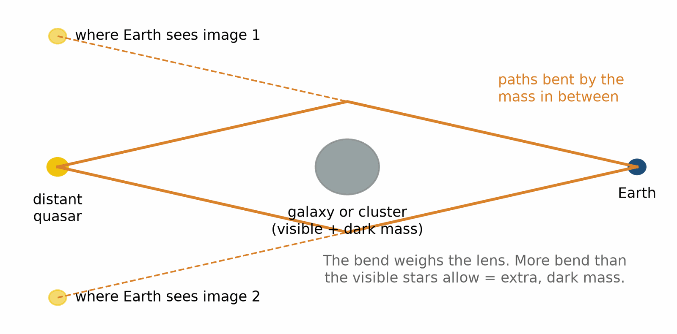
Gravitational lensing. Mass between us and a distant quasar bends its light, so we see more than one image. The amount of bending weighs the lens, dark matter included.
Dark matter is extra gravity, seen. Dark energy is a stretch that speeds up, seen. Neither name is a discovery of a substance. Both are discoveries that the books, as we can read them in light alone, do not balance.
The hot beginning, the glow, the flat large-scale geometry, the speedup: these are measurements. The story of the very first moment, and of why the numbers are what they are, is not a measurement yet. This book stops where the measurements stop.

A number you can hold
CORE
The glow is about 2.7 degrees above absolute zero. It was thousands of degrees when it flew free. The stretch did the cooling, by stretching the light. You are not looking at a fire in the distance. You are looking at the fire’s light, grown old by the ruler.
The speedup is young as a discovery and old as a fact. The supernovae that revealed it exploded billions of years ago, many of them before the Earth existed. Their light was already on its way. In 1998 it arrived in the data.

The pigeons were innocent
EXTENSION · can be skipped on a first read
In 1964 Arno Penzias and Robert Wilson were trying to get a hiss out of an antenna at Holmdel, New Jersey. The antenna was a horn, built for something else, and it hissed from every direction. They evicted pigeons. They cleaned the droppings, which is the part of the story everyone remembers, because droppings are funnier than microwaves. The hiss stayed. It was cold, about three degrees above absolute zero, and it was the same wherever they pointed. About thirty miles away, a group at Princeton was building a receiver to look for exactly this, the cooled light of the hot early universe, and had not finished. The hiss found the people who were not looking for it. The people who were looking were still assembling the radio.
They cleaned the antenna and the universe was still there. This is a good definition of a real signal.

The Bullet Cluster
EXTENSION · can be skipped on a first read
Two clusters of galaxies passed through each other about 150 million years before the light we see left them. The galaxies, far apart, sailed through. The hot gas between them, which holds most of the ordinary matter, collided and stalled in the middle, glowing in X-rays. Lensing maps of the extra bend show most of the mass traveling with the galaxies, not with the gas. Whatever dark matter is, it passed through without hitting anything.
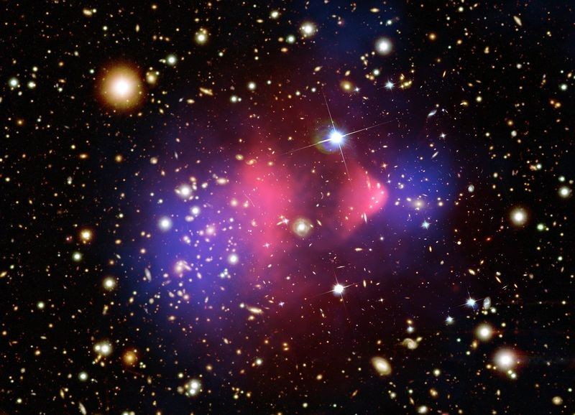
The Bullet Cluster, 1E 0657-56. Pink: hot gas seen in X-rays. Blue: where lensing puts most of the mass. Credit: X-ray: NASA/CXC/CfA/M. Markevitch et al.; optical: NASA/STScI, Magellan/U. Arizona/D. Clowe et al.; lensing map: NASA/STScI, ESO WFI, Magellan/U. Arizona/D. Clowe et al. Public domain (NASA).
A change to the law of gravity can be written to mimic a dark halo around a galaxy. It has a much harder time explaining why the extra bend and the gas have parted company. The Bullet Cluster does not say what dark matter is. It says that the extra bend behaves like stuff that is somewhere.
RECAP
• The galaxies are not flying through space. The ruler between them is growing.
• There is no center and no outside. Nearby, local pulls still win, and Andromeda is approaching.
• The microwave glow is the cooled light of the hot early universe, stretched about 1,100 times.
• Since 1998 the stretch has been known to be speeding up. Dark energy is the label on that fact.
• Dark matter is extra bend, mapped by lensing, with no identified owner.

Exercises
Exercise 6.1 · Core
Take Hubble’s constant as H₀ ≈ 70 km/s per megaparsec. How fast does the distance to a galaxy 100 megaparsecs away grow, and what is its redshift z ≈ v/c?
Worked solution. 70 × 100 = 7,000 km/s. z ≈ 7,000 / 300,000 = 0.023.
The usual mistake. Reading 7,000 km/s as the galaxy flying through space. It is the growth of the ruler between us and it.
Exercise 6.2 · Core
The Hubble time is 1/H₀. With 1 megaparsec = 3.086 × 10¹⁹ km, what is 1/H₀ in years (1 year = 3.156 × 10⁷ s)?
Worked solution. 1/H₀ = 3.086 × 10¹⁹ km / 70 km/s = 4.41 × 10¹⁷ s. Divided by 3.156 × 10⁷ s per year: 1.40 × 10¹⁰ years, about 14 billion years. The measured age of the universe is 13.8 billion years.
The usual mistake. Forgetting to convert megaparsecs to kilometers, which leaves a number with no sensible units.
Exercise 6.3 · Core
The microwave glow left at about 3,000 K and is now 2.725 K. By what factor has the universe stretched since?
Worked solution. 3,000 / 2.725 = 1,100. Every wavelength has been stretched about 1,100 times, and so has the ruler between distant galaxies.
The usual mistake. Thinking the glow cooled by giving its heat to something else. There is nothing outside to give it to. The stretch did the cooling.
Exercise 6.4 · Core
Why is the glow called microwave? Use Wien’s law: peak wavelength = 2.898 × 10⁻³ m·K divided by the temperature.
Worked solution. 2.898 × 10⁻³ / 2.725 = 1.06 × 10⁻³ m, about one millimeter. That is in the microwave band.
The usual mistake. Using degrees Celsius (−270.4) instead of kelvin. Wien’s law needs the absolute temperature.
Exercise 6.5 · Core
A supernova of known brightness looks 25 percent fainter than expected, that is, 0.75 of the expected brightness. Brightness falls as 1/distance². How much farther is it than expected?
Worked solution. Distance ratio = 1/√0.75 = 1.155. It is about 15.5 percent farther.
The usual mistake. Answering 25 percent. Brightness goes with the square of distance, so the distance changes by less than the brightness.
Exercise 6.6 · Extension
Andromeda is about 2.5 million light-years away and approaching at about 110 km/s. Hubble’s law alone would have it receding at about 54 km/s. At a steady 110 km/s, how long would it take to cover the distance (1 light-year = 9.46 × 10¹⁵ m)?
Worked solution. Distance = 2.5 × 10⁶ × 9.46 × 10¹⁵ = 2.37 × 10²² m. Time = 2.37 × 10²² / 1.1 × 10⁵ = 2.15 × 10¹⁷ s, about 6.8 billion years. The real path is neither straight nor steady, and whether and when the two galaxies merge depends on sideways motion that is still being measured. The direction is not in doubt: at this distance the local pull beats the stretch.
The usual mistake. Applying Hubble’s law to a neighbor. It describes the average over large distances, not the motion of nearby galaxies.
Exercise 6.7 · Extension
Ordinary matter is about 5 percent of the cosmic budget and dark matter about 27 percent. How much dark matter is there for each kilogram of ordinary matter?
Worked solution. 27 / 5 = 5.4. About 5.4 kg of matter that does not shine for every kilogram of atoms. The remaining 68 percent, dark energy, is not matter at all.
The usual mistake. Counting dark energy as more dark matter. One is extra bend that clumps. The other is a smooth stretch that speeds up.

7. The place you do not come back from
A black hole is not a pit, and it is not a drain, and it is not a place where gravity has become infinite at the door. It is a region where the outward path is gone.
IN THIS CHAPTER
Goal. By the end you should be able to say: a horizon is the last outward path, not a wall, and the shadow is larger than the door.
Route. First two true stories of one fall. Then how we know the holes are there, what the shell observers measure, spin, and the shadow. Then the temperature, which is calculated and unseen. Then two better pictures, the slice and the Kruskal map, and the orbits near the door.
Say. The horizon is the last outward path, and the shadow is larger than the door.
Do not say. A wall, a funnel you fall into, a white hole in the catalog. The temperature is calculated; the glow has not been seen.
A question to carry. If nothing is there to knock on, what did the dishes photograph?

Two true stories
CORE
Watch from far away. A clock falling toward the horizon ticks slower and slower, compared with yours. Its light reddens and fades. You never see it cross. The crossing is pushed out to the end of your time. This is not a delay in the mail. It is the geometry of the paths the light must take to reach you.
Fall with the clock. You cross the horizon in a finite time on your own watch. At a giant black hole you feel nothing special as you cross. No wall, no flash, no inspector. Ahead, every path leads further in. The center is not a place you can avoid, and it is not a place the present theory can describe. Density and the bend grow without limit in the mathematics. That is a signal that the theory has left its domain, not a fact about a physical infinity we have measured. We do not know the inside. We know the outside very well. The outside has been weighed.
If this feels like a trick, it is the same trick as the train, grown up (see “The train, told without a trick”). Two accounts, both right, because time is not a single clock on the wall of the universe. The horizon is where that fact stops being a thought experiment and becomes a door.

How we know they are there
CORE
A black hole itself is dark. The evidence is everything else. Gas falling in heats up and shines in X-rays before it crosses. Stars orbit an unseen mass, and the mass comes out larger than any star or neutron star that could hide there.
Cygnus X-1, an X-ray source found in the 1960s, was the first strong case: a heavy companion that does not shine, tugging on a bright star. Kip Thorne once bet Stephen Hawking that it was a black hole. Hawking, who spent his life on these objects, bet against, as a form of insurance. Thorne won. The insurance paid out as a subscription to a magazine. Science is occasionally this human.
Since then, many stellar-mass black holes have been weighed this way, typically a few to a few dozen times the Sun.
At the center of the Milky Way, stars whip around an unseen point in orbits we have now followed for decades. The mass inside those orbits is about four million Suns. The region they orbit in is tiny on a galactic scale: the closest star’s orbit is only about thirty times the size of Neptune’s. Nothing but a black hole fits. In 2020 the Nobel Prize went, in part, for that patient watching.
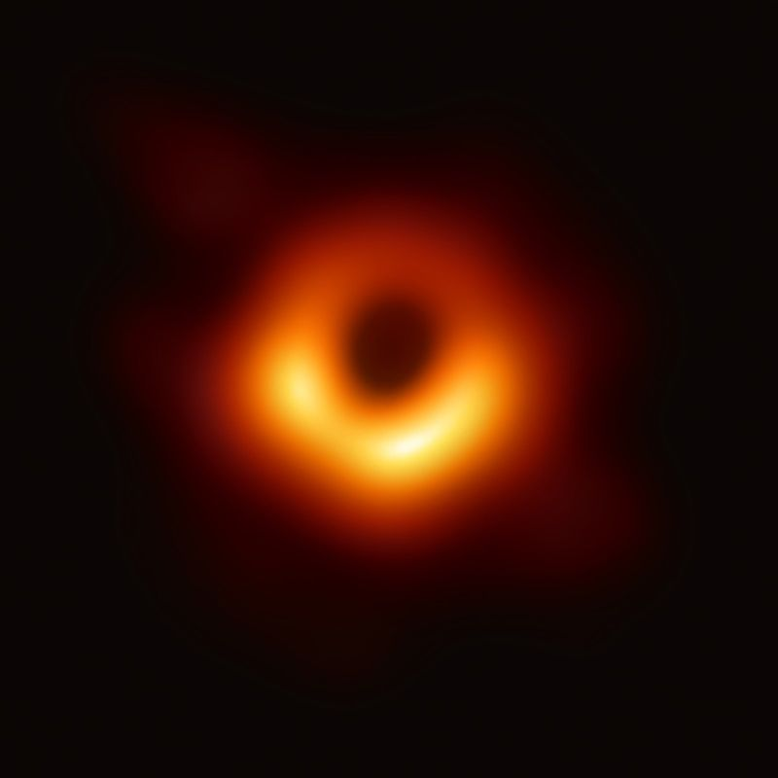
The black hole in the galaxy M87, imaged by the Event Horizon Telescope and published in April 2019. The dark center is the shadow, larger than the horizon itself. The ring is light from hot gas, bent around the hole. Image: EHT Collaboration, CC BY 4.0.

The bookkeeper and the shell observers
CORE
Edwin Taylor and John Wheeler, and later Edmund Bertschinger, wrote Exploring Black Holes to let a reader with algebra do real calculations near a hole without tensors. The trick is to be careful about who measures what. Picture nested spherical shells around a non-spinning hole, each held in place by rockets or struts, with an observer on each shell carrying a ruler and a clock. Far away sits the bookkeeper, who keeps the map. Nobody can reach the center to measure a radius, so the map’s r is defined by something you can measure: walk once around a shell and divide the distance by 2π.
Now the surprise. Climb a ladder from one shell to the next and the ruler on the ladder reads more than the difference in r. The extra is a factor of 1 / √(1 − rₛ/r), where rₛ is the horizon radius. Far away the factor is 1 and nothing looks strange. Near the horizon it grows without limit, so shells that crowd together on the map stay well apart by the ruler. Clocks on the shells run slow by the opposite factor, √(1 − rₛ/r). Those two factors are most of what the geometry around a non-spinning hole says, the geometry Schwarzschild found in 1916.
A third observer helps. Drop a stone from rest, very far away, and let it fall straight in. Taylor and Wheeler call it a raindrop. Each shell observer it passes times it with her own ruler and clock and gets a speed of c × √(rₛ/r). At four horizon radii that is half the speed of light. At the horizon it would be the speed of light, which is another way of saying that no shell can be held in place there.

Spin
CORE
Most of these objects spin. A spinning mass drags the nearby geometry around with it, the same twist Gravity Probe B looked for near the Earth, here enormous. Outside the horizon of a spinning hole there is a region, the ergosphere, where nothing can sit still relative to the distant stars. You can still escape it, if you are outside the horizon. You cannot hover in it. Frame dragging is not an ornament. It is how we read spin off the X-rays and off the ring of light.
The Sun, squeezed to a black hole, would have its horizon about 3 kilometers from the center. The Earth’s would be about the size of a marble. M87’s horizon is larger than the orbits of all the planets around the Sun. Same rule. The tide at the horizon is violent for the small ones and gentle for the giant ones. What you would feel depends on the size of the hole.
The name came later (see “A room at Princeton”). The geometry was older. Karl Schwarzschild found the non-spinning solution within weeks of Einstein’s rule, early in 1916, while serving with the German army on the Russian front. For a long time serious people hoped nature would find a way out, a last push, a bounce. The last size of stars is why that hope thinned (see “Past the last size”). Past the neutron star, we have no push. The sky, since, has been full of the objects the hope was meant to forbid.
The name is better than it looks. Black, because light does not come out. Hole, because the outward path is missing, not because there is a lining. People hear “hole” and picture a well with a bottom you could stand on. There is no standing. There is no bottom the theory can vouch for. There is a region the future points only one way.

A planet pretending to be a dish
EXTENSION · can be skipped on a first read
The black-hole images of 2019 and 2022 were not taken by a camera. They were taken by radio dishes that did not share a valley. Chile, Hawaii, Spain, Mexico, the South Pole, and others, linked so the Earth itself was the dish. The data did not fit in a wire. They flew hard drives. The dark patch in M87 is the shadow a horizon casts on the light around it, for a hole of about six and a half billion Suns. The patch in our own center, published in 2022, is the same trick, harder, because the source flickers while you are still collecting. A patient planet, used as a lens, saw a thing that does not shine. The thing is inferred the way a missing tooth is inferred, from the row.
Wheeler would have liked the method. The geometry did not pose. The light around it did, and the posing was enough.

What a short book got right
EXTENSION · can be skipped on a first read
Stephen Hawking’s A Brief History of Time, 1988, is the book most people mean when they say they have read about this. It is useful. It is not this book. Three of its results belong here, told again in plain speech, because they are the part a reader should keep.
The first is a theorem, not a picture. In 1965 Roger Penrose showed that a collapsing star, if the geometry is Einstein’s and a few mild conditions hold, cannot stop at a dense but ordinary core. The paths run into a place where the theory stops giving answers. A singularity, in the technical sense: not a point you could visit with a ruler, a sign that the rule has quit. Hawking then turned the argument around. Run the universe backward and the same dead end sits at the beginning. The hot early glow is not the start. It is as far back as the light can be asked to talk. Behind it, if nothing but the 1915 rule is allowed, the theory fails. That is not a description of a first moment. It is a confession.
The second result is the one with his name on it. In 1974 he argued that a black hole is not perfectly black. Empty space, near a horizon, is not empty in the quantum sense. Pairs of disturbances come and go. Near the horizon, one of a pair can fall in and the other can escape, and the books then say the hole has lost a little energy. The hole glows, very cold for any hole we can watch, and in principle it shrinks. A small enough hole would boil. We have not seen the glow. The argument is why the close of this book will not say the inside is settled. If the hole can shrink and vanish, the question of what became of what fell in is no longer philosophy. It is a missing page.
The third useful piece is the arrow. Why does a cup break and not unbreak? Hawking lined up three arrows, and the lining-up is the point. Disorder increases. That is the thermodynamic arrow: a broken cup is one of many messy arrangements, and a whole cup is one of few. Memory points the same way, because a memory is a mark, and a mark is an order paid for by disorder somewhere else. You remember the past and not the future because recording the past makes the world messier overall. The third arrow is the stretch of space, which so far has a direction. He wanted the three to be one fact, not three coincidences. The want is reasonable. The proof is not in. A reader can keep the cup. The cup is enough to stop time from being a movie you could run backward and still call it a Tuesday.

Drawing the slice
EXTENSION · can be skipped on a first read
The extra distance between shells can be drawn. Keep only two directions of space, a flat slice through the hole’s equator at one moment, and ask what curved surface would have the same ruler distances. Ludwig Flamm found the answer in 1916: a funnel whose wall grows steeper toward the horizon. Gravitation uses such embedding diagrams often, and with a warning worth repeating. The surface bends into a made-up extra direction with no physical meaning. It shows space at one moment and leaves out the bend in time. Nothing rolls down it. Its only job is to show distances, which makes it the honest version of the funnel in the tides chapter (see “The funnel, and its limit”).
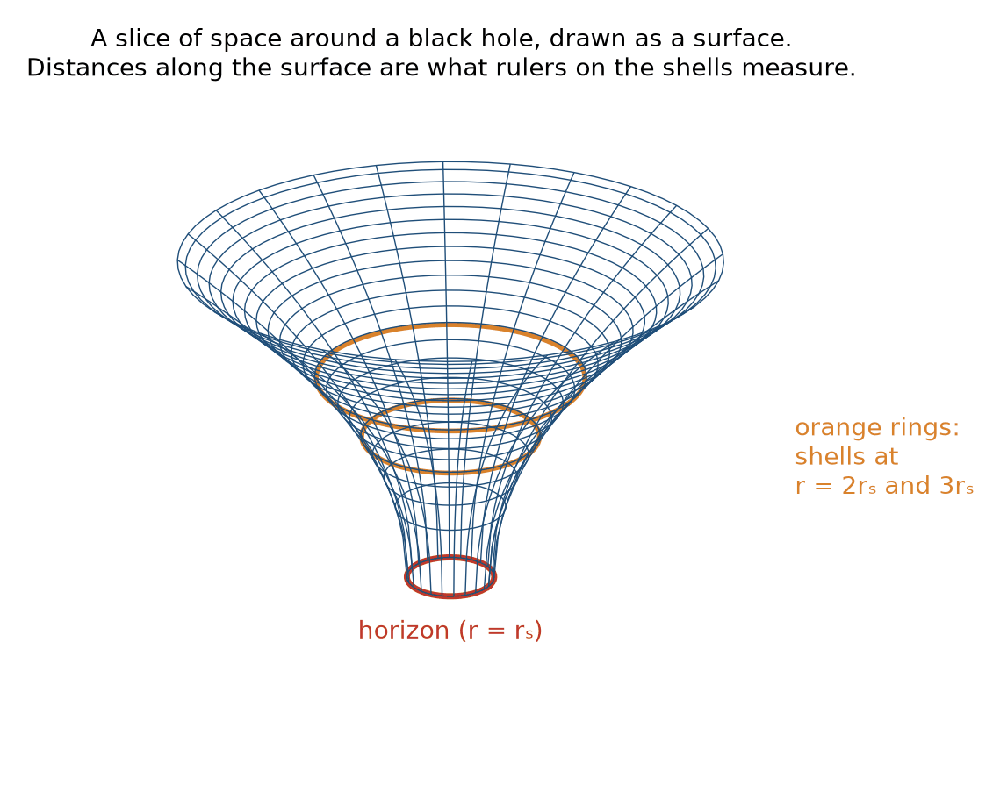
The slice of space around a non-spinning hole, drawn as a surface. The two rings are shells at twice and three times the horizon radius. The distance between them along the surface is what a ruler on a ladder measures.

A better map
EXTENSION · can be skipped on a first read
The bookkeeper’s map has a flaw. On it, a falling clock takes forever to reach the horizon, even though on its own watch it crosses in a finite time (see “Two true stories”). That is a fault in the map, like a world map that smears the North Pole into the whole top edge. In 1960 Martin Kruskal and, separately, George Szekeres drew a new map of the same geometry with one rule: light always runs at forty-five degrees, as in the light-cone pictures (see “Light is the edge”). On their map the horizon is a plain diagonal line, and the falling clock crosses it without fuss.
The new map shows three things at a glance. First, inside the horizon every future direction points toward the line marked r = 0. The singularity is not a place ahead that you could steer around. It is a moment ahead of you, like tomorrow. Second, staying at a fixed r, like the shell observers, means following a curve that bends away from the horizon, and that takes a rocket. Third, the complete map has four regions: our outside, the inside, a past singularity that would be a white hole, and a second outside, joined to ours by the throat in the wormhole picture (see “The wormhole surface”). The last two belong to an idealized hole that has existed forever. A real hole made by a collapsing star does not have them, because the star’s own surface covers the part of the map where they would be.
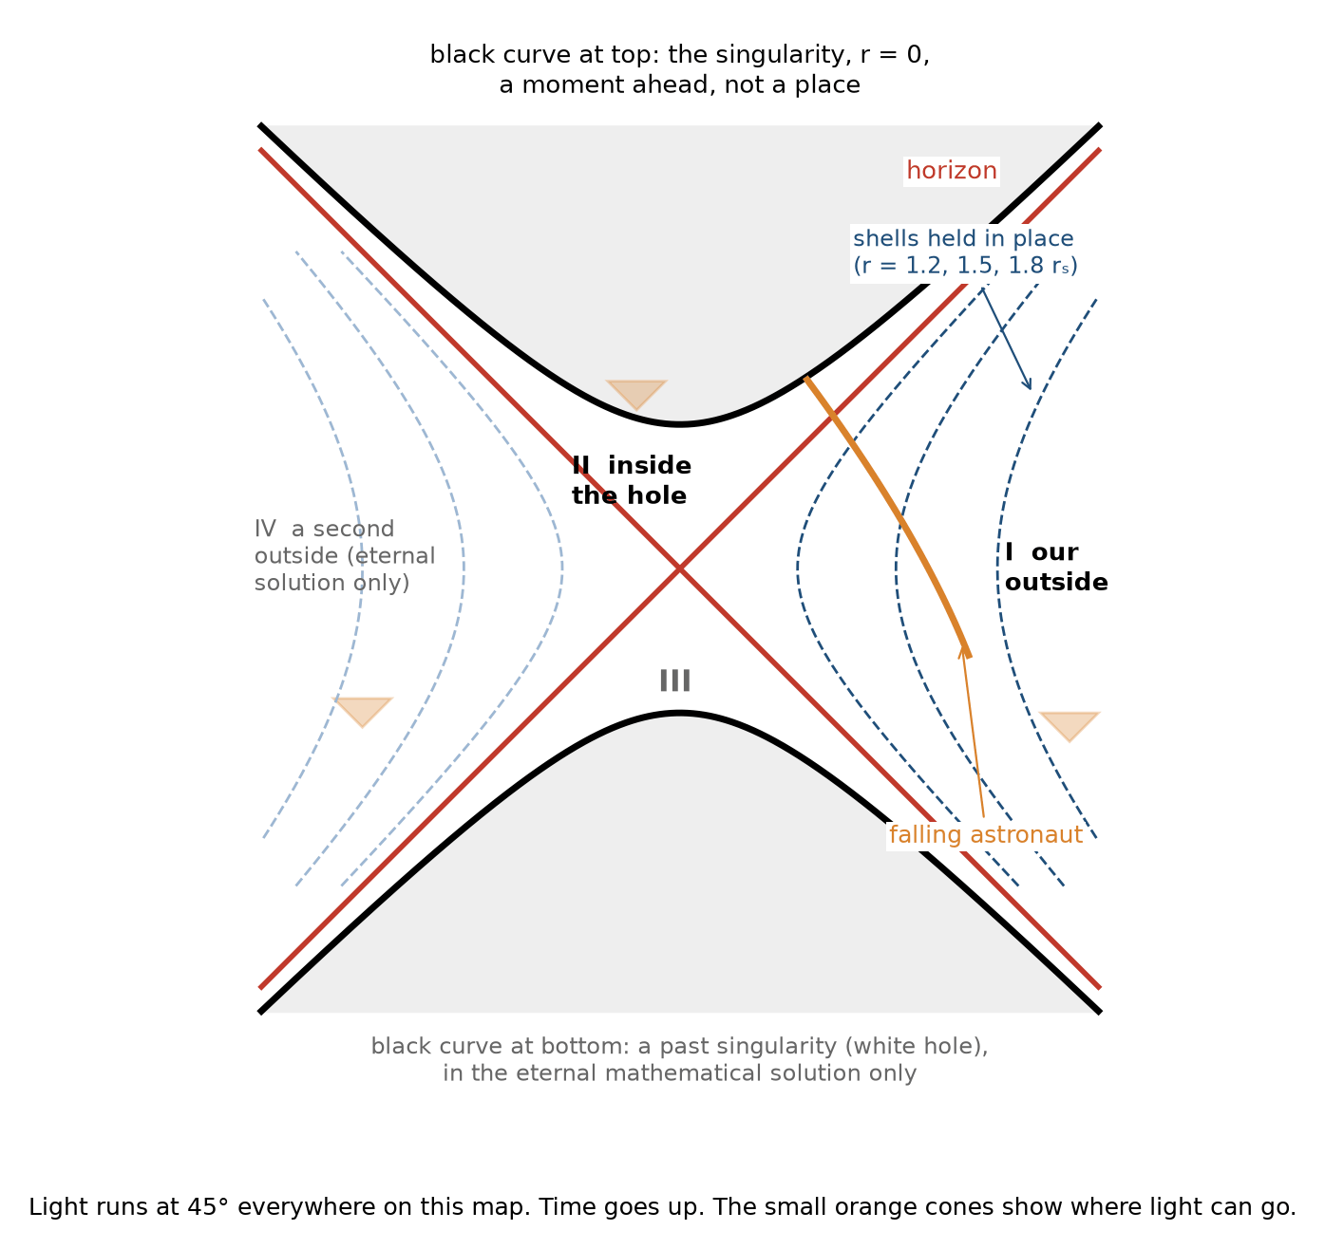
The Kruskal–Szekeres map of a non-spinning hole. Light runs at 45 degrees everywhere. The horizon is a diagonal, the singularity is a curve across the top, and a falling astronaut crosses into region II and meets it. Regions III and IV belong only to the idealized eternal hole.

Orbits near the door
EXTENSION · can be skipped on a first read
Two more places outside a horizon have names. The first is the photon sphere, one and a half times the horizon radius for a hole that does not spin. Light there can circle the hole, but the circle is unstable: a nudge and the light falls in or climbs out. The edge of the shadow is set by light that skims this region. The second is the last stable orbit, three times the horizon radius. Outside it, gas and stars can circle for as long as they like. Inside it, any orbit spirals in. The inner edge of the hot disk that makes the X-rays sits there, which is how the X-rays can be read for spin: a fast spinner pulls the last stable orbit closer in.
RECAP
• A horizon is the last outward path, not a wall. For a non-spinning hole it sits about 3 kilometers out per solar mass.
• From far away a falling clock fades and never crosses. On its own watch it crosses. Both are true.
• Black holes are weighed by orbits: S2 around Sgr A*, gas and stars around M87*, companions in X-ray binaries.
• The shadow is larger than the door. M87* was imaged in 2019 and Sgr A* in 2022.
• Hawking’s temperature is a result in the theory. The glow has not been seen.

Exercises
Exercise 7.1 · Core
The horizon radius is r = 2GM/c². For the Earth, GM/c² = 4.435 mm. How big would the Earth be as a black hole?
Worked solution. r = 2 × 4.435 mm = 8.9 mm, a marble about 1.8 cm across.
The usual mistake. Treating this as a forecast. The Earth will not collapse. The number is a comparison that shows how strong gravity would have to be.
Exercise 7.2 · Core
M87* has about 6.5 billion solar masses. Using 2.95 km per solar mass, what is its horizon radius in astronomical units (1 AU = 1.496 × 10⁸ km)?
Worked solution. 2.95 × 6.5 × 10⁹ = 1.92 × 10¹⁰ km. Divided by 1.496 × 10⁸: about 128 AU. Neptune orbits at 30 AU, so the horizon would swallow the planets.
The usual mistake. Losing a factor of a thousand by mixing kilometers and meters.
Exercise 7.3 · Core
The star S2 orbits Sgr A* with a semi-major axis of about 1,035 AU and a period of 16.05 years. Kepler’s third law in solar units says M = a³/P², with a in AU and P in years. What is the mass?
Worked solution. 1,035³ = 1.109 × 10⁹. 16.05² = 257.6. M = 1.109 × 10⁹ / 257.6 = 4.3 × 10⁶, about 4.3 million Suns.
The usual mistake. Squaring a instead of cubing it, which gives about 4,200 Suns.
Exercise 7.4 · Core
The Hawking temperature is about 6.2 × 10⁻⁸ K multiplied by (solar mass / M). What is it for a 10-solar-mass hole, and how does it compare with the 2.7 K microwave glow?
Worked solution. 6.2 × 10⁻⁸ / 10 = 6.2 × 10⁻⁹ K, about 400 million times colder than the glow around it. Such a hole absorbs more than it emits, so today it grows rather than shrinks.
The usual mistake. Thinking bigger holes are hotter. Temperature goes as 1/M: the bigger the hole, the colder.
Exercise 7.5 · Core
A 10-solar-mass hole has rₛ = 29.5 km. Two shells have reduced circumferences (circumference divided by 2π) of r = 60.0 km and r = 61.0 km. About how far apart are they by a ruler on a ladder between them?
Worked solution. Use the midpoint r = 60.5 km: 1 − 29.5/60.5 = 0.512, √0.512 = 0.716, and 1 / 0.716 = 1.40. The ladder ruler reads about 1.40 km.
The usual mistake. Answering 1.00 km, the difference in r. The map’s r is a circumference label, not a distance from the center, and near a hole the ruler distance between shells is larger.
Exercise 7.6 · Core
A raindrop falls from rest far away. What speed does a shell observer measure as it passes r = 4rₛ, and as it passes r = 1.1rₛ? Use v = c × √(rₛ/r).
Worked solution. At 4rₛ: √(1/4) = 0.5, so 0.5c. At 1.1rₛ: √(1/1.1) = 0.953, so 0.95c.
The usual mistake. Concluding that the stone slows down near the horizon because the bookkeeper’s map shows it creeping. Each shell observer, with a local ruler and clock, sees it moving faster and faster.
Exercise 7.7 · Extension
For a non-spinning hole, the shadow’s diameter is about 5.2 times the horizon radius. M87* is about 16.8 megaparsecs (5.18 × 10²³ m) away, and its horizon radius is 1.92 × 10¹³ m. What angle does the shadow cover, in microarcseconds (1 radian = 2.06 × 10¹¹ µas)?
Worked solution. Shadow diameter = 5.2 × 1.92 × 10¹³ = 1.0 × 10¹⁴ m. Angle = 1.0 × 10¹⁴ / 5.18 × 10²³ = 1.93 × 10⁻¹⁰ rad = 40 µas. The Event Horizon Telescope measured a ring about 42 ± 3 µas across.
The usual mistake. Using the horizon’s diameter instead, which gives about 15 µas. The shadow is larger than the door.
Exercise 7.8 · Extension
A clock held at rest at radius r outside a non-spinning hole ticks at √(1 − rₛ/r) of the rate of a distant clock, where rₛ is the horizon radius. What is the rate at r = 1.5 rₛ?
Worked solution. √(1 − 1/1.5) = √(1/3) = 0.577. At r = rₛ the factor is zero: nothing can hover at the horizon.
The usual mistake. Applying this to a falling clock. The formula is for a clock held in place, with a rocket firing. A falling clock notices nothing special as it crosses.
Exercise 7.9 · Extension
Inside a non-spinning hole, the longest any clock can last between the horizon and the singularity is π × GM/c³. For the Sun, GM/c³ = 4.93 µs. How long is that for a 10-solar-mass hole, and for M87* with 6.5 billion solar masses?
Worked solution. 10 Suns: π × 10 × 4.93 µs = 1.55 × 10⁻⁴ s, about 0.15 milliseconds. M87*: π × 6.5 × 10⁹ × 4.93 × 10⁻⁶ s = 1.0 × 10⁵ s, about 28 hours.
The usual mistake. Thinking a rocket fired outward buys more time. On the Kruskal map every path inside leads to r = 0, and firing the rocket shortens the trip. The longest time belongs to the clock that simply falls.
Exercise 7.10 · Extension
The last stable orbit around a non-spinning hole is at three times the horizon radius. Where is it for a 10-solar-mass hole?
Worked solution. Horizon radius 29.5 km, so the last stable orbit is at 88.6 km from the center.
The usual mistake. Assuming orbits are possible all the way down to the horizon. Inside the last stable orbit, everything spirals in.

8. The bends can travel
Shake a mass the right way and the bend does not stay put. A change in the geometry ripples outward at the speed of light. It is not a sound in a substance. It is the geometry itself, stretching and squeezing as it passes, then settling back.
A spinning perfect sphere does not radiate. A single star sitting still does not. You need a change that is lopsided: two masses orbiting, or a collapse that is not a perfect ball. The wave that leaves carries energy. That is the bill Hulse and Taylor’s pulsar was paying, the slow shrink of the orbit, measured for years before anyone caught a wave in an instrument. The universe had been sending invoices. We had not built a mailbox.
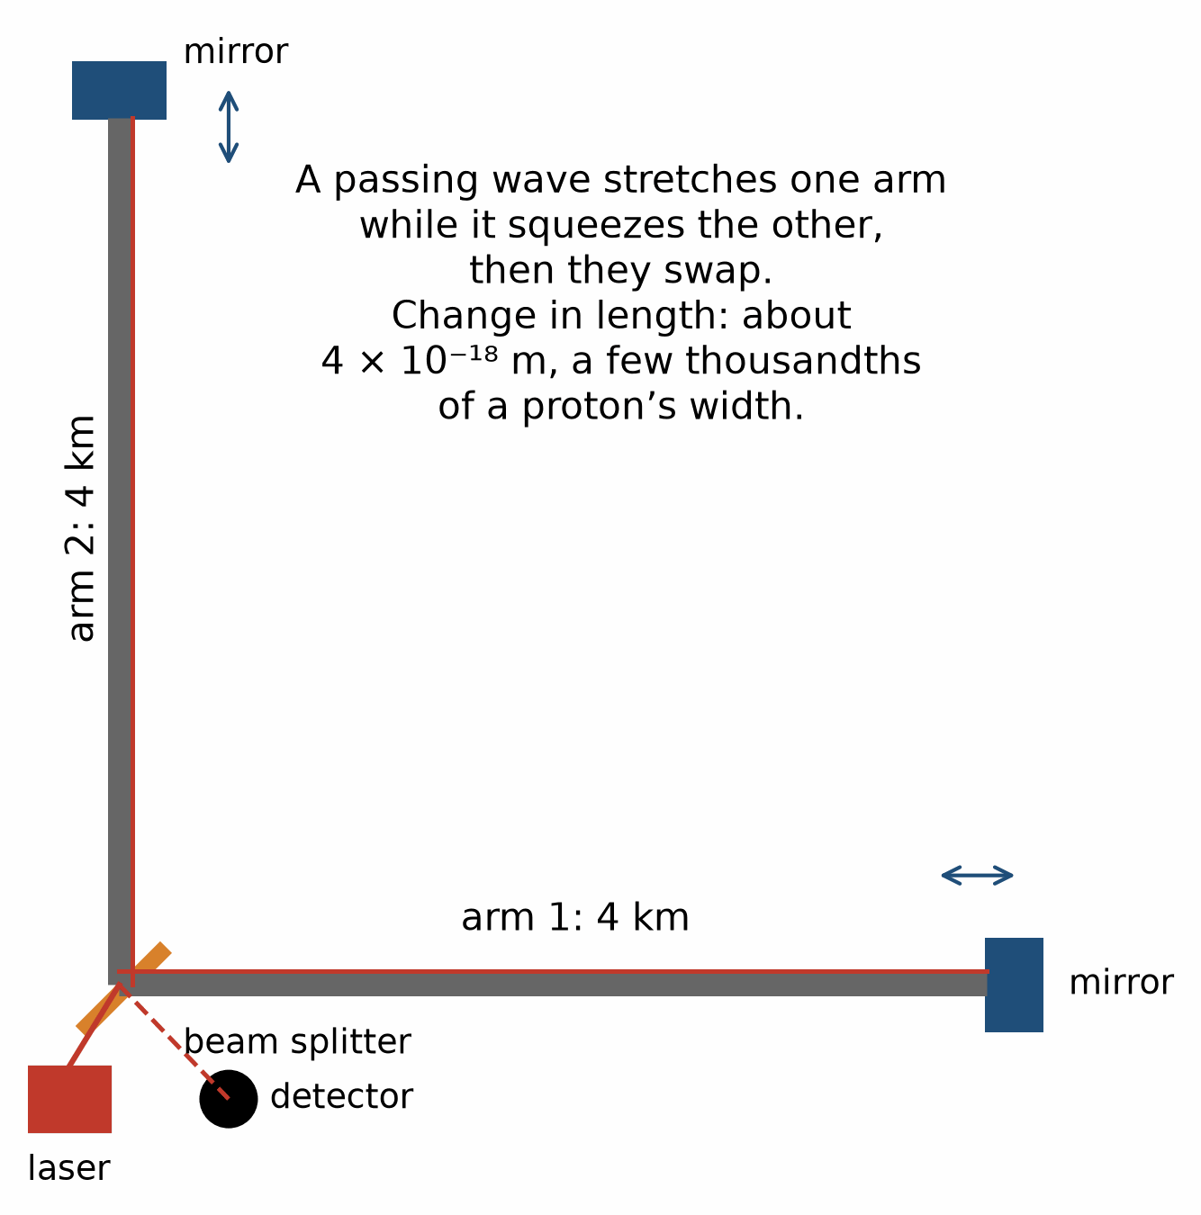
The LIGO layout. A laser is split down two 4-kilometer arms at right angles, reflected by mirrors, and recombined. A passing wave stretches one arm while squeezing the other.
IN THIS CHAPTER
Goal. By the end you should be able to say: a lopsided change sends a ripple through the geometry, and since 2015 detectors have caught them.
Route. First why a still sphere does not send ripples. Then the bill, the shrinking pulsar orbit. Then the signal of 14 September 2015 and the months spent trying to kill it. Then the neutron-star collision, ripple and light 1.7 seconds apart.
Say. A lopsided change sends a ripple, and a detector caught one.
Do not say. The black holes hummed. The audio online was shifted in pitch; the graph is the result.
A question to carry. If space between the mirrors is empty, what exactly stretched?

A ruler shorter than a proton
CORE
The instrument is a ruler made of light. LIGO has two of them, one in Louisiana and one in Washington State, each with arms 4 kilometers long. A laser split down the arms comes back and is compared. If a ripple passes, one arm stretches and the other squeezes, then they trade. For the strongest waves caught so far, the difference between the two arm lengths changes by a few thousandths of the width of a proton. Isolation, mirrors, and a ferocious amount of engineering are what make that readable. Virgo in Italy and KAGRA in Japan joined the watch.
On 14 September 2015, the two LIGO sites recorded the same chirp, seven milliseconds apart, the delay of a thing moving at light speed between Louisiana and Washington. The shape of the chirp was the orbit of two black holes, about 36 and 29 times the Sun, tightening, then merging, then a new single hole ringing down. About three Suns of mass left as waves. The merger was more than a billion light-years away. The announcement came in February 2016, after months of checking that the chirp was not a fault in the machine.
It was the first time a bend had been caught in the act, rather than inferred from a bill. The bill had been paid since 1974. In 2015 someone finally heard the coin drop.
The tides chapter already has the picture of what a wave does (see “Two crumbs falling side by side”). Set a ring of free crumbs flat, facing the oncoming wave. As the wave passes, the ring stretches into an oval one way and squeezes the other, then swaps, over and over at the wave’s pitch. Gravitation draws such rings in its chapter on waves. There are two patterns, turned 45 degrees to each other, called plus and cross. LIGO’s mirrors are four of those crumbs, hung so they swing freely along the arms, and an L is the right shape to catch the oval.
The chirp rises in pitch because the orbit is running out of room. As the two holes lose energy to waves, they move closer and circle faster, and the wave’s frequency, twice the orbital frequency, climbs. At the end the two holes are moving at a sizable fraction of the speed of light, a few hundred kilometers apart, and then there is one hole, and a ringdown, like a bell you are not allowed to see, only to hear in the stretch of a ruler.
A gravitational wave is not a wobble traveling through space, the way a wave wobbles through water. It is a passing change in distances. Two free masses get closer, then farther, as it goes by. LIGO’s mirrors are as free as engineering can make them. The laser is the ruler. The universe played a note. The ruler changed length.

Light and ripples from the same place
CORE
On 17 August 2017 the detectors caught a different chirp, longer, the sound of two neutron stars spiraling in. 1.7 seconds later a gamma-ray satellite saw a flash. Telescopes found a new point of light in a galaxy 130 million light-years away, and watched it fade over days. The glow was a kilonova, the radioactive debris of the merger making heavy elements, gold among them, just as astronomers had predicted for neutron-star collisions.
The ripples and the light arrived together, after 130 million years on the road. The ripples did not beat the light. They travel at the same speed, to a precision that closes a long list of rival ideas in which they would not. One event did that. A century of argument, settled by a second and a half and a new dot in a nearby galaxy.
Gold in a wedding ring is, some of it, from a collision like this. Not all of it. Enough that the sentence is allowed. The geometry rang, the neutrons flew, and a heavy atom later sat on a hand. The book has earned one romantic sentence. That was it.

Since the first chirp
CORE
Since 2015 the catalogs have filled. Black hole with black hole, neutron star with neutron star, and black hole with neutron star. The masses run from a little above the neutron-star range to well over a hundred Suns, which is a puzzle of its own about how such holes are built. Each event is a measured stretch, with a waveform the geometry predicted before the detectors existed. The prediction was not adjusted after the chirp. The chirp fit.
That is the theory checked, not just written down. Wheeler liked to say the geometry is the thing. In September 2015 the thing moved, and two instruments in the United States felt it. The apple’s skin twitched. The ants, had they been four kilometers long and absurdly still, would have noticed.
There is a second mailbox, much larger and much slower. Pulsars are clocks, and a passing wave of very low pitch would shift the arrival times of their beeps in a pattern across the sky. In June 2023 several pulsar timing groups, in North America, Europe, Australia, and China, reported evidence for a common murmur of this kind, the expected sound of pairs of giant black holes in the centers of galaxies. It is evidence, not yet a firm detection. If it holds, the bends are not only chirps. They are a weather.

What the chirp is not
CORE
It is not a sound in air. Space between the mirrors changed. The 2015 signal swept from about 35 to about 250 hertz, which is inside the range of human hearing but low and faint. The “sound” you have heard online is that strain turned into audio, usually shifted up by a few hundred hertz so a small speaker can play it. The shape is honest. The pitch shift is a courtesy.
It is not a picture of the holes. It is a measurement of the stretch, matched to the only family of stretches those masses can make. The match is how we know the masses. We did not see the 36 and the 29. We heard the way 36 and 29 fall together, and nothing else falls together quite like that.

They did not believe the chirp
EXTENSION · can be skipped on a first read
The signal arrived on 14 September 2015, days after the upgraded detectors had been switched on, and the collaboration’s first reaction was suspicion. A blind injection, a fake signal planted to test the team, was one fear. A fault, or a disturbance felt at both sites, was another. They confirmed that no injection had been made, searched thousands of sensors for local noise, and showed that the delay between the sites matched light travel and the shape matched waveforms computed years before. Only then, in February 2016, did they say it out loud.
The months of disbelief are part of the result. A chirp announced on the day is a press release. A chirp that survived the attempt to kill it is a measurement.
RECAP
• A lopsided change in mass sends a ripple in the geometry outward at the speed of light.
• The difference between LIGO’s two 4-kilometer arms changed by a few thousandths of a proton’s width in 2015.
• GW150914 was two holes of about 36 and 29 Suns. About three Suns left as waves.
• GW170817 arrived with light 1.7 seconds behind, after 130 million years. Gravity and light keep the same speed.
• The audio clip is the real signal made audible. The graph is the result.

Exercises
Exercise 8.1 · Core
A wave with a strain of 1 × 10⁻²¹ passes, lined up so it stretches one 4 km arm while it squeezes the other. By how much does the difference between the two arm lengths change, compared with a proton’s width of about 1.7 × 10⁻¹⁵ m?
Worked solution. ΔL = strain × L = 1 × 10⁻²¹ × 4,000 m = 4 × 10⁻¹⁸ m. Divided by 1.7 × 10⁻¹⁵ m: about 1/400 of a proton, a few thousandths of its width.
The usual mistake. Forgetting to multiply by the arm length and quoting 10⁻²¹ m. The strain is a fraction, not a length.
Exercise 8.2 · Core
The two LIGO sites are about 3,002 km apart. What is the longest possible delay between them for a wave moving at light speed? Is the observed 7 ms delay allowed?
Worked solution. 3.002 × 10⁶ m / 3.0 × 10⁸ m/s = 0.0100 s = 10 ms. Seven milliseconds is less than 10, so it is allowed. A delay longer than 10 ms would have meant something other than a wave from the sky.
The usual mistake. Expecting exactly 10 ms. That only happens for a source lying along the line through both sites.
Exercise 8.3 · Core
About three solar masses left GW150914 as waves. How much energy is that? Use E = mc².
Worked solution. E = 3 × 1.99 × 10³⁰ kg × (3.0 × 10⁸ m/s)² = 5.4 × 10⁴⁷ J, released in a fraction of a second.
The usual mistake. Multiplying by c instead of c², which is wrong by a factor of 300 million.
Exercise 8.4 · Core
In 2017 the gamma rays arrived 1.7 s after the waves, after about 130 million years of travel (4.1 × 10¹⁵ s). What does that say about the speed of gravity?
Worked solution. 1.7 / 4.1 × 10¹⁵ = 4 × 10⁻¹⁶. The two speeds agree to better than about one part in a thousand million million. The 1.7 s is mostly the time the flash took to get going at the source.
The usual mistake. Concluding that gravity is slower than light by 1.7 seconds’ worth. The delay belongs to the source, not the road.
Exercise 8.5 · Core
A gravitational wave from a circling pair has twice the orbital frequency. When the 2015 signal reached 250 Hz, how many times a second were the holes circling each other?
Worked solution. 250 / 2 = 125 times a second.
The usual mistake. Taking the wave frequency as the orbital frequency. Each orbit gives two stretches and two squeezes.
Exercise 8.6 · Extension
For a hole that does not spin, horizon area grows as the square of the mass. Before GW150914: 36 and 29 Suns, both spinning little. After: one hole of 62 Suns, spinning at about two-thirds of the maximum. Compare the total horizon area before and after, first ignoring the spin, then allowing for it.
Worked solution. Ignoring spin: before, 36² + 29² = 1,296 + 841 = 2,137 units; after, 62² = 3,844 units, about 80 percent more. Spin shrinks a horizon: at two-thirds of the maximum the area is about 0.87 of the non-spinning value, so the final hole has about 3,350 units, still about 57 percent more than before. Either way the area grew while the mass went down by 3 Suns, as Hawking’s area theorem requires.
The usual mistake. Adding the masses first and squaring once (65² = 4,225) for the before total. Areas add; masses are squared first.
Exercise 8.7 · Extension
The 2015 signal swept from about 35 to 250 Hz. A public audio version shifted it up by 400 Hz. What range do you hear?
Worked solution. 435 to 650 Hz. The original range was already audible, since human hearing runs from about 20 Hz, but it is low and hard for a phone speaker to play. The shift is a courtesy.
The usual mistake. Saying the real signal is below hearing. It is low, not inaudible.

What is still open
The outside of this story is in good order. Clocks, orbits, light bent by the Sun, the last size of stars, the microwave glow, the shadow of a horizon, the chirp of a merger: these match one rule. The rule is Einstein’s, from 1915, audited ever since. It has had a century to fail in public. It has failed to fail, which is the nicest thing a rule can do.
The inside is not in order. Past the horizon the mathematics points to a place the theory cannot describe. Whether anything a falling person carried, information in the physicist’s sense, can ever be read again from outside is unsolved. Stephen Hawking calculated that a black hole should glow, very faintly, by a quantum effect at the horizon, and that a small enough hole would shrink and vanish. We have not seen that glow. The holes we can watch are too big and too cold. The argument is serious. The fate of what fell in is not agreed. Anyone who tells you it is agreed is selling a smoother story than the one we have.
Empty space weighs a little, and the stretch of the universe speeds up. Why the weight is the tiny number it is, and not the enormous number a naive quantum estimate gives, is unanswered. The mismatch is so large it is almost funny, and then it is not, because it means we do not understand empty. Dark matter is extra gravity with no identified owner. Both blanks are measured. Neither is explained. A third, smaller puzzle is a disagreement over how fast the universe expands today: measured nearby, from stars and supernovae, the rate comes out near 73 kilometers a second per megaparsec; inferred from the microwave glow, near 67. This Hubble tension may be a hidden error or a hint of something new. A book that names them and then explains them is writing fiction in the last chapter. This one stops.
And the largest open question is the one this book has dodged on purpose. The geometry is a classical thing, smooth, definite. The rest of physics, at small scales, is quantum: jumpy, uncertain, badly suited to a single definite bend. No one has a tested rule for gravity in that regime. The early universe and the center of a black hole are where the missing rule would matter. We do not have it. The candidates are many. The scoreboard is zero. That is not an insult. It is the state of the work.
IN THIS CHAPTER
Goal. By the end you should be able to separate a measurement from a reading.
Route. First what has been weighed, timed, or imaged. Then what is a label on a measurement: dark matter, dark energy. Then what is a proposal: candidates for quantum gravity, readings of time, an Omega Point, a traversable throat. The apple and the floor do not move. The proposals do not get to borrow them.
Say. What has been weighed, timed, or imaged is a result. An interpretation is only an interpretation.
Do not say. Time does not exist, the multiverse has been seen, a throat is a road. Those are proposals. The floor is not.
A question to carry. If the floor is settled, why is the owner of the extra gravity not?

Measurements and readings, side by side
CORE
Weighed, timed, or imaged. White dwarfs, held up by electrons, up to about 1.4 Suns. Neutron stars, city-sized, weighed up to about two Suns. Black holes, from a few Suns to billions, weighed by orbits, with two shadows imaged, M87* in 2019 and Sgr A* in 2022. Supernovae of two kinds: a white dwarf pushed past its limit that detonates, and a massive star whose core collapses. The kilonova that follows a neutron-star merger, a different and fainter light. The microwave glow, the speedup, the extra bend of dark matter, and the chirps.
Calculated, not seen. Hawking radiation, far too cold for any hole we can watch. White holes, the time-reverse of a black hole in the mathematics, unstable in any realistic story, and never observed. Traversable wormholes, which stay open only if threaded with negative energy in a quantity nobody has.
Proposals. A multiverse, which is really three ideas wearing one coat: pockets of eternal inflation, a landscape of possible laws, and the branches of the many-worlds reading of quantum theory. Grains of space (loop quantum gravity, in which space comes in smallest pieces). Strings (string theory, in which particles are tiny vibrating strings). A “frozen river” (the block-universe reading, in which past, present, and future all exist alike). Time made only of “Nows” (Julian Barbour’s proposal that time is not fundamental). An Omega Point (Frank Tipler’s final state of unlimited computation). None has a chirp, a shadow, or a lamp.
Mishearings. There is no black matter and no black energy in the catalogs. The things meant are dark, which means they do not shine. Black, in this subject, means a horizon.

The wormhole surface
EXTENSION · can be skipped on a first read
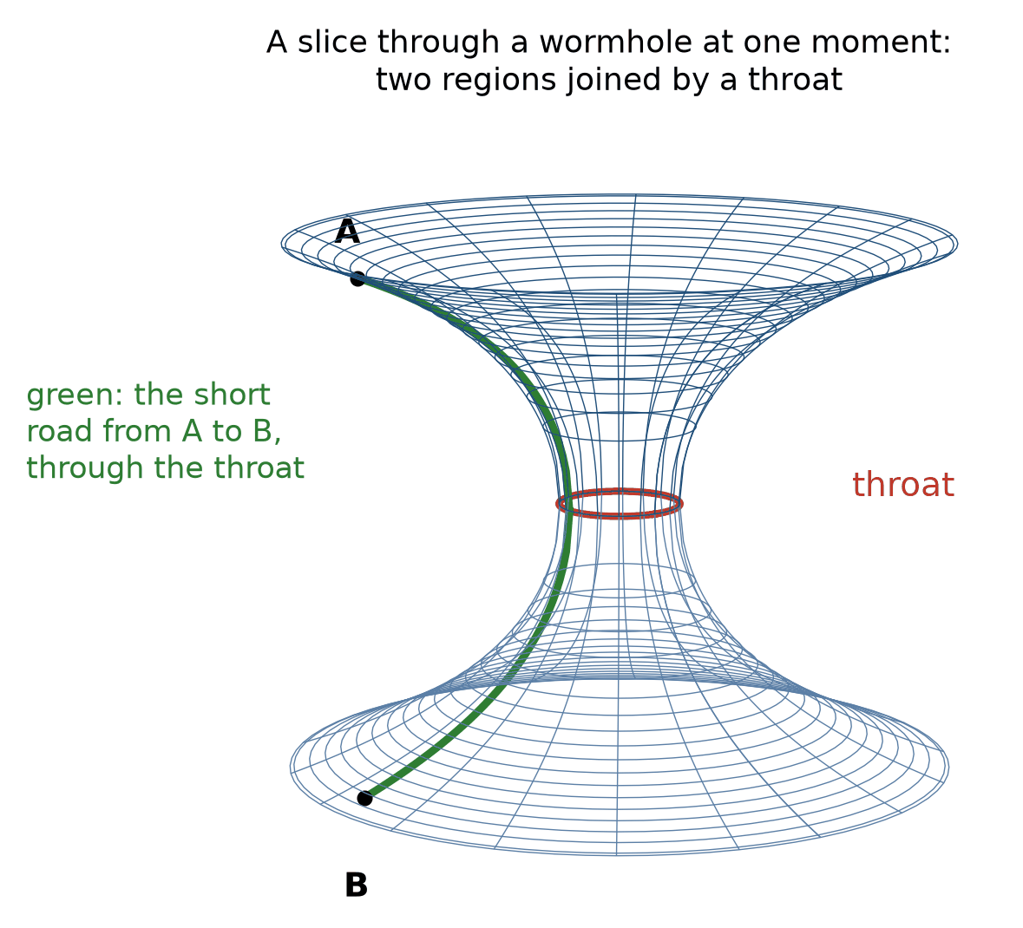
Two sheets joined by a throat: a slice through a wormhole geometry at one moment, drawn as a surface. A still picture, not a tunnel that stays open.
The funnel in the tides chapter was a dent in a sheet. The other popular surface looks like two trumpets joined at the mouth, and it is a picture of a wormhole, not of the Earth. Take a slice through the tunnel at one moment, keep two of the three directions of space, and draw it. Far away the surface is nearly flat. It narrows to a throat and opens again. A line along the long way is the long road. A line through the throat is the short road. That is the whole of the advertisement.
The advertisement omits the catch. The surface is a slice, frozen. The 1935 bridge of Einstein and Rosen does not sit there waiting: follow it in time and it pinches shut before a signal can cross. The traversable kind, written down by Michael Morris and Kip Thorne in 1988, stays open only if threaded with negative energy. The drawing does not supply the energy. It only shows the shape the energy would have to hold open.
That is a good place to stop. The apple let go is still the straight path. The ground is still the interruption. The bends travel, and we have heard them. What the geometry is, underneath, when quantum rules cannot be ignored, is the next book, and it has not been written yet. When it is, it will probably be harder, and it will still have to recover the apple.

Appendix A. The steps the argument needs
Each entry is one step: what it is, the detail, what to keep straight, and a check. Skip an entry only if you can already answer its check.

Light clock
What it is. Two mirrors and a flash. One round trip is one tick. On the train the flash chases the mirror, so the path is the long side of a right triangle.
The detail. Pythagoras on that triangle gives the factor 1 over the square root of 1 minus v squared over c squared. At 0.6c the factor is 1.25. At 0.8c it is 1.667. At walking speed it is 1 for every purpose a watch can serve.
Keep straight. The person carrying the clock does not feel a slow tick. The platform is comparing two paths.
Check. If both clocks are right, what were they disagreeing about? The slice, not the flash.

Simultaneity
What it is. Two events at different places can share a time label in one frame and not in another. The disagreement remains after you subtract the travel time of the light that brought the news.
The detail. A platform observer and a train observer who set their origins together will not draw the same ‘now’ line through a distant event. The tilt is vx/c squared in the time transformation.
Keep straight. This is not a broken clock. A broken clock is a fault in one instrument. This is two honest instruments and two slices.
Check. Can a change of frame reverse the order of two events in the same room, one after the other? No. Those two events are timelike, and their order is the same for everyone.

Spacelike and timelike
What it is. If the interval is dominated by the time part, a massive traveler can connect the events. If it is dominated by the space part, nothing that rides at or under the speed of light can connect them.
The detail. With c = 1 and the book’s sign convention (minus on time), events 4 seconds and 3 light-seconds apart have interval squared −16 + 9 = −7: negative, so timelike. Change the distance to 5 light-seconds and it becomes −16 + 25 = +9: positive, so spacelike. The sign is the question of whether a cause is possible.
Keep straight. A frame change can reorder only the spacelike pair. The timelike pair keeps its order for every inertial observer.
Check. Which pair can send a warning that arrives in time? Only the timelike pair, and only if the warning leaves early enough.

Velocity addition
What it is. A ball thrown forward at 10 meters a second from a train is not seen at train speed plus 10 by the platform, once the speeds are a serious fraction of light. The exact rule is (u+v) over (1+uv/c squared).
The detail. 0.6c and 0.6c do not add to 1.2c. They add to 0.882c. Light plus anything still gives light.
Keep straight. The old sum is the low-speed approximation. It is the right tool for a car. It is the wrong tool for a beam.
Check. Why does the platform not measure train speed plus c? Because c is the same number in both frames. That was the postulate.

Proper time
What it is. Proper time is the reading of an ideal clock that travels the path in question. It is the time in the interval when the clock’s own position does not change.
The detail. Two paths between the same parting and the same reunion need not carry the same proper time. The straight inertial path carries more. The path that turns around carries less.
Keep straight. Fuel is the wrong analogy. On a road the direct driver burns less fuel. In spacetime the straight path ages more.
Check. Which twin is younger, and why is the answer not ‘both’? Because only one path bent.

Geoid
What it is. Clocks at rest at sea level tick at the same rate. Faster spin at the equator is offset by greater distance from the center.
The detail. The sea settles on a surface of equal gravitational-plus-rotational potential. Greece and London, at sea level, share a rate. Only time spent in the air differs.
Keep straight. This is not a claim that every clock on Earth agrees. A clock on a mountain does not.
Check. Why does a harbor clock not need a latitude correction against another harbor clock? Because both sit on the geoid.

Equivalence limit
What it is. In a small room, for a short time, falling is indistinguishable from no gravity, and standing in a closed room is indistinguishable from being accelerated.
The detail. Two balls a kilometer apart fall slightly toward each other, both aiming at the center. No single accelerating room does that everywhere at once.
Keep straight. The principle was never a promise about the whole Earth. The mismatch is the tide: the part of gravity no falling room can hide.
Check. When does the disguise fail? When the room is large enough for the two paths to converge.

Field equation in words
What it is. The bend follows the stuff. Mass, pressure, and light are the stuff. In a kitchen, pressure and light are a whisper beside mass. Near a neutron star they are not.
The detail. The cosmological constant, if kept, is a little weight for empty space on the same line. It is not a third equation for the kitchen.
Keep straight. Newton’s pull remains the tool for a harbor and a probe. The new sentence is for clocks, light, and the last size.
Check. What is on the stuff side besides mass? Pressure and light.

Chandrasekhar limit
What it is. Past about 1.4 solar masses the electron refusal loses. Chandrasekhar worked the limit on the voyage to England. A meeting disliked it. The stars used it anyway.
The detail. A white dwarf fed past the limit by a companion does not sit at a new size. It detonates. That wreck is one of the lamps of the 1990s.
Keep straight. The limit is not a taste. It is the mass at which no size is stable.
Check. What happens if you add mass past the limit? Detonation, not a larger ember.

Mass gap
What it is. The heaviest neutron stars weighed sit near two solar masses. Black holes in the mergers start higher. A gap sits between.
The detail. The gap is an argument about the last size. A few merging objects have been weighed inside it, at about 2.5 to 4 Suns, so the gap may be a scarcity rather than an empty band. The argument is not closed.
Keep straight. A gap in a catalog is not a law by itself. It is a place to look harder.
Check. What would settle what the objects in the gap are? A measured size, or light from the merger, showing whether each is a neutron star or a black hole.

Horizon radius
What it is. The last outward path. For a hole that does not spin, about 3 kilometers times the mass in suns. The Earth at that size would be a marble. The Earth is not at that size.
The detail. The number is a comparison, not a forecast. A spinning hole has an ergosphere outside the horizon, where you cannot hover and can still leave.
Keep straight. A horizon is not a wall and not a funnel you fall down. The funnel is a drawing of a slice, and it hides the bend in time.
Check. How big would the horizon be if the Sun were squeezed into a black hole? About 3 kilometers in radius. The Sun will never be squeezed like that.

Shadow versus door
What it is. Light that would have skimmed the horizon is bent back. The dish sees a dark patch on hot gas, larger than the door.
The detail. M87, 2019: about 6.5 billion Suns, a horizon larger than the orbits of all the planets. Our own center, 2022: about 4 million Suns, already weighed by the star S2, followed for about thirty years around its sixteen-year orbit, with a reddening at closest approach.
Keep straight. The shadow is not the photon sphere, though they are related. The photon sphere is unstable. A nudge and the light falls in or climbs out.
Check. What did the dishes photograph, if nothing is there to knock on? A dark patch on hot gas.

Hawking temperature
What it is. The 1974 argument gives the horizon a temperature. Smaller holes are hotter. A stellar hole is colder than the microwave glow, so it is not shrinking.
The detail. The radiation has not been seen. The temperature is a result of the theory. Observing it is still an open bill.
Keep straight. A confident story about what happens to information that falls in is not a result. It is an open question.
Check. Has the glow been seen? No.

Ringdown
What it is. The last part of a chirp. The settled hole rings at the pitches its mass and spin allow, and no others.
The detail. If the pitches had been wrong, the rule would have failed in public. They were not wrong.
Keep straight. A ringdown is not a hum you could sing. It is the last part of the measured signal, fitted with the predicted pitches.
Check. What would a wrong pitch have meant? The rule, failed on that event.

Standard siren
What it is. A chirp used as a distance. The waveform itself gives the masses, so its strength gives the distance. The 2017 event was the first with a galaxy attached.
The detail. More of them will weigh the stretch beside the lamps. Two methods agreeing is the signature the sky can offer.
Keep straight. A siren is not a lamp. It does not need a known brightness. It needs only the waveform: the masses come from its shape, the distance from its strength.
Check. What does a siren measure that a lamp also measures? Distance, by another road.

Frame dragging
What it is. A mass that turns twists the geometry near it a little. Gravity Probe B watched gyroscopes drift against a guide star. The drift was tiny. The error bars were large. The twist was there.
The detail. The orbits of the laser-ranged satellites LAGEOS and LARES show the same drag. How precise those results are is still argued over.
Keep straight. Frame dragging is a real prediction, and it has been measured, though not yet very precisely.
Check. Has frame dragging been seen by more than one method? Yes: by gyroscopes in orbit and by satellite orbits.

Innermost orbit
What it is. There is a last place a stone can circle a hole without being committed. Inside that, the stone plunges. Nothing is built there. It is a property of the geometry.
The detail. For a hole that does not spin, that orbit sits at three times the door’s radius. Spin moves it.
Keep straight. An orbit near a hole does not close. Each lap swings around a little, as Mercury’s does, and near the last stable orbit the swing is large.
Check. What happens inside the last stable orbit? The stone plunges.

Andromeda slice
What it is. A small change of speed on this beach swings the ‘now’ slice at Andromeda across days. That is a statement about slices for events that cannot send news to each other.
The detail. It is not a telephone. No signal arrives early because your walk tilted a slice.
Keep straight. Penrose’s illustration is about simultaneity, not about messages.
Check. Can walking get a message to Andromeda faster? No.

Pulsar timing
What it is. Radio telescopes on several continents time dozens of pulsars as one clock, listening for a background of very low-pitched waves from pairs of giant black holes. In 2023 several groups reported evidence for a common murmur.
The detail. If it holds, the bends are not only chirps. They are a weather. The check is whether the groups agree after the next years of timing.
Keep straight. A murmur is not yet a chirp with a name and a mass.
Check. What would promote the murmur? Agreement that survives the next data.

Two supernovae and a kilonova
What it is. Two different wrecks carry the name supernova. A white dwarf fed past its limit detonates and is destroyed. A massive star’s core collapses and may leave a neutron star or a black hole. A third wreck, two neutron stars merging, makes a kilonova, a light ten to a hundred times fainter than a supernova that fades in days.
The detail. A nova, without the super, is a flare on a white dwarf that does not destroy it. The words sit next to each other in the language and do not sit next to each other in the sky.
Keep straight. The 2017 merger was a kilonova, not a supernova.
Check. Which wreck needs a companion to push it past the limit? The white dwarf.

Appendix B. The worked numbers
Three tables carry most of the arithmetic in the chapters. Each starts with one row worked in full, so you can check any other row the same way.

Speed: the factor, the sum, and the interval
Worked row, 0.6c. The factor is 1/√(1 − 0.36) = 1/0.8 = 1.25. Two speeds of 0.6c combine to (0.6 + 0.6)/(1 + 0.36) = 0.882c. For a traveler at 0.6c covering 0.6 light-seconds in 1 second, the interval squared is −1 + 0.36 = −0.64 (light-seconds squared): negative, so timelike, and the traveler’s clock reads √0.64 = 0.8 s.
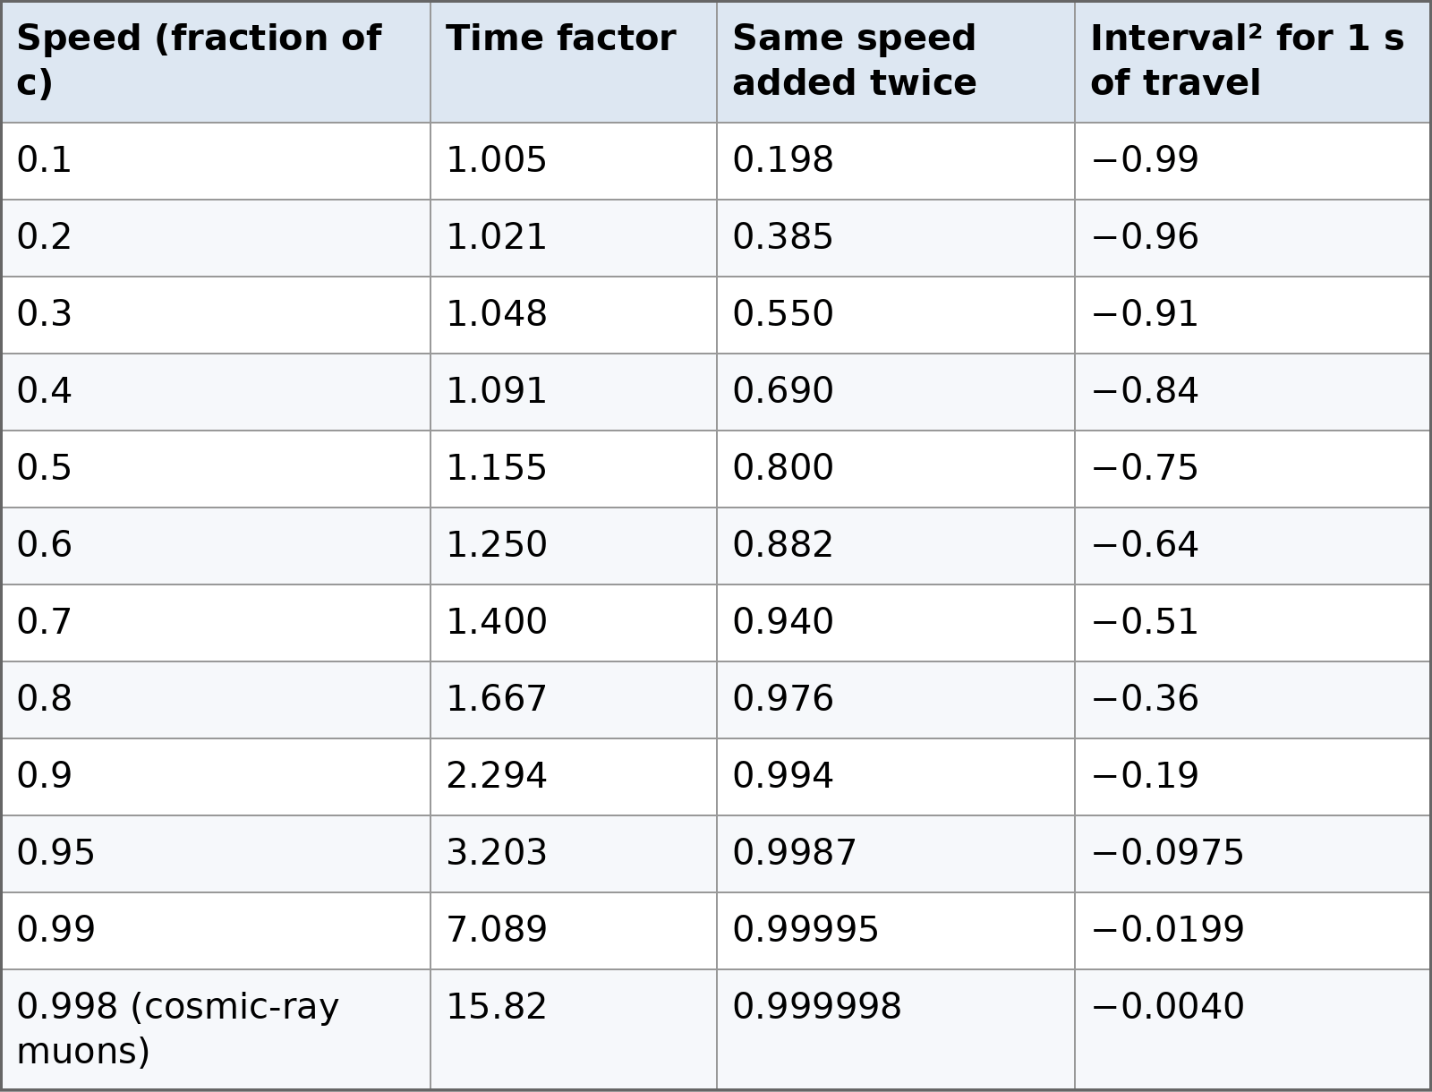

Mass: where the horizon sits
Worked row, 10 Suns. The horizon radius is 2GM/c². For one Sun, 2GM/c² = 2 × 1,477 m = 2.95 km. For ten Suns, 29.5 km. The radius grows in direct proportion to the mass.
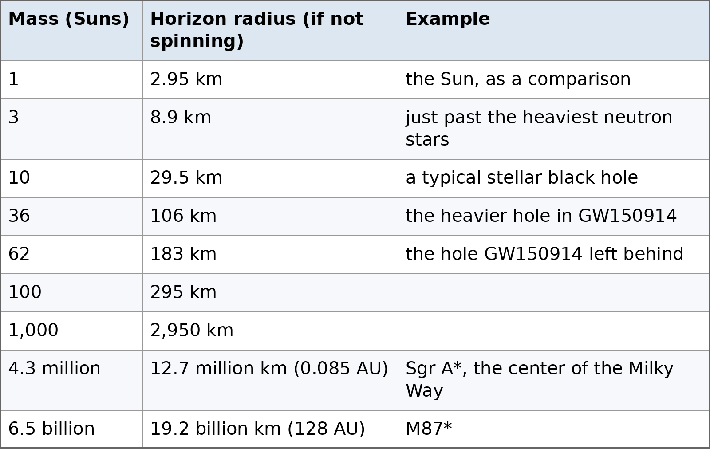

Height: how much faster a higher clock runs
Worked row, a GPS satellite. The height term is (GM/c²)(1/R − 1/r), with GM/c² = 4.435 mm for the Earth, R = 6,371 km, and r = 6,371 + 20,200 = 26,571 km. That is 5.29 × 10⁻¹⁰, or 45.7 µs a day. For an orbit, subtract the speed term v²/2c², which is 7.2 µs a day at GPS speed. For a tower or a mountain, gh/c² gives the same answer as the exact formula. For an orbit it does not, because g weakens with height.
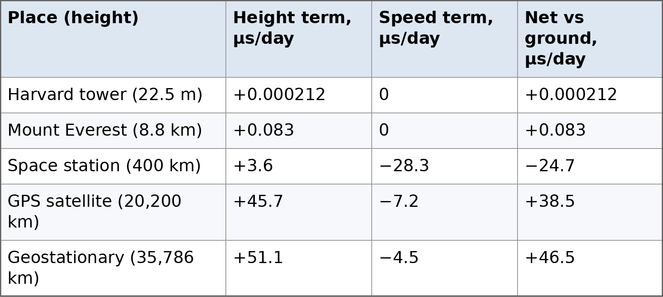

Ground clocks are taken at rest at sea level. The Earth’s own rotation is ignored, which changes the last digits but not the pattern: low orbits run slow, high orbits run fast.

The budget, as numbers
Quantity — Value — Where it appears
Ordinary matter
Value: about 5 percent
Where it appears: stars, gas, planets, people
Dark matter
Value: about 27 percent
Where it appears: extra bend, no identified owner
Dark energy
Value: about 68 percent
Where it appears: the label on the speedup
Microwave glow today
Value: 2.725 K
Where it appears: the cooled early light
Smoothness of the glow
Value: 1 part in 100,000
Where it appears: the seeds of galaxies
Andromeda
Value: about 2.5 million light-years, approaching at about 110 km/s
Where it appears: local pull beating the stretch
Moon’s retreat
Value: about 3.8 cm a year
Where it appears: the tide’s other bill

Appendix C. Experiments with their own numbers
Each entry is an experiment or observation the chapters lean on, with its number and the one point to keep.

Michelson and Morley, 1887
An interferometer in Cleveland looked for a change in the speed of light with the Earth’s motion through a supposed ether. The change was not there, to the precision of the instrument.
The null is a fact. The interpretation took years. Einstein’s 1905 postulates make the null the expected result, not a puzzle to be patched with a dragged ether.
A null is a measurement. It rules out the sizes of effect the instrument could have seen.

Rossi and Hall, 1941
They counted cosmic-ray muons at Echo Lake, near Mount Evans in Colorado, and in Denver, about 1,600 meters lower. More survived the descent than a 2.2-microsecond life allows without time dilation.
The 1963 measurement by David Frisch and James Smith, on Mount Washington, is the cleaner classroom version. Rossi and Hall’s wartime one came first.
The first experiment and the clearest one are both worth citing.

Gravity Probe A, 1976
Robert Vessot and Martin Levine flew a hydrogen maser on a rocket to about 10,000 kilometers and compared it with a maser on the ground.
The height term matched the prediction to about 70 parts in a million of the effect.
A clock on a rocket is the tower experiment with a much taller tower.

Galileo satellites, 2014
Two navigation satellites were launched into elliptical orbits by mistake. The eccentricity made a clean test of the height and speed terms.
The clocks confirmed both terms as the rule requires.
An accident can be a better experiment than a plan, if the orbit is known.

The star S2
The star’s period is about 16 years. Closest approach is about 120 astronomical units from the dark mass. In 2018 the reddening at that pass matched the rule, and in 2020 the GRAVITY team reported that the orbit swings forward by the amount the rule requires, about 12 minutes of arc per orbit.
The mass is about 4 million suns.
The orbit gives the mass. The reddening tests how clocks run near it.

EHT 2019 mass
The M87 shadow gives a mass consistent with the gas-dynamical and stellar weighs, about 6.5 billion suns.
Consistency is the result. A shadow that had demanded a different mass would have been a crisis.
The dark patch is larger than the horizon: about 5.2 horizon radii across for a hole that does not spin. Leave out that factor and the mass comes out about 2.6 times too large.

EHT 2022
Sagittarius A* varies while you look. The 2022 image is an average over that fidget. The mass matches the stellar orbits.
A changing source blurs the picture. It does not change the mass.
The gas around our own black hole flickers within minutes.

Cygnus X-1
A bright X-ray source in a binary. The mass of the dark partner sits above the neutron-star range.
It was the first widely accepted stellar hole. The bet, a magazine subscription, is color. The mass is the result.
The bet is a story. The orbit is the measurement.

GW170817 distance
About 40 megaparsecs, 130 million light-years, from the waves, with a galaxy attached.
That attachment is what makes a siren. A chirp without a galaxy is a distance with a larger error.
The galaxy is NGC 4993. The name is the check against a vague ‘somewhere’.

GW150914 frequency
The note rose from about 35 hertz to about 250 hertz in a fraction of a second.
Those frequencies are inside the range of human hearing, low and faint. The public audio is usually shifted up so a small speaker can play it. The graph is not shifted.
If you can hum it, it has been shifted in pitch. Say so when you play it.

Oppenheimer and Snyder, 1939
They followed a pressureless collapse and found a horizon. The paper went quiet in the war.
The idealization is pressureless. The conclusion, that past a last size the geometry wins, survived better models.
A simplified star is a tool. Name the simplification.

Penrose, 1965
A theorem: under reasonable conditions, collapse ends in a singularity, meaning a path that cannot be continued.
A singularity is the map running out, not a place with a furniture of infinite density that you could visit and describe.
The theorem is classical. Quantum gravity may amend the map. It has not yet.

Lunar laser ranging
The round trip to the mirrors left by Apollo crews is timed well enough to give the distance to a few millimeters. The Moon recedes about 3.8 centimeters a year.
The recession is the tide, angular momentum leaving the spin of the Earth and entering the orbit.
The measurement needs only the mirrors, not the history of the landings.

Optical clocks
Clocks based on optical transitions now beat caesium for stability. Comparisons between them see the height difference of a centimeter.
Comparing two clocks can now measure a difference in height.
Over a human lifetime these differences remain far too small to notice.

Appendix D. Short essays

Einstein synchronization
To compare clocks at different places you need a rule. The usual rule sends a light signal out and back and sets the far clock so the one-way trip is half the round trip. The round trip is measured. The split is chosen. A different split can be written. The two-way speed of light stays c. The one-way split is the convention. The navigation satellites use a defined time and a defined split. The map works because the convention is held fixed and the two relativistic rates are corrected. The convention is not the correction. Both are required.

The stress that gravitates
Energy density is the familiar source. Momentum, pressure, and shear are sources too. A single particle of light has no rest mass, yet a box full of light weighs more than the empty box, and it bends the geometry, because the light carries energy and pressure. Inside a neutron star the pressure that keeps the star from collapsing is itself a source of the bend that is trying to collapse it. That is why pushing harder is not a strategy past the last size: the push joins the load. In the solar system these extra sources are tiny beside mass, which is why Newton remains the tool for a probe. Mercury’s extra 43 seconds of arc a century do not come from them. They come from the shape of the geometry outside the Sun itself, where space is slightly curved and the rule’s corrections to Newton grow as Mercury swings close.

Light bending, the factor of two
A Newtonian particle picture of light, if you force one, gives half the deflection the 1915 rule gives. Einstein published the half, doubted it, and the full rule doubled it. The eclipse expeditions were looking for the doubled number. The plates were rough. The radio measurements of quasars are not. The doubled number is the one that survives. A popular account that still quotes the half has not reached 1915. The bend is also a lens. A galaxy in front of a quasar can split the image. The split is a weighing. Where the bend exceeds the luminous mass, the maps draw the extra.

LIGO, what the arm measures
Each arm is four kilometers. A passing bend changes the two arms differently, by a fraction of a proton’s width, a few thousandths in the 2015 event. The light in the arms reports the difference. The instrument does not hear a sound. It records a strain. The sound online is the strain shifted into a speaker. Shifting the pitch makes it audible. It does not change the measurement. Two sites, seven milliseconds apart, are the check against a local bang. A magnet in one building does not arrive at the other on a light-travel delay. The delay is why there are two sites.

Core collapse
A massive star holds itself up by heat from fusion. When the fuel that holds the core runs out, the core falls. If the fall halts on the neutron refusal, a neutron star can remain and the envelope can be thrown off in a supernova. If the core is heavier, the halt does not come, and the remnant is a horizon. The thrown envelope seeds the gas with the elements the star made. Most of the iron around you came from wrecks like this and from white-dwarf detonations. Much of the gold came from rarer neutron-star mergers.

Appendix E. Review questions, with answers
Cover the answer, say yours, then check. If you cannot answer, the section named in the chapter is where to go back.
Why does the scale show a number if nothing is pulling the apple down? Because the scale is the floor, and the floor is pushing up. The number is the push. Step off and the number goes. The Earth did not leave.
Why do astronauts float if gravity up there is still most of what it is on the ground? Because the station is falling, and they are falling with it. The floor falls with them, so nothing presses. They are not escaping. They keep falling around the Earth and missing it.
Why did the heavy ball and the light ball keep the same pace? Because the falling does not consult the mass, once the air is out of it. That is why the apple in the elevator has nothing left to do. If heavy and light had disagreed, the floor would not have been the whole story.
What is the interval, in one sentence? The mix of a time separation and a space separation, with a minus on the time. Space adds. Time subtracts. Two people in motion cut that mix on different slants. Both clocks are right about themselves.
Why is “time slows down” a bad sentence? Because the person carrying the clock does not feel a slow second. The second is a second. The disagreement appears when you compare that clock with one that took another route. The comparison is the result. The feeling is not.
Why does the phone need the correction? A satellite clock is high, so it runs fast against a pavement clock, and it is moving, so it runs slow. The fast wins, by about thirty-eight millionths of a second a day. Light covers about eleven kilometers in that leftover. Leave it out and the pin walks.
Why two high tides? The near water is pulled a little harder than the Earth under it. The Earth is pulled a little harder than the far water. Two bulges. A string from the Moon would give one. Tide tables have recorded the pattern for centuries.
What did the leftover turn in Mercury’s orbit measure? Forty-three seconds of arc a century, left over after the other planets were included. A second of arc is a coin at a few kilometers. The geometry near the Sun produces it. Vulcan was the patch. The patch was empty.
What is the field equation, in one sentence? The bend follows the stuff. Mass, pressure, and light are the stuff. In a kitchen, pressure and light are a whisper beside mass. Near a neutron star they are not.
Why is a white dwarf dim and hot? The fuel is gone. What holds it is the refusal of electrons to share a state. Sirius B has a Sun’s mass in an Earth’s volume. The light has a small surface to leave from. Dim is not cold.
What happens past about 1.4 Suns? The electron refusal loses. A white dwarf fed past that limit does not sit down at a new size. It detonates. That wreck is one of the lamps the 1990s teams used.
What is a pulsar? A neutron star, spinning, a lighthouse the size of a city. The first one was a scruff on chart paper, 1.337 seconds, too steady for the joke about little green men. A second scruff retired the joke.
Why is there a gap between neutron stars and black holes? The heaviest neutron stars we have weighed sit near two Suns. We have not found one at three. Past the last refusal, pressure itself gravitates, and the quarrel ends in a horizon.
What is a horizon? The last outward path. Not a wall. For a hole that does not spin, about three kilometers times the mass in Suns. The Earth at that size would be a marble. The Earth is not at that size. The number is a comparison.
Why is the shadow larger than the door? Light that would have skimmed the horizon is bent back. The dish sees a dark patch on hot gas. M87, 2019, about six and a half billion Suns. Our center, 2022, four million Suns, already weighed by the star S2.
Has Hawking radiation been seen? No. The temperature is a result in the theory. A stellar hole is colder than the microwave glow, so it is not shrinking. No one has observed it yet.
What is a white hole? The film run backward. A door that only exits. Nothing in the catalog has behaved like one.
What would keep a throat open? Negative energy, in bulk, which we do not have. The 1935 bridge pinches shut before a signal can cross. The drawing does not supply the energy.
What are the three things called a multiverse? Inflating pockets, with no door between them. A landscape of possible laws. Quantum branches, which are not another gravity. One word, three proposals, no detection.
Why were the lamps too faint? Everyone expected the stretch to slow, because mass pulls. Two teams found the lamps farther than a slowing stretch allows. The label is dark energy. The simplest tenant is a constant. Why that little, and not the enormous value the quantum rules suggest, is unanswered.
What is dark matter, as a measurement? Extra bend. Galaxies spin too fast at the edge. Clusters bend light too strongly. In the Bullet Cluster two clusters passed through each other, the gas stayed in the middle, and the extra bend traveled with the galaxies. No detector has yet caught a dark-matter particle.
What did the mailbox catch in 2015? The same rising note at two sites, seven milliseconds apart. Two holes, about thirty-six and twenty-nine Suns. At the peak, the two arm lengths differed by a few thousandths of a proton’s width. They spent months trying to kill it. In February 2016 it was still alive.
Why is the online sound not the measurement? It was shifted into a speaker’s range. The real signal is low, near the bottom of human hearing, and faint. The graph is the result. The speaker is a courtesy.
What arrived 1.7 seconds after the 2017 ripple? Gamma rays, then a point of light that faded through the colors of heavy-element debris. One hundred and thirty million years on the road. Theories in which gravity and light travel at different speeds were ruled out.
What is a standard siren? A chirp used as a distance. The waveform itself gives the masses, so its strength gives the distance. The 2017 event was the first with a galaxy attached. More of them will weigh the stretch beside the lamps.
What is a ringdown? The settled hole, ringing at the pitches its mass and spin allow, and no others. If the pitches had been wrong, the rule would have failed in public.
What is the photon sphere? The place outside a horizon where light can orbit. Unstable. A nudge and the light falls in or climbs out. The shadow is related to it and is not it.
Why is spaghettification the wrong picture for a giant hole? The tide at a small horizon is lethal. At a giant horizon you can cross without a drama in the feet. The tide becomes lethal later, farther in. The popular picture has the sizes backward.
What should you leave on the shelf? A seen white hole. A road through a throat. A multiverse detection. A grain of space. A frozen river offered as a measurement. Time declared absent. An Omega Point offered as a result. The apple and the floor do not go on that shelf. They have been weighed by a scale, a tower, a phone, a harbor, a chart, a dish, and a mailbox.

Glossary
Black hole. A region where every outward path has disappeared. The boundary is the horizon. Not a pit, and not a surface you could knock on.
Chandrasekhar limit. The largest mass a white dwarf can have, about 1.4 times the Sun. Past it, the electrons’ refusal to be packed cannot hold the star up.
Cosmological constant. A steady weight of empty space, written into Einstein’s rule as one extra number. The simplest candidate for dark energy.
Curvature. The failure of nearby straight paths to stay parallel. Tides are curvature you can see. The floor’s push is not.
Dark energy. The name for whatever makes the stretch of the universe speed up. A label, not an explanation.
Dark matter. Extra gravity, mapped by how galaxies spin and how light bends, with no identified substance yet.
Embedding diagram. A drawing of a slice of curved space as a surface, so that distances along the surface match real ruler distances. The extra direction it bends into is not real, and nothing rolls down it.
Equivalence. In a small falling room, for a short time, physics looks like physics with no gravity. The floor’s push is what we feel as weight.
Ergosphere. The region outside a spinning black hole where nothing can sit still relative to the distant stars. You can still escape it. You cannot hover in it.
Geodesic deviation. How the gap between two nearby free paths speeds up or slows down. The textbook name for the tide, and the working definition of curvature.
Geodesic. The straightest path the geometry allows. In spacetime it is the path of most proper time. Freely falling things follow geodesics.
Geoid. The surface of equal gravitational-plus-rotational potential that the sea settles on. Clocks at rest on it tick at the same rate.
Gravitational wave. A passing change in distances, traveling at the speed of light. Not a wobble in a substance.
Hawking radiation. The argument that a horizon has a temperature and leaks. Predicted in 1974. Not yet seen.
Horizon. The last place from which an outward path exists. From far away, a falling clock seems to fade there and never cross.
Innermost stable orbit. The smallest circular orbit a stone can keep around a black hole: three horizon radii for one that does not spin. Inside it, the stone plunges.
Interval. The mix of time and distance that two observers agree on. The first equation in this book. The minus sign is the point.
Kilonova. The glow after two neutron stars, or a neutron star and a black hole, merge. Radioactive debris making heavy elements. Ten to a hundred times fainter than a supernova. First seen with certainty in 2017.
Kruskal–Szekeres map. A map of the geometry around a non-spinning hole on which light always runs at 45 degrees. The horizon is a plain diagonal, and the singularity is a moment ahead, not a place.
Light cone. The set of paths light can take from, or to, an event. Everything that can affect you, or that you can affect, lies inside it.
Local inertial frame. A small, freely falling room, used for a short time, inside which the flat rules of special relativity hold to the accuracy of your instruments. Also called a local Lorentz frame or a free-float frame.
Maximal aging. Taylor and Wheeler’s name for the rule that a free clock, between two meetings, takes the path on which it ages the most.
Neutron star. A city-sized star held up by the refusal of neutrons to be packed tighter. The last size before collapse, if the mass is not too high.
Omega Point. Teilhard’s name for a culmination of evolution. Tipler’s name for a final cosmological state of unlimited processing. Not a result in this book.
One-form. A gradient pictured as a stack of surfaces. The number of surfaces an arrow crosses is the change along that arrow.
Photon sphere. The radius, 1.5 times the horizon radius for a hole that does not spin, where light can circle the hole. The circle is unstable.
Proper time. The time a clock measures along its own path. The straight path is the one with the most of it.
Pulsar. A spinning neutron star whose radio beam sweeps past the Earth like a lighthouse beam, so it appears as a regular beep.
Redshift. Light stretched to a longer wavelength. Motion can do it. A bend in time can do it. The expansion of space can do it. Three causes, one word. Ask which.
Reduced circumference. The r in the geometry around a black hole: the circumference of a shell divided by 2π. It labels the shell. It is not a distance from the center.
Shell observer. An observer held at fixed r around a black hole, with a local ruler and clock. Shell rulers find more distance between shells than the difference in r, and shell clocks run slow.
Spacetime. Space and time treated as one geometry. The interval is how you measure a step in it.
Standard siren. A gravitational-wave event used to measure distance: the waveform gives the masses, and its strength gives the distance.
Strain. The fractional change in length that a gravitational wave causes, a pure number. LIGO’s first signal peaked at about 10⁻²¹.
Supernova. A star destroyed in public. Two kinds: a white dwarf pushed past its limit detonates, or a massive star’s core collapses. A neutron-star merger is not a supernova. Its light is a kilonova.
Tide. The part of gravity that changes from head to foot. Falling does not cancel it. It is the real curvature.
White dwarf. An Earth-sized ember held up by the refusal of electrons to share a state. Unstable past about 1.4 solar masses. More weight, smaller star.
White hole. The time-reverse of a black hole in the mathematics: a door that only exits. Unseen. Unstable in any realistic story.

Further reading and sources
The books are for the next read. The papers are the measurements this book relies on.

Books
Barbour, Julian. The End of Time: The Next Revolution in Physics. Oxford University Press, 1999. Time as not fundamental: only configurations and records. A proposal.
Carroll, Sean. The Biggest Ideas in the Universe: Space, Time, and Motion. Dutton, 2022. The symbols behind this book’s two equations.
Einstein, Albert. Relativity: The Special and the General Theory. 1916 and later editions. The author’s own short account.
Geroch, Robert. General Relativity from A to B. University of Chicago Press, 1978. A short geometric book, harder than this one and still free of machinery.
Greene, Brian. The Fabric of the Cosmos: Space, Time, and the Texture of Reality. Knopf, 2004. The weave, the frozen river, the low-entropy beginning.
Hartle, James B. Gravity: An Introduction to Einstein’s General Relativity. Addison-Wesley, 2003. The first textbook to open after this one.
Hawking, Stephen. A Brief History of Time. Bantam, 1988. The singularity theorems, the glow of a horizon, and the arrows of time.
Misner, Charles W., Kip S. Thorne, and John Archibald Wheeler. Gravitation. W. H. Freeman, 1973; Princeton University Press, 2017. The graduate book this one is not, and the source of several of its teaching ideas: the ants on the apple, the two tracks, local Lorentz frames, geodesic deviation, one-forms as stacks of surfaces, embedding diagrams, and the Kruskal–Szekeres map.
Panek, Richard. The Trouble with Gravity. Houghton Mifflin Harcourt, 2019. A magnet beats the Earth, and we still do not know what gravity is.
Rovelli, Carlo. Reality Is Not What It Seems. Allen Lane, 2016. Loop quantum gravity as a candidate. Untested.
Schutz, Bernard. Gravity from the Ground Up. Cambridge University Press, 2003. Phenomena first, with more numbers than this book.
Taylor, Edwin F., and John Archibald Wheeler. Spacetime Physics: Introduction to Special Relativity. 2nd ed. W. H. Freeman, 1992. The parable of the surveyors, the free-float frame, the pole and the barn, and light-cone diagrams.
Taylor, Edwin F., and John Archibald Wheeler. Exploring Black Holes: Introduction to General Relativity. Addison Wesley Longman, 2000. A second edition, with Edmund Bertschinger, is free online. Shell observers, the bookkeeper, the raindrop, and black-hole numbers done with algebra.
Teilhard de Chardin, Pierre. The Phenomenon of Man. 1955; English 1959. The Omega Point as a culmination of evolution.
Thorne, Kip S. Black Holes and Time Warps: Einstein’s Outrageous Legacy. W. W. Norton, 1994. The long popular account by one of the three.
Tipler, Frank J. The Physics of Immortality. Doubleday, 1994. A cosmological Omega Point. A proposal.
Tyson, Neil deGrasse. Astrophysics for People in a Hurry. W. W. Norton, 2017. The cosmic budget, told fast.
Wheeler, John Archibald. A Journey into Gravity and Spacetime. Scientific American Library, 1990. Wheeler’s own short book: gravity as curvature in plain words, the boomerang through the Earth, and the two-way grip of mass and spacetime.
Wheeler, John Archibald, with Kenneth Ford. Geons, Black Holes, and Quantum Foam: A Life in Physics. W. W. Norton, 1998. Wheeler’s memoir, with his own account of the spacetime-and-matter slogan.

Papers and measurements
Abbott, B. P., et al. “GW170817: Observation of Gravitational Waves from a Binary Neutron Star Inspiral.” Physical Review Letters 119, 161101 (2017).
Abbott, B. P., et al. (LIGO and Virgo). “Observation of Gravitational Waves from a Binary Black Hole Merger.” Physical Review Letters 116, 061102 (2016). GW150914.
Agazie, G., et al. (NANOGrav). “The NANOGrav 15 yr Data Set: Evidence for a Gravitational-wave Background.” The Astrophysical Journal Letters 951, L8 (2023).
Ashby, Neil. “Relativity in the Global Positioning System.” Living Reviews in Relativity 6, 1 (2003).
Baez, John C., and Emory F. Bunn. “The Meaning of Einstein’s Equation.” American Journal of Physics 73, 644 (2005). The shrinking ball of crumbs in chapter 4.
Chandrasekhar, Subrahmanyan. “The Maximum Mass of Ideal White Dwarfs.” The Astrophysical Journal 74, 81 (1931).
Chou, C. W., D. B. Hume, T. Rosenband, and D. J. Wineland. “Optical Clocks and Relativity.” Science 329, 1630 (2010). Clock rates differing over 33 centimeters of height.
Clowe, D., et al. “A Direct Empirical Proof of the Existence of Dark Matter.” The Astrophysical Journal Letters 648, L109 (2006). The Bullet Cluster.
Delva, P., et al. “Gravitational Redshift Test Using Eccentric Galileo Satellites.” Physical Review Letters 121, 231101 (2018).
Event Horizon Telescope Collaboration. “First M87 Event Horizon Telescope Results. I. The Shadow of the Supermassive Black Hole.” The Astrophysical Journal Letters 875, L1 (2019).
Event Horizon Telescope Collaboration. “First Sagittarius A* Event Horizon Telescope Results. I.” The Astrophysical Journal Letters 930, L12 (2022).
Flamm, Ludwig. “Beiträge zur Einsteinschen Gravitationstheorie.” Physikalische Zeitschrift 17, 448 (1916). The first embedding of the Schwarzschild slice.
Frisch, D. H., and J. H. Smith. “Measurement of the Relativistic Time Dilation Using μ-Mesons.” American Journal of Physics 31, 342 (1963).
GRAVITY Collaboration. “Detection of the Schwarzschild precession in the orbit of the star S2 near the Galactic centre massive black hole.” Astronomy & Astrophysics 636, L5 (2020).
Hafele, J. C., and R. E. Keating. “Around-the-World Atomic Clocks: Predicted Relativistic Time Gains” and “Observed Relativistic Time Gains.” Science 177, 166 and 168 (1972).
Hawking, S. W. “Black Hole Explosions?” Nature 248, 30 (1974).
Herrmann, S., et al. “Test of the Gravitational Redshift with Galileo Satellites in an Eccentric Orbit.” Physical Review Letters 121, 231102 (2018).
Hewish, A., S. J. Bell, J. D. H. Pilkington, P. F. Scott, and R. A. Collins. “Observation of a Rapidly Pulsating Radio Source.” Nature 217, 709 (1968).
Hubble, Edwin. “A Relation between Distance and Radial Velocity among Extra-Galactic Nebulae.” Proceedings of the National Academy of Sciences 15, 168 (1929).
Hulse, R. A., and J. H. Taylor. “Discovery of a Pulsar in a Binary System.” The Astrophysical Journal Letters 195, L51 (1975).
Klotz, Alexander R. “The gravity tunnel in a non-uniform Earth.” American Journal of Physics 83, 231 (2015). About 38 minutes through the real Earth.
Kruskal, M. D. “Maximal Extension of Schwarzschild Metric.” Physical Review 119, 1743 (1960).
Lemaître, Georges. “Un Univers homogène de masse constante et de rayon croissant rendant compte de la vitesse radiale des nébuleuses extra-galactiques.” Annales de la Société Scientifique de Bruxelles A47, 49 (1927).
Morris, Michael S., and Kip S. Thorne. “Wormholes in spacetime and their use for interstellar travel.” American Journal of Physics 56, 395 (1988).
Oppenheimer, J. R., and H. Snyder. “On Continued Gravitational Contraction.” Physical Review 56, 455 (1939).
Penrose, Roger. “Gravitational Collapse and Space-Time Singularities.” Physical Review Letters 14, 57 (1965).
Penzias, A. A., and R. W. Wilson. “A Measurement of Excess Antenna Temperature at 4080 Mc/s.” The Astrophysical Journal 142, 419 (1965).
Perlmutter, S., et al. “Measurements of Ω and Λ from 42 High-Redshift Supernovae.” The Astrophysical Journal 517, 565 (1999).
Planck Collaboration. “Planck 2018 Results. VI. Cosmological Parameters.” Astronomy & Astrophysics 641, A6 (2020). The expansion rate from the microwave glow.
Pound, R. V., and G. A. Rebka, Jr. “Apparent Weight of Photons.” Physical Review Letters 4, 337 (1960).
Riess, A. G., et al. “Observational Evidence from Supernovae for an Accelerating Universe and a Cosmological Constant.” The Astronomical Journal 116, 1009 (1998).
Riess, A. G., et al. “A Comprehensive Measurement of the Local Value of the Hubble Constant with 1 km s⁻¹ Mpc⁻¹ Uncertainty from the Hubble Space Telescope and the SH0ES Team.” The Astrophysical Journal Letters 934, L7 (2022). The expansion rate measured nearby.
Rossi, Bruno, and David B. Hall. “Variation of the Rate of Decay of Mesotrons with Momentum.” Physical Review 59, 223 (1941).
Szekeres, G. “On the Singularities of a Riemannian Manifold.” Publicationes Mathematicae Debrecen 7, 285 (1960).
Vessot, R. F. C., et al. “Test of Relativistic Gravitation with a Space-Borne Hydrogen Maser.” Physical Review Letters 45, 2081 (1980). Gravity Probe A.
Weisberg, J. M., and Y. Huang. “Relativistic Measurements from Timing the Binary Pulsar PSR B1913+16.” The Astrophysical Journal 829, 55 (2016). The accumulated shift of the orbit.

Where the teaching ideas come from
These sections retell a teaching idea from another book in new words. Nothing is quoted beyond a few words, and the diagrams are new.
How to read the labels: the two tracks of Misner, Thorne, and Wheeler’s Gravitation (1973).
The ant on the apple; What a small room can hide: Gravitation, chapter 1; the free-float frame from Taylor and Wheeler’s Spacetime Physics (1992); Wheeler’s slogan as in A Journey into Gravity and Spacetime (1990) and Geons, Black Holes, and Quantum Foam (1998).
The surveyors; The twin, told carefully; The pole in the barn; Light is the edge: Taylor and Wheeler, Spacetime Physics.
Two crumbs falling side by side: geodesic deviation as in Gravitation; the volume picture from Baez and Bunn (2005).
A boomerang through the Earth: Wheeler, A Journey into Gravity and Spacetime.
The other equation: Wheeler’s slogan; Baez and Bunn. Stacks of surfaces: the pictures of one-forms and tensors in Gravitation.
The bookkeeper and the shell observers: Taylor, Wheeler, and Bertschinger, Exploring Black Holes. Drawing the slice: Flamm (1916) and the embedding diagrams of Gravitation. A better map: Kruskal (1960), Szekeres (1960), and Gravitation.
A ruler shorter than a proton (the ring of crumbs): the wave chapter of Gravitation.
Exercises 1.6, 2.7, 2.8, 3.6, 3.8, 4.10, 7.5, 7.6, and 7.9 are set in the style of these books, with new numbers.

Picture credits
Diagrams (two ants, light clock, two surveyors, light cone, tidal stretching, the sheet and the clock-rate curve, stack of clock-rate surfaces, GPS clock budget, gravitational lensing, slice of space around a black hole, Kruskal map, LIGO layout, slice through a wormhole) and the three number tables: drawn for this book with Python plotting scripts. The ants, surveyors, stack, slice, and Kruskal diagrams illustrate teaching ideas from Taylor and Wheeler and from Misner, Thorne, and Wheeler, drawn new. They are not copies of those books’ figures.
Fruit floating in the International Space Station, chapter 1: NASA photo ISS038-E-043011, 6 February 2014, showing astronaut Rick Mastracchio. Public domain under NASA’s media usage guidelines; NASA does not endorse this book. Source: NASA Image and Video Library.
M87* black hole, chapter 7: Event Horizon Telescope Collaboration, 2019. Licensed under Creative Commons Attribution 4.0 International (CC BY 4.0). Source: Wikimedia Commons, “Black hole - Messier 87 crop max res.jpg”, cropped and resized.
Bullet Cluster, chapter 6: X-ray: NASA/CXC/CfA/M. Markevitch et al.; optical: NASA/STScI, Magellan/U. Arizona/D. Clowe et al.; lensing map: NASA/STScI, ESO WFI, Magellan/U. Arizona/D. Clowe et al. NASA release STScI-2006-39, public domain. Source: Wikimedia Commons, resized.
Covers: drawn for this book with Python scripts, a falling apple on a spacetime grid. No photographs and no AI image generators were used.

Thank you for reading
If this book gave you something, a laugh, an idea, or a better question, I’d love to hear about it. A short review on Amazon, even a sentence or two, helps other curious readers find it, and I read every one.

About the Author
Lothar J. Musiol is a graduate of Munich University of Applied Sciences who spent more than forty years in the semiconductor industry, first at Germany’s largest company in the field, then at a string of American start-ups. He studied physics alongside all of it, seriously enough to know exactly how much he is simplifying. Dual citizenship, put to its most sensible use, lets him split his time between San Clemente, California, and Passau, Bavaria, where Austria begins at the garden fence. The household includes one married daughter, one grumpy Teacup Pomeranian named Gucci, and eleven chickens, listed in order of seniority rather than volume.
He writes to make complex ideas clearer and more engaging than most treatments manage, without ever pretending they are simpler than they actually are.

Also by Lothar J. Musiol
Physics, Actually
- Physics, Actually, Volume 1: Motion, Forces, Time, and Relativity
- Physics, Actually, Volume 2: Gravity, Cosmology, and the Limits of Spacetime
- Physics, Actually, Volume 3: The Standard Model, Chaos, and the Edge of Knowledge
- Life, Actually: From the First Cell to the Edited Genome and the Search for Life Elsewhere
More Actually Books
- The Universe, Actually: What Humanity Currently Understands About Reality
Math, Actually
- Math, Actually, Volume 1: From Arithmetic to Calculus
- Math, Actually, Volume 2: From Multivariable Calculus to Set Theory & Logic
- Math, Actually, Volume 3: From Differential Equations to Abstract Algebra
- Math, Actually, Volume 4: From Category Theory to the Frontier
Quantum, Actually
- Quantum, Actually, Volume 1: Questions and Answers from the Double Slit to the Superconducting Wire
- Quantum, Actually, Volume 2: A QED Course
Science Sparks
- Science Sparks: Physics, Life, and Mathematics — The Same Few Rules, Told in Highlights
Look First
- Look First, Volume 1: The Universe Has No Now
- Look First, Volume 2: A Trip Is Not a New Life
Electrical Engineering Series
- Foundations of Electronics (Book 1)
- Circuits, Components, and Control (Book 2)
- Semiconductor Physics and Devices (Book 3)
- RF, Microwave, and Transceivers (Book 4)
- Communications, Wireless, and SDR (Book 5)
- Power and Energy (Book 6)
- Packaging, Layout, EMC, and Test (Book 7)
History
- The Dolphins’ View of History
Fiction
- The Murder That Hadn’t Happened Yet (The Relativistic Investigation Bureau, Book 1), Lothar J. Musiol writing as Spezala Genara Relavi (S.G.R.)
- The Warning That Was Sent Too Late (The Relativistic Investigation Bureau, Book 2), Lothar J. Musiol writing as Spezala Genara Relavi (S.G.R.)
- Schrödinger’s Paperwork (Lolly Wren’s Curious Science Adventures, Book 1), Lothar J. Musiol writing as Quentin Edmund Darling (Q.E.D.)
- The Permitted Options (Lolly Wren’s Curious Science Adventures, Book 2), Lothar J. Musiol writing as Quentin Edmund Darling (Q.E.D.)
- Protocol Flamingo (The Invasion Storybooks, Book 1), Lothar J. Musiol writing as George Herbert Fontaine
- In Love with Murder, Actually: A Derailed Mystery in Provence, Lothar J. Musiol writing as Romuald Livingston
In German
- Auswandern – Ab in die USA, Kanada, Australien oder Neuseeland?

